CEBU INSTITUTE OF TECHNOLOGY
UNIVERSITY

COLLEGE OF COMPUTER STUDIES

Software Test Document
for
DASIGConnect

Change History
Version | Date | Author(s) | Description of Changes
1.0 | 10/11/2026 | Chris Daniel Cabatana, Jaylord Bayonas, Lerah Caones, Mark Anton Camoro, Richemmae V. Bigno | Initial draft — comprehensive test plan, 25 use-case-aligned test cases (UC-1.1–UC-3.6), execution logs, test results matrix, and incident reports based on the Software Requirements Specification (SRS v6.0).
2.0 | 10/16/2026 | Chris Daniel Cabatana, Jaylord Bayonas, Lerah Caones, Mark Anton Camoro, Richemmae V. Bigno | Re-executed the full automated suite on the dev baseline 247522c (deployed release v3.0.1 plus test/lint fixes): backend 899 tests in 93 classes, 0 failures; frontend lint 0 errors; production build pass; Playwright 33 tests, 30 pass / 2 fail / 1 flaky. Added 2.4 Test Types and Procedures; added Cases 26–30 (Media Trash, runtime guard-rail configuration with GR-T1/GR-T6, durable media-AI queue, mobile operability, and acceptance tests for refactoring priorities RP-01–RP-05); replaced A.2 with an expected-versus-actual results matrix from the 16 Oct run; re-verified incidents (INC-01, INC-02, INC-04 resolved; INC-11–INC-14 opened); aligned tools to Flyway V1–V122, Gemini, Resend, and Railway. | VF-01–VF-05 (MVP Validation Findings, 12 Oct 2026): every refactoring priority RP-01–RP-05 needs an acceptance test and a measurable pass condition, and Findings #2 and #4 require role-task and mobile-viewport tests that v1.0 did not have. Results also had to reflect code merged after validation (PRs #325–#402).
2.1 | 10/17/2026 | Richemmae V. Bigno | Hardened SystemHealthService.escape() against CSV formula injection (CWE-1236) by neutralizing =+-@\t\r trigger characters with a leading apostrophe (') and verified with unit test; synced regression test incident statuses by moving INC-01 through INC-05 to Resolved; updated UC-3.4 live content quality telemetry and UC-3.5 CSV sanitization specifications; | Regression incident closure, security hardening of System Health CSV exports (INC-05), and documentation synchronization following demo readiness refactoring.

Table of Contents

1. Introduction 10
1.1. System Overview 10
1.2. Test Approach 10
1.3. Definitions and Acronyms 11
2. Test Plan 14
2.1. Features to be Tested 14
2.2. Features not to be Tested 17
2.3. Testing Tools and Environment 18
2.3.1. Hardware Environment 18
2.3.2. Software & Runtime Environment 18
3. Test Cases 20
3.1. Case-1: Administrator Account Management & 3-Admin Cap Enforcement (UC-1.1) 20
3.1.1. Purpose 20
3.1.2. Inputs 20
3.1.3. Expected Outputs & Pass/Fail Criteria 20
3.1.4. Test Procedure 20
3.2. Case-2: Admin Promotion Proposal & Admin Owner Transfer Governance (UC-1.1 A7, A8) 21
3.2.1. Purpose 21
3.2.2. Inputs 21
3.2.3. Expected Outputs & Pass/Fail Criteria 21
3.2.4. Test Procedure 21
3.3. Case-3: Institution Lifecycle & Protected Default Institution Safeguards (UC-1.2) 21
3.3.1. Purpose 22
3.3.2. Inputs 22
3.3.3. Expected Outputs & Pass/Fail Criteria 22
3.3.4. Test Procedure 22
3.4. Case-4: Contributor Account Provisioning & Footprint-Aware Deletion (UC-1.3) 22
3.4.1. Purpose 22
3.4.2. Inputs 23
3.4.3. Expected Outputs & Pass/Fail Criteria 23
3.4.4. Test Procedure 23
3.5. Case-5: Authentication, Account Lockout, Password Policy & DB Session Revocation (UC-1.4) 23
3.5.1. Purpose 23
3.5.2. Inputs 23
3.5.3. Expected Outputs & Pass/Fail Criteria 24
3.5.4. Test Procedure 24
3.6. Case-6: Three-Step Post Composer, Readiness Checklist & Post Templates (UC-1.5) 24
3.6.1. Purpose 24
3.6.2. Inputs 24
3.6.3. Expected Outputs & Pass/Fail Criteria 25
3.6.4. Test Procedure 25
3.7. Case-7: AI Template Synthesis from Top-Performing Facebook Posts (UC-1.5 A10) 25
3.7.1. Purpose 25
3.7.2. Inputs 25
3.7.3. Expected Outputs & Pass/Fail Criteria 26
3.7.4. Test Procedure 26
3.8. Case-8: AI Caption Generation, Writing Check & Fancy Unicode Text Styling (UC-1.6) 26
3.8.1. Purpose 26
3.8.2. Inputs 26
3.8.3. Expected Outputs & Pass/Fail Criteria 26
3.8.4. Test Procedure 27
3.9. Case-9: Media Attachment Rules, AI-Suggested Media & Album Auto-Match (UC-1.7) 27
3.9.1. Purpose 27
3.9.2. Inputs 27
3.9.3. Expected Outputs & Pass/Fail Criteria 27
3.9.4. Test Procedure 28
3.10. Case-10: Peak-Hour Engagement Recommendations & Guard-Rail Filtering (UC-1.8) 28
3.10.1. Purpose 28
3.10.2. Inputs 28
3.10.3. Expected Outputs & Pass/Fail Criteria 28
3.10.4. Test Procedure 29
3.11. Case-11: Draft Submission, Guard-Rail Re-Validation, Withdrawal & Fast-Track Prioritization (UC-1.9) 29
3.11.1. Purpose 29
3.11.2. Inputs 29
3.11.3. Expected Outputs & Pass/Fail Criteria 29
3.11.4. Test Procedure 29
3.12. Case-12: Moderator Account Management & Lateral Role Changes (UC-1.10) 30
3.12.1. Purpose 30
3.12.2. Inputs 30
3.12.3. Expected Outputs & Pass/Fail Criteria 30
3.12.4. Test Procedure 30
3.13. Case-13: Standalone Media Library Uploads, Nested Albums & Manual Tag Floor (UC-2.1) 30
3.13.1. Purpose 30
3.13.2. Inputs 31
3.13.3. Expected Outputs & Pass/Fail Criteria 31
3.13.4. Test Procedure 31
3.14. Case-14: Semantic Media Search, Keyword Fallback & Asset Detail Panel (UC-2.2) 31
3.14.1. Purpose 31
3.14.2. Inputs 31
3.14.3. Expected Outputs & Pass/Fail Criteria 31
3.14.4. Test Procedure 32
3.15. Case-15: Media History Tracking, Tiered Deletion Precedence & Duplicate Hash Detection (UC-2.3) 32
3.15.1. Purpose 32
3.15.2. Inputs 32
3.15.3. Expected Outputs & Pass/Fail Criteria 32
3.15.4. Test Procedure 33
3.16. Case-16: Approval Workflow, 15-Minute Review Lock & Self-Review Prevention (UC-2.4) 33
3.16.1. Purpose 33
3.16.2. Inputs 33
3.16.3. Expected Outputs & Pass/Fail Criteria 33
3.16.4. Test Procedure 34
3.17. Case-17: Edit-During-Review Diff Tracking, Restore Original & Late Publish Override (UC-2.4 A9–A15) 34
3.17.1. Purpose 34
3.17.2. Inputs 34
3.17.3. Expected Outputs & Pass/Fail Criteria 34
3.17.4. Test Procedure 34
3.18. Case-18: Automated Brand Watermarking, Aspect-Ratio Rendering & Opt-Out (UC-2.5) 35
3.18.1. Purpose 35
3.18.2. Inputs 35
3.18.3. Expected Outputs & Pass/Fail Criteria 35
3.18.4. Test Procedure 35
3.19. Case-19: Master Calendar Visibility, Moderator Reschedule Caps & GiST Conflict Integrity (UC-3.1) 36
3.19.1. Purpose 36
3.19.2. Inputs 36
3.19.3. Expected Outputs & Pass/Fail Criteria 36
3.19.4. Test Procedure 36
3.20. Case-20: Automated Facebook Publishing, Atomic Claiming & Retry/Cleanup Pipeline (UC-3.2) 37
3.20.1. Purpose 37
3.20.2. Inputs 37
3.20.3. Expected Outputs & Pass/Fail Criteria 37
3.20.4. Test Procedure 37
3.21. Case-21: Missed Slot Sweep (PUBLISH_FAILED vs. MISSED_REVIEW) & Manual Publishing Fallback (UC-3.2 A2, UC-2.4 A8) 38
3.21.1. Purpose 38
3.21.2. Inputs 38
3.21.3. Expected Outputs & Pass/Fail Criteria 38
3.21.4. Test Procedure 38
3.22. Case-22: Real-Time SSE Notifications, Cross-Session Read Sync & Messenger Delivery (UC-3.3) 39
3.22.1. Purpose 39
3.22.2. Inputs 39
3.22.3. Expected Outputs & Pass/Fail Criteria 39
3.22.4. Test Procedure 39
3.23. Case-23: Role-Scoped Social Engagement Analytics & CSV Formula-Injection Sanitization (UC-3.4) 40
3.23.1. Purpose 40
3.23.2. Inputs 40
3.23.3. Expected Outputs & Pass/Fail Criteria 40
3.23.4. Test Procedure 40
3.24. Case-24: System Health Analytics, 16 Tracked Jobs, On-Demand Re-Run & Token Re-Auth (UC-3.5) 41
3.24.1. Purpose 41
3.24.2. Inputs 41
3.24.3. Expected Outputs & Pass/Fail Criteria 41
3.24.4. Test Procedure 41
3.25. Case-25: Immutable Audit Log Review, Structured Diffs & Multi-Institution Tenant Isolation (UC-3.6, SRS 3.5) 42
3.25.1. Purpose 42
3.25.2. Inputs 42
3.25.3. Expected Outputs & Pass/Fail Criteria 42
3.25.4. Test Procedure 42
3.26. Case-26: Media Trash Management (UC-2.3 A5, BR-MED-02) 43
3.26.1. Purpose 43
3.26.2. Inputs 43
3.26.3. Expected Outputs & Pass/Fail Criteria 43
3.26.4. Test Procedure 43
3.27. Case-27: Runtime Guard-Rail Configuration, GR-S1, GR-T1 and GR-T6 (UC-1.5, SRS 3.3) 43
3.27.1. Purpose 43
3.27.2. Inputs 43
3.27.3. Expected Outputs & Pass/Fail Criteria 44
3.27.4. Test Procedure 44
3.28. Case-28: Durable Media-AI Processing Queue and Dead-Letter Retry (UC-2.1, GR-T7, UC-3.5) 44
3.28.1. Purpose 44
3.28.2. Inputs 44
3.28.3. Expected Outputs & Pass/Fail Criteria 44
3.28.4. Test Procedure 44
3.29. Case-29: Mobile Operability of Role-Critical Actions (RP-04, REQ-218) 45
3.29.1. Purpose 45
3.29.2. Inputs 45
3.29.3. Expected Outputs & Pass/Fail Criteria 45
3.29.4. Test Procedure 45
3.30. Case-30: MVP Refactoring Acceptance Tests (RP-01, RP-02, RP-03, RP-05) 45
3.30.1. Purpose 45
3.30.2. Test Cases 46
3.30.3. Test Procedure 46
Appendix (Test Logs) 47
A.1 Log for Test n 47
Log for Test 1 (Case-1 — UC-1.1 Administrator Account Management & 3-Admin Cap) 47
Log for Test 2 (Case-2 — UC-1.1 A7, A8 Admin Promotion & Admin Owner Transfer) 47
Log for Test 3 (Case-3 — UC-1.2 Institution Lifecycle & Protected Institution) 47
Log for Test 4 (Case-4 — UC-1.3 Contributor Account Provisioning & Footprint-Aware Deletion) 48
Log for Test 5 (Case-5 — UC-1.4 Login, Lockout, Password Policy & Session Revocation) 48
Log for Test 6 (Case-6 — UC-1.5 Three-Step Post Composer, Readiness & Templates) 48
Log for Test 7 (Case-7 — UC-1.5 A10 Generate Template from Top Posts) 48
Log for Test 8 (Case-8 — UC-1.6 AI Caption Generation, Writing Check & Fancy Text) 49
Log for Test 9 (Case-9 — UC-1.7 Media Attachment Rules, AI Suggestions & Album Auto-Match) 49
Log for Test 10 (Case-10 — UC-1.8 Peak-Hour Engagement Recommendations) 49
Log for Test 11 (Case-11 — UC-1.9 Draft Submission, Withdrawal & Fast-Track Sorting) 49
Log for Test 12 (Case-12 — UC-1.10 Moderator Account Management & Lateral Role Change) 50
Log for Test 13 (Case-13 — UC-2.1 Standalone Library Uploads, Nested Albums & Tag Floor) 50
Log for Test 14 (Case-14 — UC-2.2 Semantic Search, Keyword Fallback & Asset Detail Panel) 50
Log for Test 15 (Case-15 — UC-2.3 Media History, Tiered Deletion & Duplicate Detection) 50
Log for Test 16 (Case-16 — UC-2.4 Approval Workflow, 15-Min Lock & Self-Review Block) 50
Log for Test 17 (Case-17 — UC-2.4 A9–A15 Edit-During-Review Diffs & Late Publish Override) 51
Log for Test 18 (Case-18 — UC-2.5 Automated Brand Watermarking & Derivative Purge) 51
Log for Test 19 (Case-19 — UC-3.1 Master Calendar, Moderator Caps & GiST Conflict Constraint) 51
Log for Test 20 (Case-20 — UC-3.2 Automated Facebook Publishing & Atomic Claim) 51
Log for Test 21 (Case-21 — UC-3.2 A2 Stale Sweep & Manual Publishing Fallback) 52
Log for Test 22 (Case-22 — UC-3.3 Real-Time SSE Notifications & Cross-Session Sync) 52
Log for Test 23 (Case-23 — UC-3.4 Social Engagement Analytics & CSV Sanitization) 52
Log for Test 24 (Case-24 — UC-3.5 System Health Analytics & 16 Tracked Jobs) 52
Log for Test 25 (Case-25 — UC-3.6 Immutable Audit Log & Multi-Institution Tenant Isolation) 53
A.2 Test Results 53
Summary of Test Execution Metrics 53
Test Case Traceability & Results Matrix 53
A.3 Incident Report 57
Open Incidents & Known Discrepancies 57
Resolved Incidents Verified During Regression Testing 59
A.4 Screenshot Evidence 61
Screenshots for Test 1 (Case-1 — UC-1.1 Administrator Account Management & 3-Admin Cap 61
Screenshots for Test 2 (Case-2 — UC-1.1 A7, A8 Admin Promotion & Admin Owner Transfer) 66
Screenshots for Test 3 (Case-3 — UC-1.2 Institution Lifecycle & Protected Institution) 70
Screenshots for Test 4 (Case-4 — UC-1.3 Contributor Account Provisioning & Footprint-Aware Deletion) 75
Screenshots for Test 5 (Case-5 — UC-1.4 Login, Lockout, Password Policy & Session Revocation) 80
Screenshots for Test 6 (Case-6 — UC-1.5 Three-Step Post Composer, Readiness & Templates) 83
Screenshots for Test 7 (Case-7 — UC-1.5 A10 Generate Template from Top Posts) 85
Screenshots for Test 8 (Case-8 — UC-1.6 AI Caption Generation, Writing Check & Fancy Text) 86
Screenshots for Test 9 (Case-9 — UC-1.7 Media Attachment Rules, AI Suggestions & Album Auto-Match) 87
Screenshots for Test 10 (Case-10 — UC-1.8 Peak-Hour Engagement Recommendations) 89
Screenshots for Test 11 (Case-11 — UC-1.9 Draft Submission, Withdrawal & Fast-Track Sorting) 90
Screenshots for Test 12 (Case-12 — UC-1.10 Moderator Account Management & Lateral Role Change) 92
Screenshots for Test 13 (Case-13 — UC-2.1 Standalone Library Uploads, Nested Albums & Tag Floor) 95
Screenshots for Test 14 (Case-14 — UC-2.2 Semantic Search, Keyword Fallback & Asset Detail Panel) 95
Screenshots for Test 15 (Case-15 — UC-2.3 Media History, Tiered Deletion & Duplicate Detection) 96
Screenshots for Test 16 (Case-16 — UC-2.4 Approval Workflow, 15-Min Lock & Self-Review Block) 98
Screenshots for Test 17 (Case-17 — UC-2.4 A9–A15 Edit-During-Review Diffs & Late Publish Override) 99
Screenshots for Test 18 (Case-18 — UC-2.5 Automated Brand Watermarking & Derivative Purge) 101
Screenshots for Test 19 (Case-19 — UC-3.1 Master Calendar, Moderator Caps & GiST Conflict Constraint) 103
Screenshots for Test 20 (Case-20 — UC-3.2 Automated Facebook Publishing & Atomic Claim) 104
Screenshots for Test 21 (Case-21 — UC-3.2 A2 Stale Sweep & Manual Publishing Fallback) 105
Screenshots for Test 22 (Case-22 — UC-3.3 Real-Time SSE Notifications & Cross-Session Sync) 106
Screenshots for Test 23 (Case-23 — UC-3.4 Social Engagement Analytics & CSV Sanitization) 107
Screenshots for Test 24 (Case-24 — UC-3.5 System Health Analytics & 16 Tracked Jobs) 109
Screenshots for Test 25 (Case-25 — UC-3.6 Immutable Audit Log & Multi-Institution Tenant Isolation) 110

Introduction

System Overview
DASIGConnect is a centralized, web-based Social Media Content Workflow and Scheduling Management System developed as a capstone project (Team Code: 2526-sem2-it332-38) for the DOST Acadême–Science and Innovation Group (DASIG) under the Department of Science and Technology (DOST) Region 7. The system replaces informal, ad hoc social media coordination across member Higher Education Institutions (HEIs)—such as Cebu Institute of Technology – University (CIT-U), Silliman University, and partner institutions—with a structured, traceable, role-based digital workflow integrated with the official DASIG Facebook Page.
DASIGConnect is engineered around a three-layer operational model designed to eliminate the administrative coordination bottleneck:
- Layer 1 — Self-Service (Contributors): Institutional representatives draft event posts, attach media, utilize advisory AI tools, and self-schedule content within software-enforced guard rails.
- Layer 2 — Automation (System Rules and Cron Jobs): Deterministic scheduling guard rails (30-minute conflict buffer, 2-hour minimum lead time, 30-day maximum horizon, 8:00 AM–8:00 PM posting window, 6-post daily cap, and 3-post active institutional quota) and 16 background scheduled jobs handle conflict prevention, automated Facebook Graph API publishing, stale-submission sweeps, embedding reconciliation, and multi-channel notifications.
- Layer 3 — Governance & Exception Handling (Moderators and Administrators): Network-wide Moderators and Administrators triage and review the Validation Queue (Approve, Request Revision, Reject, or Edit & Approve), while Administrators retain exclusive authority over system governance, guard-rail overrides, manual publishing fallback, token re-authentication, watermark configuration, System Health, and the append-only Audit Log.
Architecturally, DASIGConnect operates as a three-tier client-server application:
- Presentation Tier: A React 19 + TypeScript Single-Page Application (SPA) built with Vite, Tailwind CSS v4, Radix UI / shadcn/ui, FullCalendar, Axios, and Server-Sent Events (SSE), deployed on Vercel.
- Application Tier: A stateless Spring Boot 4.0.6 (Java 21) REST API (/api/v1) deployed on Railway/Render, enforcing JWT authentication (8-hour TTL with database-backed revocation), Role-Based Access Control (RBAC), tenant scoping, state machines, and background cron scheduling.
- Data & Storage Tier: Supabase PostgreSQL with the pgvector extension (VECTOR(1024) cosine similarity) and Row-Level Security (RLS) policies for multi-institution tenant isolation, paired with Cloudflare R2 S3-compatible object storage using presigned PUT uploads and backend-proxied reads (/api/v1/media-files/).
- External Integrations: Meta Facebook Graph API (v25.0) and Messenger Platform webhook, Anthropic Claude API (claude-haiku-4-5: captions, writing check, top-post templates, content ideas), Google Gemini API (gemini-3.8-flash: image classification and metadata), Voyage AI Embedding API (voyage-4-lite text and voyage-multimodal-3.5 image, 1024 dimensions), and Resend HTTP-API transactional email delivery.

Test Approach
Testing for DASIGConnect follows a multi-layered Verification and Validation (V&V) strategy aligned with the project's Agile/Scrum 2-week sprint methodology, verifying every functional use case (UC-1.1 through UC-3.6), business rule (BR-ACC through BR-AI), guard rail (GR-H1–GR-T9), non-functional requirement (SRS Section 3.4), and multi-tenant security boundary (SRS Section 3.5).
- Unit & Service-Layer Testing (White-Box):
  - Scope: Business logic, state transitions, guard-rail calculations, account caps, password complexity validation, review lock lifecycles, watermark coordinate scaling, and CSV sanitization across all Spring Boot @Service classes.
  - Technique: Isolated unit tests using JUnit 5 (Jupiter), Mockito (@ExtendWith(MockitoExtension.class)), and AssertJ. External APIs (Facebook Graph API, Anthropic Claude, Voyage AI, Cloudflare R2, Gemini, Resend) are mocked to deterministically test both normal execution and failure/timeout branches (503, 504, 429, exponential backoff).
- API Controller & Security Slice Testing (Grey-Box):
  - Scope: REST endpoint contracts under /api/v1/, request payload validation (400 Bad Request, 422 Unprocessable Entity), conflict handling (409 Conflict, 423 Locked), JWT filter authentication (401 Unauthorized), and role-based authorization (@PreAuthorize returning 403 Forbidden or 404 Not Found for cross-tenant isolation).
  - Technique: Spring @WebMvcTest slices importing SecurityConfig and executed via MockMvc.
- Database Migration, Concurrency & Tenant Isolation Testing (Integration):
  - Scope: Flyway schema migrations (V1–V122), PostgreSQL Row-Level Security (RLS) policies (app.current_institution_id, app.current_role), append-only audit log enforcement (V78 RLS blocking UPDATE/DELETE), atomic conditional claims (claimForPublishing, claimModeratorReschedule), and the PostgreSQL GiST exclusion constraint (V95/V96) preventing concurrent ±30-minute slot reservation races.
  - Technique: Repository/service integration tests and live SQL verification against PostgreSQL / H2 test contexts.
- End-to-End (E2E), UI Workflow & Performance Regression Testing (Black-Box):
  - Scope: Full browser-level user journeys across Contributor, Moderator, and Administrator personas, including workspace bootstrap, SSE real-time notification badge updates (INC, READ_SYNC), debounced media search, 3-step post drafting, validation queue tab switching, FullCalendar event loading, analytics rendering, and bundle size budget verification.
  - Technique: Automated headless Chromium browser tests using Playwright (@playwright/test) against the production-mode Vite preview build (npm run test:e2e, npm run test:performance, npm run check:bundle) plus structured manual walkthroughs of visual/canvas interactions.
- Defect Tracking & Regression Verification:
  - Any discrepancy between the SRS (including its use case specifications) and system behavior is logged as an Incident in Appendix A.3, classified by severity, root-caused to the specific service/controller/component, and re-tested upon resolution.

Definitions and Acronyms
Term / Acronym | Definition
ACTIVE / PENDING / EXPIRED / INACTIVE / CANCELLED | User account lifecycle states governed by the User Account State Machine (SRS Section 1.4).
Admin Owner | Governance designation (is_admin_owner = true) held by exactly one active Administrator at a time; required for actions targeting existing Admin accounts, erasing personal data, switching the connected Facebook Page, and transferring ownership (UC-1.1).
Administrator | Network-wide user role (role = admin, institution_id = NULL) with full governance, approval, scheduling override, exception handling, System Health, Watermark, and Audit Log authority.
Contributor | Institution-scoped user role (role = contributor) responsible for drafting posts, uploading media, and self-scheduling content within guard rails for their assigned member HEI.
CWE-1236 | Common Weakness Enumeration for Improper Neutralization of Formula Elements in a CSV File (Formula Injection), mitigated by prepending an apostrophe (') to cells starting with =, +, -, @, \t, or \r.
DASIG | DOST Acadême–Science and Innovation Group under DOST Region 7.
DASIG Central Visayas | Protected network-default institution seeded at deployment; exempt from deactivation and permanent deletion (UC-1.2 A6, A8).
DRAFT / PENDING / IN_REVIEW / NEEDS_REVISION / SCHEDULED / PUBLISHING / PUBLISHED / PUBLISHED_MANUAL / PUBLISH_FAILED / MISSED_REVIEW / REJECTED | Submission lifecycle states governed by the content workflow state machine (SRS Section 1.3 & 3.2).
E2E | End-to-End testing conducted through a real browser environment (Playwright + Chromium).
Fast-Track (Live Event) | Submission mode (UC-1.5, UC-1.9 A5, UC-3.2 A5) that bypasses scheduled-slot guard rails, sorts to the top of the active Validation Queue, and publishes asynchronously immediately upon approval.
GiST | Generalized Search Tree index in PostgreSQL, used in migration V95/V96 to enforce database-level exclusion constraints on overlapping ±30-minute slot reservations.
Guard Rail (GR-H*, GR-S*, GR-T*) | System-enforced business rule classified as Hard (GR-H1..H4, blocks action), Soft (GR-S1..S2, warns actor), or Trigger (GR-T1..T9, autonomous cron action).
HEI | Higher Education Institution participating in the DASIG network (e.g., CIT-U, Silliman University).
JWT | JSON Web Token used for stateless 8-hour session authentication (HS256), carrying role, session_version, and institution_id (for Contributors).
Moderator | Network-wide reviewer role (role = moderator, institution_id = NULL, formerly termed Validator) with access to the network-wide Validation Queue, Master Calendar (with capped rescheduling), and Contributor invitation management (UC-1.10).
MockMvc | Spring Test framework component allowing HTTP controller testing with full Spring Security filter chains without starting an external servlet container.
pgvector | PostgreSQL extension storing 1024-dimensional Voyage AI embeddings (VECTOR(1024)) for cosine-distance (<=>) semantic similarity search.
R2 | Cloudflare R2 S3-compatible object storage used for raw media assets and temporary watermarked derivatives.
RBAC | Role-Based Access Control enforced server-side via Spring Security @PreAuthorize and route gates.
RLS | PostgreSQL Row-Level Security enforcing multi-institution tenant isolation at the database engine layer (SRS Section 3.5).
SSE | Server-Sent Events (GET /api/v1/notifications/stream) used for real-time in-app notification delivery and cross-session read-state synchronization (UC-3.3).
SRS | Software Requirements Specification.
STD | Software Test Document (this document).
SUS | System Usability Scale questionnaire targeting a minimum score of ≥68 (SRS Section 3.4.8).
Two-Step Publishing | Verified Facebook Graph API photo publishing flow: Step 1 stages unpublished photos (POST /{PAGE_ID}/photos with published=false), and Step 2 publishes a single feed post (POST /{PAGE_ID}/feed with attached_media).

Test Plan

Features to be Tested
All functional requirements across the three development modules (UC-1.1 through UC-3.6), scheduling guard rails (GR-H1–GR-T9), application business rules (BR-ACC–BR-AI), and non-functional requirements defined in the SRS and its use case specifications are in scope for testing:
Module / Category | SRS Reference | Feature / Capability Under Test | Target Test Cases
Module 1: User Access & Content Creation | UC-1.1, BR-ACC-04 | Administrator account invitations (72h SHA-256 hashed tokens), uniform 3-Admin cap (ACTIVE + pending invites + pending promotions), Admin Owner-gated deactivation/reactivation/deletion/erasure, propose/confirm Admin promotion (72h expiry), and Admin Owner transfer (24h expiry). | Case-1, Case-2
Module 1: User Access & Content Creation | UC-1.2, BR-ACC-01 | Institution creation, editing, deactivation (blocked if Contributors remain), reactivation, Contributor reassignment, permanent deletion with confirmation code, and protection of "DASIG Central Visayas". | Case-3
Module 1: User Access & Content Creation | UC-1.3, BR-ACC-01..04 | Contributor invitation (Admin & Moderator), 72h token activation, re-invite block on INACTIVE accounts, Moderator scope restriction to personally sent invites, and footprint-aware deletion (USER_REMOVED vs. USER_DELETED) / Right-to-be-Forgotten erasure (USER_ANONYMIZED). | Case-4
Module 1: User Access & Content Creation | UC-1.4, BR-ACC-02..07 | JWT login (8h TTL), 5-attempt / 15-minute account lockout, 12-char password complexity policy, single-token logout (revoked_tokens) vs. account-wide session invalidation (session_version), session expiry modal, and 10-minute Facebook Messenger link code. | Case-5
Module 1: User Access & Content Creation | UC-1.5, BR-SUB-03 | 3-step composer (Media → Post Details → Organize & Schedule), 0–100 Readiness Checklist (75% Required, 25% Recommended), built-in & personal templates, Generate from Top Posts (UC-1.5 A10), autosave, dirty-state warning, and guardrails_enforced runtime switch. | Case-6, Case-7
Module 1: User Access & Content Creation | UC-1.6, BR-AI-01..03, BR-AI-07 | On-demand Claude Vision caption generation (3 tones, 280-char prompt cap, 30 req/hr rate limit, 3,000-char caption ceiling), advisory AI Check writing (ProofreadService), and Fancy Unicode text styling (5 styles + Plain revert). | Case-8
Module 1: User Access & Content Creation | UC-1.7, BR-SUB-01..02, BR-AI-05..06 | Device upload validation (7 formats, ≤50 MB, ≤10 assets/post), presigned R2 upload, per-asset caption (≤500 chars), per-photo watermark opt-out, AI-Suggested Media (≥0.40 similarity floor, top 8), and AI Album Auto-Match (≥0.55 confident, 0.32–0.54 ambiguous). | Case-9
Module 1: User Access & Content Creation | UC-1.8 | Historical Facebook engagement peak-hour slot recommendations (last 100 posts, ≥20 samples or Tue/Wed/Thu 6:00 PM fallback), guard-rail pre-filtering, and inline soft-warning display. | Case-10
Module 1: User Access & Content Creation | UC-1.9, GR-H1..H3, GR-S1..S2 | Draft submission completeness gate, submit-time guard-rail re-validation (409 slot conflict redirects to Step 3), pending withdrawal (blocked once locked), resubmission from needs_revision or rejected, and Fast-Track top-of-queue sorting. | Case-11
Module 1: User Access & Content Creation | UC-1.10 | Network-wide Moderator account invitation, deactivation, reactivation, footprint-aware deletion, erasure, and immediate lateral role change (Contributor ↔ Moderator) with review-lock release. | Case-12
Module 2: Media Library & Approval Pipeline | UC-2.1 | Standalone Media Library upload (all 3 roles), text-based Album Auto-Match (≥0.6 confident, ≥0.3 ambiguous), nested parent-child albums with cycle guard, mandatory ≥1 manual tag floor (A9), and image PROCESSING → READY vs. video immediate READY lifecycle. | Case-13
Module 2: Media Library & Approval Pipeline | UC-2.2, BR-MED-01 | Media Library grid/list browsing, Voyage + pgvector semantic search with keyword fallback, manual/AI tag searchability, institution filter for Moderator/Admin, editable display_title, and Add to Existing Draft. | Case-14
Module 2: Media Library & Approval Pipeline | UC-2.3, BR-MED-02 | Asset Detail Panel Used In history (live links + historical MEDIA_ASSET_REUSED audit rows + deleted placeholders), 3-tier deletion precedence (409 active block, force=true draft warning, 30-day soft-delete purge), and SHA-256 content-hash duplicate detection. | Case-15
Module 2: Media Library & Approval Pipeline | UC-2.4, BR-APP-01..03 | Network-wide Validation Queue (8 tabs), 15-minute ReviewLock acquisition/expiry, unconditional self-submission review block (A5), Approve, Request Revision (10–1,000 chars), Reject (7 standardized codes), inline edit diff severity (Quiet/Flagged/Added Media), Restore original, and Late Publish Override (A15). | Case-16, Case-17
Module 2: Media Library & Approval Pipeline | UC-2.5 | Network-wide Watermark Configuration canvas (up to 3 elements, 1:1/4:5/16:9 aspect ratios), publish-time proportional rendering on photos, default text fallback when unconfigured, non-blocking publish fallback on render error (PUBLISH_WATERMARK_FAILED), and 3-day derivative purge (GeneratedWatermarkPurgeJob). | Case-18
Module 3: Scheduling, Publishing & Analytics | UC-3.1, BR-PUB-01, GR-H1 | Role-scoped Master Calendar visibility (Contributor masking of other HEIs vs. full view of own HEI + DASIG Central Visayas + own in-flight posts), Moderator reschedule caps (≤2 reschedules, ±1 day of originalScheduledAt), Admin override justification, atomic reschedule claims, and PostgreSQL GiST exclusion constraint (V95/V96). | Case-19
Module 3: Scheduling, Publishing & Analytics | UC-3.2, BR-PUB-02..05, GR-T5, GR-T9 | Minute-level PublishingSchedulerJob with atomic scheduled → publishing claim, 2-step photo publishing with orphan cleanup (photoIdsCleanupFailed), single-call video publishing, 3-retry exponential backoff (5s, 25s, 125s), Fast-Track async publishing, 5-minute stale sweep (publish_failed vs. missed_review), and 3-step Manual Publishing Fallback. | Case-20, Case-21
Module 3: Scheduling, Publishing & Analytics | UC-3.3, BR-NOT-01..04 | Event-driven notifications across 29 event types (T-01–T-12 plus untagged triggers), reviewer fan-out to both Moderators and Administrators, real-time SSE badge & cross-session read/read-all sync, independent email retry logging, and opt-in Facebook Messenger delivery. | Case-22
Module 3: Scheduling, Publishing & Analytics | UC-3.4, BR-ANA-01..06 | Role-scoped Analytics dashboard (Contributor institution-wide, Moderator network-wide unfiltered, Admin network-wide with institution drilldown + Operational Health & AI Performance reports), 5-minute auto-refresh, and CSV export with CWE-1236 formula-injection sanitization. | Case-23
Module 3: Scheduling, Publishing & Analytics | UC-3.5 | Admin-only System Health dashboard: PostgreSQL & Cloudflare R2 storage capacity probes (80% Warning, 95% Critical), 6 external service checks, 16 tracked background jobs with manual Re-run (sync vs. async), 14 operational/AI metrics (including missed-review rate), CSV snapshot export, and Facebook OAuth token re-authentication. | Case-24
Module 3: Scheduling, Publishing & Analytics | UC-3.6, SRS 3.5 | Admin-only Audit Log with 11 categories, 8 entity types, structured before/after diff inspector, 5,000-row sanitized CSV export, DB-enforced append-only RLS (V78), and 4-layer Multi-Institution Tenant Isolation (404 Not Found on cross-tenant access). | Case-25
Module 2 (added v2.0) | UC-2.3 A5, BR-MED-02 | Administrator-only Media Trash: list, restore, bulk restore, purge, empty, 30-day automatic purge. | Case-26
Cross-cutting (added v2.0) | SRS 3.3, GR-H1..H3, GR-S1..S2, GR-T1, GR-T6 | Runtime guard-rail thresholds in Page Settings (V116, V121, V122), per-institution quota, approaching-publish priority flag, publish-failure consolidation. | Case-27
Module 2 (added v2.0) | UC-2.1, GR-T7, UC-3.5 | Durable media-AI job queue (Gemini classification, Voyage image and text embeddings), dead-letter and Administrator retry. | Case-28
MVP refactoring (added v2.0) | RP-04, REQ-218 | Mobile operability of role-critical actions at 360 px. | Case-29
MVP refactoring (added v2.0) | RP-01, RP-02, RP-03, RP-05 | Acceptance tests for the submission gate, next-action guidance, caption-on-upload / media-first, and bulk invitations. | Case-30

Features not to be Tested
Based on the SRS (Sections 1.2, 2.3, and 3.3) and the scope boundaries documented in its use case specifications, the following features are explicitly excluded from testing:
- Integration with Non-Facebook Social Media Platforms (SRS 1.2, SRS 2.3): Publishing or analytics integration with Instagram, X/Twitter, LinkedIn, TikTok, or YouTube is out of scope; DASIGConnect is scoped exclusively to the official DASIG Facebook Page.
- Automated Publishing of Mixed-Media (Image + Video) Posts (SRS 1.2, UC-1.7 A7, UC-3.2 A6): Due to structural Facebook Graph API constraints, combining photos and videos in a single automated feed call is not supported. Only the detection of mixed-media submissions and their routing to PUBLISH_FAILED for Manual Publishing Fallback is tested.
- AI Classification, Vector Embedding, and Watermarking for Video Assets (UC-2.1, UC-2.5, GR-T7): Video uploads (MP4, MOV, WebM) bypass Claude/Gemini image classification, Voyage AI vector embedding, and Java2D watermarking by design, transitioning immediately to READY and publishing unwatermarked.
- Generative AI Image Creation & Autonomous Content Moderation (SRS 1.2): AI tools in DASIGConnect are strictly advisory; the system does not generate synthetic images or autonomously approve/publish Contributor posts without human review.
- Public Facebook Post Visibility Under Live Mode / Meta Business Verification (SRS 1.2, UC-3.2 A4): During development and capstone evaluation, the Meta Developer Application operates in Development Mode (posts visible to app role holders). Transitioning to Live Mode requires organizational Meta Business Verification by DOST/DASIG and is outside software testing scope.
- Contributor-Initiated Guard-Rail Override Requests (SRS 3.3.1.2): Hard guard-rail violations (GR-H1..H3) strictly block Contributor slot selection and submission; only Administrators can override a hard guard rail during their own actions.
- Restore of Soft-Deleted Media by Non-Administrators (UC-2.3 A5): The Trash (list, restore, purge, empty) is Administrator-only; Contributors and Moderators have no self-service restore. Only the 403 response for non-Administrators is tested (Case-26).
- Per-Channel and Per-Event Notification Opt-Out Toggles (BR-NOT-04): Granular notification preference toggles are out of scope for the pilot; all in-app and email triggers are mandatory for their target roles, with only Facebook Messenger delivery operating as an individual opt-in via account linking (UC-1.4 A8).
- Initial Seeded Admin Provisioning & Unreachable Admin Owner Recovery (UC-1.1 Preconditions & A11): The initial Admin Owner account is seeded at deployment, and recovery from an unreachable Admin Owner is an organizational governance procedure outside application scope.
- Internal Uptime & SLA of Third-Party Cloud Providers: Internal availability of Meta's Graph API servers, Anthropic's Claude inference cluster, Voyage AI's embedding cluster, Supabase's managed PostgreSQL infrastructure, and Cloudflare R2's global storage network are not tested; only DASIGConnect's resilience, timeouts, retries, and graceful degradation when calling these interfaces are tested.

Testing Tools and Environment

Hardware Environment
- Development & Test Execution Workstation:
  - Processor: Multi-core x64 CPU (Intel Core i5/i7 or AMD Ryzen 5/7, ≥4 cores)
  - Memory: 16 GB RAM minimum
  - Storage: NVMe SSD with ≥20 GB free disk space
  - Network: Broadband internet connection (for Supabase, Cloudflare R2, and external API sandbox connectivity)
  - Display: Desktop (1920×1080 / ≥1280px) and emulated responsive mobile/tablet viewports (≤900px, <768px)

Software & Runtime Environment
Layer / Category | Tool / Technology | Version / Configuration | Purpose in Testing
Operating System | Microsoft Windows 11 / Linux (Railway/Render container) | 64-bit | Local test execution and cloud deployment runtime (java.awt.headless=true for server-side Java2D watermarking).
Backend Runtime | Java SE Development Kit (JDK) & Spring Boot | Java 21, Spring Boot 4.0.6, Maven Wrapper (./mvnw) | Execution of REST API server, business services, Spring Security RBAC, and 19 @Scheduled jobs (16 tracked on System Health, plus AuditLogRetentionJob, RevokedTokenCleanupJob, and the MediaProcessingWorker poller).
Backend Unit & Slice Testing | JUnit 5 (Jupiter), Mockito, AssertJ, Spring Boot Test (MockMvc) | spring-boot-starter-test, spring-boot-starter-security-test, spring-boot-starter-webmvc-test | Automated unit testing of services (SubmissionServiceTest, ValidationServiceTest, UserServiceTest, MediaAssetServiceTest, etc.) and HTTP/RBAC controller slices (@WebMvcTest).
In-Memory / Relational Test DB | H2 Database & Supabase PostgreSQL + pgvector | H2 (test scope), PostgreSQL 15+ (VECTOR(1024), GiST, RLS), Flyway (V1–V122), HikariCP (max pool size 5) | Schema migration verification, repository testing, GiST slot-conflict exclusion testing, and 4-layer tenant isolation verification.
Frontend Runtime & Build | Node.js, React, TypeScript, Vite | Node.js 18+, React 19.2.6, TypeScript ~6.0.2, Vite ^8.0.12 | Compilation (tsc -b && vite build --mode test) and local preview server (http://127.0.0.1:4173 / http://localhost:5173).
Frontend E2E & Performance Testing | Playwright Test & Headless Chromium | @playwright/test ^1.63.0, scripts/run-playwright.mjs, scripts/check-bundle-budgets.mjs | End-to-end UI workflow testing, network request deduplication, SSE stream verification, and bundle budget enforcement (npm run test:e2e, npm run test:performance, npm run check:bundle).
Static Analysis & Linting | ESLint & TypeScript Compiler | ESLint ^10.3.0, typescript-eslint ^8.59.2 | Static type checking and code quality enforcement (npm run lint).
Object Storage & External Sandboxes | Cloudflare R2, Meta Graph API v25.0, Claude Vision, Gemini, Voyage AI, Resend | AWS SDK S3 2.28.29, Meta Development Mode Page, claude-haiku-4-5-20251001, gemini-3.8-flash, voyage-4-lite (text) and voyage-multimodal-3.5 (image), Resend HTTP mail API | Presigned media upload/proxy streaming, 2-step photo & single-call video publishing verification, AI caption/proofread/embedding tests, and email delivery logging.

Test Cases

Case-1: Administrator Account Management & 3-Admin Cap Enforcement (UC-1.1)

Purpose
Verify that an active Administrator can invite a new Administrator using a 72-hour single-use SHA-256 hashed invitation token, that the uniform 3-Admin cap (ACTIVE Admins + pending Admin invitations + pending Admin promotions ≤ 3) is strictly enforced across invitation, activation, promotion, and reactivation gates (UC-1.1 Main Flow & A2), and that Admin Owner authority is required to deactivate, reactivate, delete, or erase an existing Administrator account (UC-1.1 A3–A6).

Inputs
- Authenticated Actor 1: Admin Owner (administrator@dasigconnect.com, role = admin, isAdminOwner = true, state = ACTIVE).
- Authenticated Actor 2: Peer Administrator (admin.second@dasigconnect.com, role = admin, isAdminOwner = false, state = ACTIVE).
- New Admin Invitee Email: admin.third@dasigconnect.com ( takes slot 3 of 3) and admin.fourth@dasigconnect.com (exceeds cap of 3).
- Activation Payload: Raw 64-character hex token from email, password "DasigAdmin#2026!Secure".

Expected Outputs & Pass/Fail Criteria
- Expected Outputs:
  - Inviting admin.third@dasigconnect.com succeeds (HTTP 200/201), creating a PENDING user with institution_id = NULL and storing only the SHA-256 token hash.
  - Attempting to invite admin.fourth@dasigconnect.com while 2 active Admins and 1 pending Admin invite exist is rejected (HTTP 409/422) with an Admin limit reached error (UC-1.1 A2).
  - Activating admin.third@dasigconnect.com re-validates the cap, transitions the account to ACTIVE, and logs INVITATION_ACCEPTED.
  - Peer Administrator (isAdminOwner = false) attempting to deactivate admin.third@dasigconnect.com is rejected with HTTP 403 Forbidden.
  - Admin Owner (isAdminOwner = true) deactivating admin.third@dasigconnect.com succeeds, transitions status to INACTIVE, increments session_version to revoke all active JWT sessions, and records USER_STATUS_UPDATED.
  - Attempting to re-invite an INACTIVE Admin is rejected (HTTP 409 Conflict), directing the actor to use Reactivation (UC-1.1 A4).
- Pass/Fail Criteria: PASS if all 6 assertions hold and audit log entries match UC-1.1 postconditions; FAIL otherwise.

Test Procedure
- Authenticate as administrator@dasigconnect.com and navigate to Admin Management.
- Submit Invite Admin for admin.third@dasigconnect.com; verify PENDING record creation and hashed token persistence.
- Submit Invite Admin for admin.fourth@dasigconnect.com; verify the 3-Admin cap blocks the request (UC-1.1 A2).
- Complete the activation link flow for admin.third@dasigconnect.com with a valid password; verify transition to ACTIVE.
- Authenticate as Peer Admin (admin.second@dasigconnect.com) and attempt Deactivate on admin.third@dasigconnect.com; verify 403 Forbidden.
- As Admin Owner, execute Deactivate on admin.third@dasigconnect.com; verify status becomes INACTIVE, sessions are revoked, and re-inviting admin.third@dasigconnect.com is blocked in favor of Reactivate.

Case-2: Admin Promotion Proposal & Admin Owner Transfer Governance (UC-1.1 A7, A8)

Purpose
Verify the two-step propose/confirm workflow for promoting an existing Moderator or Contributor to Administrator (UC-1.1 A7) and the Admin Owner transfer workflow (UC-1.1 A8) restricted strictly to an existing active Administrator target (preventing demotion of the outgoing Owner).

Inputs
- Proposing Actor: Admin Owner (administrator@dasigconnect.com, isAdminOwner = true).
- Target 1 (Promotion): Active Moderator (moderator@dasigconnect.com, role = moderator, institution_id = NULL).
- Target 2 (Admin-to-Admin Owner Transfer): Active Peer Admin (admin.peer@dasig.org, role = admin, isAdminOwner = false)

Expected Outputs & Pass/Fail Criteria
- Expected Outputs:
  - Proposing moderator@dasigconnect.com for Admin promotion reserves a slot against the 3-Admin cap, creates a pending 72-hour promotion request without immediately changing moderator's role, and logs ADMIN_PROMOTION_REQUESTED.
  - When moderator@dasigconnect.com confirms the promotion, the system re-checks the 3-Admin cap, promotes the account to admin (isAdminOwner = false), revokes active sessions, and logs ADMIN_PROMOTION_CONFIRMED.
  - Attempting to initiate an Admin Owner Transfer to a Moderator target (moderator@dasigconnect.com) is rejected (HTTP 400 Bad Request), enforcing that only active Administrators can receive Admin Owner status.
  - When Admin Owner initiates an Admin Owner Transfer to an existing Administrator (admin.second@dasigconnect.com), initiation logs ADMIN_TRANSFER_REQUESTED with a 24-hour expiry; upon confirmation by admin.second@dasigconnect.com, admin.second becomes admin with isAdminOwner = true, the outgoing Owner relinquishes isAdminOwner = false while remaining an admin, outgoing active sessions are revoked, and ADMIN_TRANSFER_CONFIRMED is logged.
- Pass/Fail Criteria: PASS if promotion propose/confirm/decline/cancel, Moderator-target transfer rejection (400), and Admin-to-Admin Owner transfer succeed per specification; FAIL if Admin-target Owner transfer confirmation fails with a role-gating error.

Test Procedure
- As Admin Owner (with < 3 total occupied Admin slots), propose promoting moderator@dasigconnect.com to Admin.
- Verify ADMIN_PROMOTION_REQUESTED is written and a second concurrent promotion proposal for moderator@dasigconnect.com is rejected.
- Log in as moderator@dasigconnect.com, confirm the promotion, and verify role elevation to admin and session invalidation.
- Attempt Admin Owner transfer initiation to a Moderator target; verify rejection with HTTP 400 Bad Request.
- Test Admin Owner transfer initiation to an existing Administrator target (admin.second@dasigconnect.com) and confirm via `POST /api/v1/users/admin-transfer/confirm`; verify admin.second@dasigconnect.com becomes Admin Owner while outgoing Owner remains Administrator.

Case-3: Institution Lifecycle & Protected Default Institution Safeguards (UC-1.2)

Purpose
Verify institution creation, duplicate detection, Contributor reassignment, deactivation gating, permanent deletion rules, read-only Moderator visibility, and unconditional protection of the seeded default institution "DASIG Central Visayas" (UC-1.2 Main Flow & A1–A8).

Inputs
- Actors: Administrator (administrator@dasigconnect.com) and Moderator (moderator@dasigconnect.com).
- New Institution Payload: Name "Cebu Institute of Technology - University", Code "CITU", Domain "cit.edu".
- Protected Institution: "DASIG Central Visayas".

Expected Outputs & Pass/Fail Criteria
- Expected Outputs:
  - Moderator viewing Institution Management sees all institutions in read-only mode; direct API attempts by Moderator to create/edit/deactivate/delete an institution return HTTP 403 Forbidden (UC-1.2 A7).
  - Administrator creating "CITU" succeeds (ACTIVE status); attempting to create another institution with duplicate name, code, or domain returns HTTP 409 Conflict (UC-1.2 A5).
  - Attempting to deactivate "CITU" while an active Contributor is assigned is blocked (HTTP 409/422) until the Contributor is reassigned to another ACTIVE institution (UC-1.2 A2, A4).
  - Attempting to deactivate or permanently delete "DASIG Central Visayas" is unconditionally rejected (UC-1.2 A6, A8).
  - Permanent deletion (UC-1.2 A8) of an eligible empty institution succeeds only when the exact institution code is confirmed and no active/pending Contributors, submissions of any state, or non-deleted media assets exist; logs INSTITUTION_DELETED.
- Pass/Fail Criteria: PASS if all creation, duplicate, reassignment, protection, and permanent deletion guards behave as specified; FAIL otherwise.

Test Procedure
- Log in as Moderator, open Institution Management, verify action controls are hidden, and send a POST /api/v1/institutions request; assert 403 Forbidden.
- Log in as Administrator, create institution "CITU", then repeat with the same code "CITU"; assert duplicate rejection.
- Assign a Contributor to "CITU" and attempt to deactivate "CITU"; assert rejection. Reassign the Contributor to another active institution (verifying historical submissions retain their original institution attribution), then deactivate "CITU".
- Attempt to deactivate and delete "DASIG Central Visayas"; assert both actions are blocked.
- Create a footprint-free test institution "TEST-HEI", confirm its code in the Permanent Delete dialog, and verify removal and INSTITUTION_DELETED audit logging.

Case-4: Contributor Account Provisioning & Footprint-Aware Deletion (UC-1.3)

Purpose
Verify Contributor invitation by both Administrators and Moderators, institution-status validation (BR-ACC-01), Moderator ownership scoping on sent invitations (UC-1.3 A5, A6), footprint-aware account deletion (USER_REMOVED vs. hard-delete), and Admin Owner Right-to-be-Forgotten erasure (UC-1.3 A7).

Inputs
- Actors: Administrator (administrator@dasigconnect.com), Moderator 1 (moderator@dasigconnect.com), Moderator 2 (moderator2@dasigconnect.com).
- Invitees: contrib.citu@cit.edu (invited by Moderator 1 to "CITU"), contrib.fresh@cit.edu (no historical footprint).

Expected Outputs & Pass/Fail Criteria
- Expected Outputs:
  - Moderator 1 can invite contrib.citu@cit.edu to any ACTIVE institution with role restricted to contributor; inviting to an INACTIVE institution is rejected (BR-ACC-01).
  - Moderator 2 attempting to resend, cancel, or delete Moderator 1's pending invitation is rejected (HTTP 403 Forbidden), whereas Moderator 1 succeeds (UC-1.3 A5, A6).
  - Once contrib.citu@cit.edu activates their account and creates a submission or uploads media (establishing a historical footprint), deactivating (INACTIVE) and then deleting the account does not hard-delete the database row; instead, it persists as an anonymized inactive record with a USER_REMOVED audit entry (UC-1.3 A6).
  - Deleting contrib.fresh@cit.edu (cancelled/expired with zero footprint) hard-deletes the row.
  - Admin Owner executing Erase (UC-1.3 A7) on an INACTIVE Contributor anonymizes PII in place and logs USER_ANONYMIZED.
- Pass/Fail Criteria: PASS if Moderator scoping, institution-status checks, footprint-preserving soft-removal, and PII erasure all match UC-1.3; FAIL otherwise.

Test Procedure
- Authenticate as Moderator 1 and invite contrib.citu@cit.edu to "CITU".
- Authenticate as Moderator 2 and attempt to cancel or resend contrib.citu@cit.edu's invite; assert 403 Forbidden.
- Activate contrib.citu@cit.edu, create a draft submission, then as Administrator deactivate and delete contrib.citu@cit.edu; verify the row remains in the database anonymized at rest with USER_REMOVED logged.
- Invite and cancel contrib.fresh@cit.edu (zero footprint), then delete the account; verify hard deletion.
- As Admin Owner, invoke Erase on an INACTIVE account and verify USER_ANONYMIZED audit logging.

Case-5: Authentication, Account Lockout, Password Policy & DB Session Revocation (UC-1.4)

Purpose
Verify login authentication, JWT claims scoping, 5-attempt / 15-minute account lockout (UC-1.4 A1), password complexity enforcement (UC-1.4 A5, A6), single-device logout (revoked_tokens, UC-1.4 A10) vs. account-wide session invalidation (session_version, UC-1.4 A5), session-expiry warning banner/modal (UC-1.4 A7), and 10-minute Facebook Messenger link-code generation (UC-1.4 A8).

Inputs
- Accounts: Active Contributor (contrib.citu@cit.edu), Active Moderator (mod.a@dasigconnect.com), PENDING user, INACTIVE user.
- Passwords Tested:
  - Weak passwords: "Short1!" (<12 chars), "DasigWelcome123!" (contains forbidden fragment "dasig"/"welcome"/"123"), "contrib.citu@cit.eduA1!" (contains email).
  - Valid password: "Str0ng#Pass_987!" (≥12 chars, upper, lower, digit, special, no whitespace or forbidden fragments).

Expected Outputs & Pass/Fail Criteria
- Expected Outputs:
  - Valid login returns an 8-hour JWT: Contributor token includes institution_id; Moderator and Admin tokens have no institution_id claim (UC-1.4 Main Flow).
  - Five failed login attempts within 15 minutes lock the account for 15 minutes; further attempts return HTTP 401 with "Account temporarily locked. Try again later." and the lock is audited as ACCOUNT_LOCKED (UC-1.4 A1).
  - Login attempts by PENDING, EXPIRED, or INACTIVE accounts are rejected with state-specific guidance (UC-1.4 A2–A4).
  - Password reset (UC-1.4 A5) rejects weak/fragment-containing passwords, accepts "Str0ng#Pass_987!", increments users.session_version, and invalidates all existing JWTs across all devices.
  - Authenticated password change (UC-1.4 A6) updates the password without incrementing session_version, keeping other active sessions valid.
  - Single-session logout (POST /api/v1/auth/logout, UC-1.4 A10) inserts the SHA-256 token hash into revoked_tokens, rejecting subsequent requests with that token while leaving other device sessions active.
  - Generating a Facebook Messenger link code (UC-1.4 A8) succeeds for Moderator and Administrator (10-minute code) and returns HTTP 403 Forbidden for Contributor.
- Pass/Fail Criteria: PASS if all authentication, lockout, password policy, DB-persisted token revocation, and Messenger link-code role checks pass; FAIL otherwise.

Test Procedure
- Attempt 5 failed logins for contrib.citu@cit.edu; verify the 5th attempt triggers a 15-minute lockout (423 Locked).
- Log in with valid Contributor and Moderator credentials on two separate sessions (Session 1 and Session 2); inspect decoded JWT payloads for institution_id and session_version.
- Call POST /api/v1/auth/logout on Session 1; verify Session 1's JWT is rejected by JWTService.extractClaims (revoked_tokens) while Session 2 remains valid.
- Execute unauthenticated Password Reset (A5) testing both invalid fragments ("dasig", "123") and valid password "Str0ng#Pass_987!"; verify Session 2 is immediately invalidated via session_version mismatch.
- As Contributor and Moderator, test POST /api/v1/auth/messenger-link-code (or Messenger connection endpoint); verify Moderator receives a 10-minute code and Contributor receives 403.

Case-6: Three-Step Post Composer, Readiness Checklist & Post Templates (UC-1.5)

Purpose
Verify the 3-step post composer wizard (Step 1: Media → Step 2: Post Details → Step 3: Organize & Schedule), the live 0–100 Readiness Checklist (75% Required, 25% Recommended), built-in and personal post templates, Posting As institution switching for Moderators/Administrators, autosave, and the network-wide guardrails_enforced runtime toggle (UC-1.5 Main Flow & A1–A9).

Inputs
- Actor: Contributor (contrib.citu@cit.edu) and Administrator (administrator@dasigconnect.com).
- Draft Content:
  - Media: 1 valid JPEG image (event-banner.jpg, 1.8 MB).
  - Event Title: "CIT-U Regional Innovation Summit 2026", Event Date: "2026-10-20".
  - Template: Built-in "Event Announcement", plus custom personal template "My Lab Spotlight".
  - Schedule: Future slot in Asia/Manila time (Set a Schedule vs. Live Event Fast-Track).

Expected Outputs & Pass/Fail Criteria
- Expected Outputs:
  - Forward step navigation requires the current step's Required readiness items; backward navigation is always permitted and preserves entered state (UC-1.5 A8).
  - Save as Draft works on any step even with unmet Required items (UC-1.5 A6); once saved, subsequent edits autosave silently after a short debounce.
  - Opening the Templates drawer/bottom-sheet on Step 2 and applying "Event Announcement" populates the caption placeholders and tags; saving a custom template via Save current caption scopes it to ownerUserId and rejects duplicate template names for the same owner with HTTP 409 Conflict.
  - For Administrator/Moderator, changing the Posting As institution on a saved draft prompts confirmation, clears the previously selected preferred schedule, preserves attached media, and re-homes the draft on save.
  - When guardrails_enforced = false (toggled in Settings → Page), Standard drafts still require a future scheduled date and create a SlotReservation, but skip the 8:00 AM–8:00 PM window, ±30-min spacing, ≤6/day, and ≥2h lead-time checks (UC-1.5).
  - Deleting a draft or rejected submission (UC-1.5 A2) cascades cleanup of validation_logs/review_locks (V103) and writes SUBMISSION_DELETED.
- Pass/Fail Criteria: PASS if wizard gating, Readiness score calculation (0–100), template CRUD, Posting As re-homing, guard-rail toggle behavior, and draft/rejected deletion all succeed; FAIL otherwise.

Test Procedure
- Open New Post as Contributor; verify Step 1 blocks advancing to Step 2 until at least one valid media asset is attached.
- Attach event-banner.jpg, advance to Step 2, open the Templates panel, apply "Event Announcement", and save a personal template "My Lab Spotlight"; attempt to save a second template with the same name and assert 409 Conflict.
- Verify the Readiness Checklist updates live as Required items (75% weight) and Recommended items (25% weight: comfortable caption length, ≥1 hashtag, ≥1 media tag, ≥1 per-media caption, template used) are completed.
- Click Submit when all Required items are met but one Recommended item is missing; verify the non-blocking confirmation dialog displays the readiness score (UC-1.5 A7).
- As Administrator, toggle Scheduling Guard Rails OFF in Settings → Page and verify a Standard draft can be scheduled at 9:30 PM (outside 8 AM–8 PM) as long as the timestamp is in the future; re-enable Guard Rails afterward.

Case-7: AI Template Synthesis from Top-Performing Facebook Posts (UC-1.5 A10)

Purpose
Verify the Generate from Top Posts feature (POST /api/v1/ai/templates/from-top-posts, UC-1.5 A10), including engagement ranking (reactions + 2×comments + 3×shares), minimum engaged-post threshold (≥8 posts), fallback to local submission_engagement_metrics, and per-user rate limiting (10 requests/hour).

Inputs
- Actor: Authenticated Contributor or Administrator in Step 2 (Post Details) → Templates panel.
- Dataset:
  - Scenario A: < 8 engaged posts available.
  - Scenario B: ≥ 11 engaged posts available (top 6 + bottom 3 contrast sent to Claude).
  - Scenario C: 11th request within 1 rolling hour by the same user.

Expected Outputs & Pass/Fail Criteria
- Expected Outputs:
  - In Scenario A (< 8 posts with engagement), the endpoint returns available: false with an explanatory reason without calling Claude (UC-1.5 A10a).
  - In Scenario B (≥ 8 engaged posts), the system ranks the last 100 posts by reactions + 2×comments + 3×shares, sends the top 6 (and bottom 3 as contrast) to Claude outside any DB transaction, and returns a draft template containing name, placeholder caption (≤3,000 chars), up to 4 tags, and 2–4 "why this works" insights without auto-saving server-side.
  - Clicking Save Template persists the template via POST /api/v1/post-templates as a personal template without overwriting the composer's active caption.
  - In Scenario C, exceeding 10 requests/hour returns HTTP 429 Too Many Requests (UC-1.5 A10c).
- Pass/Fail Criteria: PASS if minimum sample guard, ranking formula, non-destructive save, and 10/hr rate limit all function per UC-1.5 A10; FAIL otherwise.

Test Procedure
- Open the Post Templates panel on an editable draft and click Generate from Top Posts with < 8 engaged posts seeded; verify available: false and zero Claude API invocations.
- Seed 12 published posts with varying reactions, comments, and shares; trigger Generate from Top Posts and verify the returned placeholder template, insights, and source post previews.
- Click Save Template and verify it appears under My templates without replacing the current draft caption.
- Trigger 10 consecutive requests within an hour and verify the 11th returns 429.

Case-8: AI Caption Generation, Writing Check & Fancy Unicode Text Styling (UC-1.6)

Purpose
Verify on-demand AI caption generation (POST /api/v1/ai/caption), prompt length & word-count validation, image downscaling (>5 MB), 30/hour rate limiting, interaction telemetry logging (use / use_then_edited / dismiss / re_generate), advisory AI proofreading (Check writing, POST /api/v1/ai/proofread), 3,000-character caption cap, and Fancy Unicode text styling (UC-1.6 Main Flow & A1–A7).

Inputs
- Saved Draft: Draft ID sub-101 with 1 attached image (6.2 MB high-res JPEG).
- AI Caption Prompt: "Highlight student robotics pitch winners in 120 words" (≤280 chars), Tone: energetic.
- Invalid Prompts: 285-character prompt (>280 chars); prompt requesting "Write a 2500 word essay" (>2,000 words).
- Fancy Text Selection: Substring "DASIG Innovation" styled as Bold Sans-Serif then Italic Serif then Plain.

Expected Outputs & Pass/Fail Criteria
- Expected Outputs:
  - Images >5 MB are downscaled in-memory (70% → 50% → 35% → 25% → 15%) before base64 submission to Claude (SRS 3.1.2, UC-1.6).
  - Valid caption request returns 1 caption in the selected tone within the 30-second timeout; inserting and subsequently editing the caption logs use_then_edited (BR-AI-03).
  - Prompt >280 characters disables the Generate button client-side and returns HTTP 400 server-side (UC-1.6 A5); requested word count >2,000 returns HTTP 400.
  - Exceeding 30 caption requests/hour returns HTTP 429 with reset headers (BR-AI-07); AI timeout (504) or unavailability (503) degrades gracefully and auto-recovers to idle after ~5s without blocking drafting (UC-1.6 A1, A2).
  - Clicking Check writing invokes POST /api/v1/ai/proofread and displays advisory grammar/clarity suggestions that can be applied or dismissed.
  - Fancy Text transforms "DASIG Innovation" into Unicode Mathematical Alphanumeric symbols, reverts to plain before applying a new style, leaves emoji/punctuation/accents untouched (UC-1.6 A7), and reverts cleanly to standard ASCII when Plain is selected (UC-1.6 A6).
  - Captions exceeding 3,000 code points are trimmed on paste and rejected server-side (400 on save, 422 on submit).
- Pass/Fail Criteria: PASS if all 7 expectations hold; FAIL otherwise.

Test Procedure
- Open saved draft sub-101 on Step 2 (Post Details) and click Suggest Caption.
- Test a 285-char prompt and a "2500 words" prompt; verify client/server 400 validation.
- Submit the valid energetic prompt with the 6.2 MB image attached; verify downscaling, caption insertion, subsequent manual edit, and telemetry log entry (use_then_edited).
- Click Check writing and verify proofreading suggestions render non-blockingly.
- Highlight "DASIG Innovation", open Fancy text, apply Bold Sans-Serif, switch to Italic Serif, and revert via Plain.
- Paste a 3,100-character string into the caption field; verify client-side trimming to 3,000 code points and backend enforcement (SubmissionService.MAX_CAPTION_CHARS = 3000).

Case-9: Media Attachment Rules, AI-Suggested Media & Album Auto-Match (UC-1.7)

Purpose
Verify device upload format/magic-byte/size validation (7 formats, ≤50 MB, ≤10 assets/post), presigned R2 upload flow, per-asset caption (≤500 chars) and photo-only Skip watermark toggle, AI-Suggested Media (≥10 chars context, ≥0.40 similarity floor, top 8), and Album Auto-Match (≥0.55 confident auto-apply, 0.32–0.54 ambiguous top-3 candidates, <0.32 no-match) (UC-1.7 Main Flow & A1–A10).

Inputs
- Files Tested:
  - Valid: photo1.jpg (2 MB), clip.mp4 (15 MB).
  - Invalid: malware.exe renamed to photo.jpg (invalid magic bytes), huge-video.mp4 (55 MB > 50 MB), document.pdf (unsupported format), 11th media attachment.
  - Not tested as a rejection: a non-image file renamed to .jpg. The system validates declared type and extension only; file-content (magic-byte) inspection is not implemented (SRS v7.0 BR-SUB-01).
- Event Context for AI Suggestions: Title "Regional Robotics & AI Symposium", Caption "Students showcasing autonomous drones".

Expected Outputs & Pass/Fail Criteria
- Expected Outputs:
  - document.pdf, huge-video.mp4 (>50 MB), and disguised photo.jpg (magic-byte mismatch) are rejected (HTTP 400) with zero asset records created (UC-1.7 A1, A2, BR-SUB-01).
  - Attempting to attach an 11th asset is blocked by the 10-asset-per-submission ceiling (BR-SUB-02).
  - Attaching both photo1.jpg and clip.mp4 is permitted during drafting with a mixed-media manual-publishing warning (UC-1.7 A7).
  - In the Media Caption modal, per-asset captions are capped at 500 characters, and "Skip watermark for this image" is shown for photo1.jpg but hidden for clip.mp4.
  - Once combined event text reaches ≥10 characters, AI-Suggested Media queries institution-scoped pgvector embeddings and returns up to 8 assets scoring ≥0.40 (falling back to metadata suggestions if the embedding service fails, UC-1.7 A5, A6).
  - On Step 3, clicking Auto-Match (POST /api/v1/ai/submissions/{id}/suggest-album) auto-applies the root album with an "AI-matched" badge when score ≥0.55, lists up to 3 ranked candidates inline when 0.32 ≤ score < 0.55 (UC-1.7 A8), and leaves the field for manual entry with a notice when <0.32 (UC-1.7 A8a).
- Pass/Fail Criteria: PASS if file validation, 10-asset cap, per-asset caption/watermark controls, AI media suggestions, and tiered Album Auto-Match all pass; FAIL otherwise.

Test Procedure
- In Step 1 of the composer, attempt to upload document.pdf, a 55 MB MP4, and a text file renamed to .png; verify each is rejected.
- Upload photo1.jpg, open the Media Caption modal, enter a 500-char caption, and check "Skip watermark for this image".
- Upload clip.mp4 to the same draft; verify the mixed-media inline warning appears and the watermark checkbox is absent on the video asset.
- Enter <10 characters in Step 2 and verify AI-Suggested Media stays hidden; enter the full robotics title/caption (≥10 chars) and verify up to 8 ranked suggestions (score ≥ 0.40) appear.
- In Step 3, test Auto-Match against albums yielding confident (≥0.55), ambiguous (0.32–0.54), and low (<0.32) similarity scores; verify the combobox behavior for each tier.

Case-10: Peak-Hour Engagement Recommendations & Guard-Rail Filtering (UC-1.8)

Purpose
Verify peak-hour posting slot recommendations (UC-1.8), including historical Facebook engagement bucketing (last 100 posts, ≥20 samples), fallback to Tuesday/Wednesday/Thursday 6:00 PM (Asia/Manila) when <20 samples exist (UC-1.8 A1), exclusion of hard-blocked guard-rail slots (UC-1.8 A2), silent hiding on Graph API failure (UC-1.8 A3), and inline soft-warning rendering (UC-1.8 A4).

Inputs
- Scenario 1 (Historical): 25 historical published posts with reactions, comments, and shares within 8:00 AM–8:00 PM PHT; an existing scheduled post at Tuesday 6:00 PM (creating a ±30-min GR-H1 conflict).
- Scenario 2 (Fallback): Only 5 historical posts (< 20 samples).
- Scenario 3 (Manual Soft Warning): Actor manually picks a valid slot on a calendar day that already has 6 scheduled posts (GR-S2 Daily Volume Cap) or when the institution already has 3 active scheduled posts (GR-S1).

Expected Outputs & Pass/Fail Criteria
- Expected Outputs:
  - In Scenario 1, the system buckets the last 100 posts by (dayOfWeek, hour) in Asia/Manila, excludes the hard-blocked Tuesday 6:00 PM slot (UC-1.8 A2), and displays up to 3 conflict-free recommended future slots over the next 30 days with a "Top pick" badge.
  - In Scenario 2 (<20 samples), the system falls back to Tuesday / Wednesday / Thursday 6:00 PM labeled as "Best-practice guidance" (UC-1.8 A1).
  - For a Live Event Fast-Track draft, the scheduling and recommendation panel is completely hidden (UC-1.8 Preconditions).
  - In Scenario 3, manually selecting a slot that triggers GR-S1 or GR-S2 displays an inline soft warning beneath the date/time fields while allowing the actor to proceed (UC-1.8 A4).
- Pass/Fail Criteria: PASS if historical ranking, <20-sample fallback, hard-block filtering, Fast-Track hiding, and soft-warning inline display all match UC-1.8; FAIL otherwise.

Test Procedure
- Open Step 3 (Organize & Schedule) on a Standard draft with <20 historical posts; verify the Tue/Wed/Thu 6:00 PM fallback tiles and "Best-practice guidance" notice appear.
- Seed 25 engaged historical posts with peak activity on Tuesdays at 6:00 PM, reserve a conflicting slot at next Tuesday 6:00 PM, and reload Step 3; verify next Tuesday 6:00 PM is excluded from the recommended tiles.
- Switch the draft mode to Live Event Fast-Track; verify the scheduling panel disappears.
- Switch back to Set a Schedule and manually enter a time on a day that exceeds the GR-S1 or GR-S2 soft threshold; verify the inline warning renders and does not block saving.

Case-11: Draft Submission, Guard-Rail Re-Validation, Withdrawal & Fast-Track Prioritization (UC-1.9)

Purpose
Verify final server-side completeness validation at submission (assertContentComplete), submit-time guard-rail conflict handling (409 Conflict redirecting to Step 3, UC-1.9 A4), notification dispatch to reviewers (T-01 vs. T-11), withdrawal from pending vs. locked in_review (UC-1.9 A2), resubmission from needs_revision or rejected (UC-1.9 A3), and Fast-Track top-of-queue prioritization (UC-1.9 A5).

Inputs
- Standard Draft (sub-std): Complete title, date, caption (≤3,000 chars), 1 media asset, album "CIT-U Events", scheduled slot T + 4 hours.
- Fast-Track Draft (sub-ft): Complete fields, mode = Live Event Fast-Track (no scheduled slot).
- Competing Submission: Another user claims T + 4 hours (or within ±30 minutes) moments before sub-std clicks confirm.

Expected Outputs & Pass/Fail Criteria
- Expected Outputs:
  - If a concurrent reservation claims a slot within ±30 minutes of sub-std before submit completes, POST /api/v1/submissions/{id}/submit returns HTTP 409 Conflict, closes the confirmation modal, and redirects the composer to Step 3 (Organize & Schedule) with a prompt to pick a new time (UC-1.9 A4).
  - With a valid conflict-free slot, submitting sub-std transitions status draft → pending, locks content from further editing, and dispatches notification T-01.
  - Calling POST /api/v1/submissions/{id}/withdraw while sub-std is pending (and unlocked) transitions it back to draft and logs SUBMISSION_WITHDRAWN; once a reviewer opens sub-std (ReviewLock exists, status in_review), withdrawal is rejected with HTTP 409 Conflict (UC-1.9 A2).
  - Submitting sub-ft (Fast-Track) skips slot validation, dispatches urgent notification T-11 (in-app + email + Messenger), and sorts sub-ft to the top of the active Validation Queue (fastTrack DESC, scheduledAt ASC NULLS LAST, submittedAt ASC, UC-1.9 A5).
- Pass/Fail Criteria: PASS if completeness validation, 409 conflict step-redirect, withdrawal lock guard, and Fast-Track queue sorting all pass; FAIL otherwise.

Test Procedure
- Open sub-std in the composer, simulate a concurrent slot reservation at the same time slot, and click Submit for Approval; verify 409 Conflict returns the user to Step 3.
- Select a free future slot (≥2h lead time, within 8 AM–8 PM), submit sub-std, and verify transition to pending.
- Click Withdraw while sub-std has no ReviewLock; verify transition back to draft. Re-submit sub-std, acquire a ReviewLock as a Moderator, and attempt Withdraw as the Contributor; assert 409 Conflict.
- Submit sub-ft in Live Event Fast-Track mode and inspect the Validation Queue (Pending tab); verify sub-ft is ordered above all non-Fast-Track submissions.

Case-12: Moderator Account Management & Lateral Role Changes (UC-1.10)

Purpose
Verify Administrator lifecycle management of network-wide (institutionless) Moderator accounts (UC-1.10 Main Flow & A1–A9) and immediate lateral role changes between Contributor and Moderator (UC-1.10 A11: Moderator → Contributor immediate; Contributor → Moderator confirmed by the target), including automatic release of active ReviewLock rows and session invalidation.

Inputs
- Actor: Administrator (administrator@dasigconnect.com).
- Target Account: Active Moderator mod.active@dasigconnect.com currently holding an active 15-minute ReviewLock on submission sub-std.
- Target Institution for Demotion: Active institution "CITU".

Expected Outputs & Pass/Fail Criteria
- Expected Outputs:
  - Inviting a Moderator creates a network-wide (institution_id = NULL) PENDING account with a 72-hour hashed token; upon activation, the user gains network-wide review and Contributor-invitation privileges (UC-1.10 Main Flow).
  - Changing mod.active@dasigconnect.com's role laterally from Moderator → Contributor (UC-1.10 A11) requires specifying an ACTIVE target institution ("CITU"), takes effect immediately with no confirmation step, increments session_version (forcing re-login), automatically releases mod.active's active ReviewLock on sub-std (returning sub-std to pending), and writes USER_ROLE_CHANGED.
  - Changing the account from Contributor → Moderator creates a pending promotion that the target must confirm within 72 hours (POST /api/v1/users/promotion/confirm); on confirmation institution_id is cleared (NULL), sessions are revoked, and network-wide Moderator privileges apply (UC-1.10 A11).
- Pass/Fail Criteria: PASS if Moderator provisioning, lateral Contributor ↔ Moderator transitions, session revocation, and automatic review-lock release all succeed; FAIL otherwise.

Test Procedure
- As Administrator, invite mod.active@dasigconnect.com via Moderator Management and complete activation; verify role = moderator and institution_id = NULL.
- As mod.active@dasigconnect.com, open sub-std in the Validation Queue to acquire an active ReviewLock (status = in_review).
- As Administrator, change mod.active@dasigconnect.com's role to Contributor assigned to "CITU"; verify sub-std's lock is immediately released, mod.active's JWT is invalidated, and USER_ROLE_CHANGED is logged.
- Propose mod.active@dasigconnect.com back to Moderator and verify institution_id is cleared to NULL.

Case-13: Standalone Media Library Uploads, Nested Albums & Manual Tag Floor (UC-2.1)

Purpose
Verify standalone Media Library uploads across all three roles, text-based Album Auto-Match (≥0.6 confident, ≥0.3 ambiguous), nested parent-child album creation and cycle-guarded re-parenting (UC-2.1 A8), the mandatory ≥1 actor-entered (source: "manual") tag floor (UC-2.1 A9), cross-institution asset movement (UC-2.1 A10), and asynchronous image PROCESSING → READY transition vs. immediate video READY status.

Inputs
- Upload Payload: Image summit-stage.png (3.1 MB) and video keynote-recap.mp4 (18 MB), manual tag "summit2026", nested album path "2026 Events / Q4 / Regional Summit".
- Album Hierarchy: Parent Album A → Child Album B → Grandchild Album C.

Expected Outputs & Pass/Fail Criteria
- Expected Outputs:
  - Standalone upload without at least one manual tag or without an album is rejected (HTTP 400).
  - Specifying the nested folder path "2026 Events / Q4 / Regional Summit" creates any missing parent/child album segments in one operation; attempting to re-parent Album A under its own descendant Album C is blocked by the cycle guard (UC-2.1 A8).
  - On upload confirmation, summit-stage.png starts in PROCESSING status and transitions to READY once async AI classification and Voyage embedding complete; keynote-recap.mp4 is marked READY immediately without queuing classification/embedding (UC-2.1 Main Flow).
  - Even after summit-stage.png receives 10 AI-generated tags (source = "ai_generated"), attempting to remove its last manual tag ("summit2026", source = "manual") is rejected (HTTP 400, remove × hidden in UI) (UC-2.1 A9).
  - Attempting to set an asset's albumId to null ("unfiled") is rejected (HTTP 400, UC-2.1 A5).
- Pass/Fail Criteria: PASS if nested album cycle prevention, PROCESSING → READY transitions, non-null album enforcement, and the source: "manual" tag floor all pass; FAIL otherwise.

Test Procedure
- Open the Media Library and upload summit-stage.png and keynote-recap.mp4 with tag "summit2026" into nested path "2026 Events / Q4 / Regional Summit".
- Verify keynote-recap.mp4 is immediately READY while summit-stage.png shows "Processing…" and transitions to READY after async enrichment.
- Open summit-stage.png in the Asset Detail Panel after AI tags populate; attempt to delete "summit2026" (the sole manual tag) via UI and DELETE API; assert 400 Bad Request. Add a second manual tag "citu", then delete "summit2026"; assert success.
- Create album hierarchy A → B → C and attempt to move A inside C; assert cycle-guard rejection.

Case-14: Semantic Media Search, Keyword Fallback & Asset Detail Panel (UC-2.2)

Purpose
Verify Media Library browsing, meaning-based semantic search (Voyage AI query embedding + pgvector cosine similarity) with keyword fallback (UC-2.2 Main Flow), searchability of newly added manual tags (UC-2.2 A3), inline display-title editing (display_title), Network View institution filtering for Moderators/Administrators, and Add to Existing Draft (UC-2.2 A4, A5).

Inputs
- Search Queries:
  - Semantic query: "students receiving trophy on stage" (matches image description/embedding even without exact keyword overlap).
  - Custom manual tag query: "custom-hackathon-tag-99".
- Title Rename: Click-to-edit asset title to "CIT-U Grand Champions Trophy Photo".

Expected Outputs & Pass/Fail Criteria
- Expected Outputs:
  - Meaning-based search embeds the query via Voyage AI (voyage-4-lite, 1024 dims) and returns ranked matching assets via pgvector; if the embedding service is unreachable, search falls back seamlessly to keyword matching across filename, display_title, asset code, uploader email, AI metadata, and tags (UC-2.2 Main Flow).
  - Adding manual tag "custom-hackathon-tag-99" to an asset makes that asset immediately discoverable via keyword search (UC-2.2 A3).
  - Editing the title in the Asset Detail Panel updates display_title (POST /api/v1/media-assets/{id}/title / PATCH) without altering the original file_name or R2 storage key (UC-2.2 Main Flow).
  - Use in New Social Media Post and Add to Existing Draft are available to all three roles (Contributor, Moderator, Administrator); attaching multiple assets stops cleanly at the 10-asset-per-submission ceiling (UC-2.2 A5).
- Pass/Fail Criteria: PASS if semantic/keyword search, manual tag indexing, non-destructive display-title editing, and draft attachment all succeed; FAIL otherwise.

Test Procedure
- Navigate to Media Library, enter semantic query "students receiving trophy on stage", and verify relevant award photos rank at the top.
- Open an asset's Asset Detail Panel, add manual tag "custom-hackathon-tag-99", and search for "custom-hackathon-tag-99"; verify the asset is returned immediately.
- Click the asset's title in the detail panel, rename it to "CIT-U Grand Champions Trophy Photo", press Enter, and verify the updated title persists while file_name and the /api/v1/media-files/<key> proxy URL remain unchanged.
- Click Add to Existing Draft on a draft that already has 9 media attachments while selecting 2 library assets; verify the 10th attaches and the 11th triggers the 10-asset limit notice (UC-2.2 A5).

Case-15: Media History Tracking, Tiered Deletion Precedence & Duplicate Hash Detection (UC-2.3)

Purpose
Verify the Used In relationship history in the Asset Detail Panel (UC-2.3 Main Flow), the 3-tier asset deletion precedence (UC-2.3 A1–A3, BR-MED-02), placeholder rendering for deleted records, and SHA-256 content-hash duplicate detection upon upload (UC-2.3 A4).

Inputs
- Asset 1 (asset-active): Referenced in a PENDING or SCHEDULED submission.
- Asset 2 (asset-draft): Referenced only in a DRAFT or NEEDS_REVISION submission.
- Asset 3 (asset-terminal): Referenced only in a PUBLISHED or REJECTED submission (or unreferenced).
- Duplicate Upload: Re-uploading the exact byte-identical summit-stage.png within the same institution.

Expected Outputs & Pass/Fail Criteria
- Expected Outputs:
  - Attempting to delete asset-active is hard-blocked (HTTP 409 Conflict) and displays the conflicting active submission (UC-2.3 A1).
  - Attempting to delete asset-draft without confirmation returns a warning prompt; confirming with force=true soft-deletes the asset and surfaces a broken-reference warning on the affected draft (UC-2.3 A2).
  - Deleting asset-terminal succeeds with standard confirmation, marks the asset soft-deleted for the 30-day retention buffer (MediaAssetRetentionPurgeJob), and preserves historical reuse rows ([Asset Deleted] / [Submission Deleted] placeholders, UC-2.3 A3).
  - Uploading a file whose SHA-256 content hash matches an existing non-deleted asset in the same institution triggers the duplicate-detection modal offering "Upload Anyway", "Cancel", or "Use Existing" (UC-2.3 A4).
- Pass/Fail Criteria: PASS if all 3 deletion tiers, Used In history placeholders, and SHA-256 duplicate prompts function per UC-2.3; FAIL otherwise.

Test Procedure
- Attempt to delete asset-active from the Media Library; assert 409 Conflict listing the active submission.
- Attempt to delete asset-draft; verify the broken-reference warning modal requires force=true confirmation.
- Delete asset-terminal; verify it disappears from the active library grid while its historical submission still displays [Asset Deleted] in audit/history views.
- Upload a byte-for-byte copy of summit-stage.png to "CITU"; verify the SHA-256 duplicate prompt appears and clicking "Use Existing" opens the existing asset in the repository.

Case-16: Approval Workflow, 15-Minute Review Lock & Self-Review Prevention (UC-2.4)

Purpose
Verify the network-wide Validation Queue (UC-2.4), 15-minute ReviewLock acquisition, concurrent read-only lock contention (UC-2.4 A3), automatic lock expiry cleanup (UC-2.4 A4, BR-APP-01), unconditional self-submission review blocking (UC-2.4 A5), and terminal decisions (Approve, Request Revision with 10–1,000 char remarks, and Reject with standardized reason codes BR-APP-02, BR-APP-03).

Inputs
- Reviewers: Moderator 1 (mod.a@dasigconnect.com), Moderator 2 (mod.b@dasigconnect.com), Administrator (administrator@dasigconnect.com).
- Submissions:
  - sub-citu-1: Submitted by Contributor contrib.citu@cit.edu.
  - sub-mod-self: Submitted by Moderator 1 (mod.a@dasigconnect.com).
- Revision Remarks: "Too short" (9 chars — invalid) vs. "Please add the official DOST Region 7 partner acknowledgment and registration URL." (82 chars — valid).
- Rejection Payload: Code INCOMPLETE_CONTENT (deprecated/invalid for reject) vs. DUPLICATE_EVENT (valid) and OTHER (requires written notes).

Expected Outputs & Pass/Fail Criteria
- Expected Outputs:
  - Moderator 1 opening sub-citu-1 transitions it pending → in_review and acquires a 15-minute ReviewLock (BR-APP-01).
  - Moderator 2 opening sub-citu-1 while Moderator 1 holds the lock sees who holds the lock and views the panel in read-only mode (UC-2.4 A3).
  - If Moderator 1 takes no action for 15 minutes, ReviewLockCleanupJob releases the lock and reverts sub-citu-1 from in_review to pending (UC-2.4 A4).
  - Moderator 1 attempting to acquire a review lock on or approve/reject their own submission (sub-mod-self) is unconditionally blocked (HTTP 403/409 "Your own submission must be reviewed by another moderator" , UC-2.4 A5).
  - Request Revision rejects remarks <10 chars or >1,000 chars (400/422, UC-2.4 A2), and with valid remarks transitions sub-citu-1 to needs_revision, releases its SlotReservation, and notifies the Contributor (in-app + email).
  - Reject rejects INCOMPLETE_CONTENT/WRONG_FORMAT with HTTP 422 (directing to Request Revision), requires written notes when reason is OTHER, and with a valid code (DUPLICATE_EVENT) transitions the post to rejected and releases its slot (BR-APP-03).
- Pass/Fail Criteria: PASS if lock exclusivity, 15-min timeout, self-review block, revision length bounds, and rejection reason validation all pass; FAIL otherwise.

Test Procedure
- Log in as Moderator 1, navigate to Validation Queue, and click Review on sub-citu-1; verify in_review state and 15-minute lock creation.
- Log in as Moderator 2 in a second browser session and open sub-citu-1; verify action buttons are disabled and Moderator 1 is shown as the active reviewer.
- As Moderator 1, attempt to review sub-mod-self (authored by Moderator 1); assert self-review block (UC-2.4 A5).
- On sub-citu-1, click Request Revision with a 9-character remark (assert blocked), then submit the 82-character remark; verify transition to needs_revision and slot release.
- On another pending submission, test Reject with OTHER and empty notes (assert blocked), then with DUPLICATE_EVENT; verify transition to rejected and verify the Contributor can later edit and resubmit (UC-1.5 A4, UC-2.4 Postconditions).

Case-17: Edit-During-Review Diff Tracking, Restore Original & Late Publish Override (UC-2.4 A9–A15)

Purpose
Verify inline editing during review (UC-2.4 A9), whole-cycle edit diff tracking across lock releases (UC-2.4 A10), severity classification (Quiet, Flagged, Added Media) and separate Contributor edit notification (UC-2.4 A11), Review & Save / Restore original safeguards (UC-2.4 A14), and Late Publish Override when a submission's scheduled slot passes during review (UC-2.4 A15).

Inputs
- Submission Under Review (sub-edit): Locked by Moderator 1; original caption "CIT-U hosts regional coding challenge."
- Edits Made: Caption substantially rewritten (>20% change → Flagged severity) and 1 library photo added (Added Media), followed by lock release, lock re-acquisition, and final Approve.
- Expired-Slot Submission (sub-late): Scheduled slot scheduled_at has passed (< NOW()) while held under an active ReviewLock.

Expected Outputs & Pass/Fail Criteria
- Expected Outputs:
  - Saving an inline caption edit runs the advisory AI writing check (POST /api/v1/ai/proofread) and displays a Review & Save diff summary with Undo; clicking Restore original reverts fields back to the Contributor's submitted values.
  - Releasing the review lock after editing, re-acquiring the lock later in the same review cycle, and clicking Approve with no further edits still records edited = true and preserves the full before/after diff across the entire review cycle (UC-2.4 A10).
  - On approval of an edited submission, the Contributor receives the base approval notification (T-02) plus a separate edit notification (UC-2.4 A11: Quiet → in-app only; Flagged / Added Media → in-app + email, plus in-app alert to other Admins).
  - While sub-late holds an active ReviewLock, StaleSubmissionDetectorJob skips marking it missed_review; clicking Approve normally returns HTTP 409 Conflict (slot passed), requiring either selecting a new future slot or (Administrator only) invoking ?publishNow=true, which sets the slot to NOW(), publishes, and logs LATE_PUBLISH_OVERRIDE.
- Pass/Fail Criteria: PASS if cycle-wide diff persistence, Restore original, severity-tiered notifications, and LATE_PUBLISH_OVERRIDE all behave per UC-2.4; FAIL otherwise.

Test Procedure
- Lock sub-edit as Moderator 1, modify the caption significantly, verify Review & Save diff and AI proofread suggestions, save the edit, then test Restore original and re-apply the edit.
- Release the lock on sub-edit, re-open sub-edit to acquire a new lock, and click Approve without making additional edits; verify the audit log and Contributor notifications record the edit made before the lock release.
- Lock sub-late whose scheduled_at is 2 minutes in the future, wait until scheduled_at < NOW(), verify the "slot passed" banner appears and StaleSubmissionDetectorJob does not steal the locked item, then as Administrator approve with Publish Now (?publishNow=true) and verify LATE_PUBLISH_OVERRIDE in the audit log.

Case-18: Automated Brand Watermarking, Aspect-Ratio Rendering & Opt-Out (UC-2.5)

Purpose
Verify the Administrator Watermark Configuration canvas (1:1, 4:5, 16:9 aspect-ratio previews, up to 3 image/text/shape elements), publish-time proportional rendering on photo assets, built-in default text watermark fallback (UC-2.5 A1), per-asset watermark opt-out (skipWatermark = true, UC-2.5 A5), non-blocking fallback on render failure (UC-2.5 A3), and 3-day derivative cleanup (GeneratedWatermarkPurgeJob).

Inputs
- Watermark Config: 3 elements — DASIG PNG logo (bottom-right, 12% width), text "DASIG Region 7" (bottom-left), and accent rectangle bar.
- Submission Media: Photo 1 (skipWatermark = false), Photo 2 (skipWatermark = true), and Video 1 (MP4).
- Corrupted Asset Scenario: Photo 3 with unreadable/corrupted image stream at publish time.

Expected Outputs & Pass/Fail Criteria
- Expected Outputs:
  - Saving the watermark configuration in Page Settings → Watermark stores percentage-based coordinates and element properties network-wide; updating the config between a post's approval and its scheduled publish time applies the updated config at publish time (UC-2.5 Main Flow & A2).
  - At publish time, Photo 1 is rendered with the proportional watermark overlay into generated/watermarked/ while the original asset in media_assets remains unmodified; Photo 2 (skipWatermark = true) and Video 1 publish untouched (UC-2.5 A4, A5).
  - If no watermark config exists in the database, a built-in default text watermark is applied unless watermarking is explicitly disabled (UC-2.5 A1).
  - When Photo 3 fails Java2D rendering, the publisher falls back to publishing the original unwatermarked photo without failing the post, writes PUBLISH_WATERMARK_FAILED to the audit log, and dispatches an in-app + email alert to all Administrators (UC-2.5 A3).
  - GeneratedWatermarkPurgeJob deletes generated R2 objects under generated/watermarked/ older than 3 days (app.watermark.generated-retention-days).
- Pass/Fail Criteria: PASS if live publish-time rendering, opt-out honoring, render-failure resilience + audit/alerting, and derivative purge all pass; FAIL otherwise.

Test Procedure
- Log in as Administrator, open Watermark Configuration, add 1 logo, 1 text, and 1 shape element, preview across 1:1, 4:5, and 16:9 toggles, and save.
- Approve a scheduled submission containing Photo 1 (skipWatermark = false) and Photo 2 (skipWatermark = true), modify the watermark text before the scheduled slot arrives, and trigger publishing; verify Photo 1 uses the updated watermark and Photo 2 is unwatermarked.
- Simulate a rendering exception on Photo 3 during publish; verify the post still transitions to PUBLISHED using the original image, PUBLISH_WATERMARK_FAILED is logged, and Admins receive notifications.
- Trigger GeneratedWatermarkPurgeJob with derivatives older than 3 days; verify R2 cleanup.

Case-19: Master Calendar Visibility, Moderator Reschedule Caps & GiST Conflict Integrity (UC-3.1)

Purpose
Verify role-scoped Master Calendar visibility (UC-3.1 Main Flow), Moderator drag-reschedule caps (≤2 reschedules per submission and ±1 day of originalScheduledAt, UC-3.1 A1), Administrator hard guard-rail override with justification (UC-3.1 A2), atomic concurrent reschedule protection (UC-3.1 A3), and database-level PostgreSQL GiST exclusion constraint integrity (V95/V96, UC-3.1 A4).

Inputs
- Actors: Contributor from "CITU", Moderator (mod.a@dasigconnect.com), Administrator (administrator@dasigconnect.com).
- Calendar Events:
  - sub-citu-sched: SCHEDULED post from "CITU" originally approved at 2026-10-25 10:00 AM (originalScheduledAt).
  - sub-su-sched: SCHEDULED post from "Silliman University" at 2026-10-25 02:00 PM.
  - sub-dasig-sched: SCHEDULED post from "DASIG Central Visayas" at 2026-10-25 04:00 PM.
  - sub-citu-pending: PENDING in-flight post authored by the "CITU" Contributor.

Expected Outputs & Pass/Fail Criteria
- Expected Outputs:
  - Contributor Calendar View: Renders full detail (title, caption, media) for "CITU" posts, "DASIG Central Visayas" posts, and the Contributor's own in-flight submissions (sub-citu-pending), while masking "Silliman University"'s sub-su-sched so caption, description, and contributor identity are withheld (UC-3.1 Main Flow).
  - Moderator & Administrator Calendar View: Renders all network-wide events in full detail.
  - Moderator Reschedule Caps (UC-3.1 A1): Moderator can reschedule sub-citu-sched twice within ±1 day of 2026-10-25 10:00 AM (providing mandatory written justification each time); a 3rd reschedule attempt—or any move beyond ±24 hours from originalScheduledAt—is hard-blocked (HTTP 403/422).
  - Guard-Rail Conflict & GiST Exclusion (UC-3.1 A2, A4): Moving sub-citu-sched to 2026-10-25 02:15 PM (within ±30 minutes of sub-su-sched) is blocked for Moderator (403) and rejected at the DB layer by the slot_reservations GiST exclusion constraint (V95) for normal requests, except when an Administrator explicitly supplies an override justification, which sets admin_override = true (V96) and logs the override in the audit log.
  - Two concurrent reschedule requests for sub-citu-sched execute via atomic conditional UPDATE; only one succeeds while the second receives HTTP 409 Conflict (UC-3.1 A3).
- Pass/Fail Criteria: PASS if role masking, Moderator 2-count / ±1-day anchor caps, atomic race protection, and GiST exclusion + Admin override exemption all pass; FAIL otherwise.

Test Procedure
- Fetch GET /api/v1/calendar/events as "CITU" Contributor; verify sub-su-sched is masked while sub-citu-sched, sub-dasig-sched, and sub-citu-pending include full details.
- As Moderator, drag sub-citu-sched from 10:00 AM to 11:00 AM (Reschedule #1) and then to 12:30 PM (Reschedule #2) with justification; attempt Reschedule #3 or a move to 2026-10-27 (> ±1 day from original slot) and assert hard block.
- Attempt to reschedule a post into 02:15 PM (conflicting with sub-su-sched at 02:00 PM) as Moderator; assert 403. Repeat as Administrator with an explicit override justification; verify admin_override = true succeeds and writes an audit log entry.
- Dispatch two parallel reschedule PATCH requests for the same submission; assert one returns 200 OK and the other returns 409 Conflict.

Case-20: Automated Facebook Publishing, Atomic Claiming & Retry/Cleanup Pipeline (UC-3.2)

Purpose
Verify PublishingSchedulerJob (1-minute cadence, 5-minute lookback), atomic scheduled → publishing claiming to prevent double-publishing, 2-step multi-photo publishing (/{PAGE_ID}/photos → /{PAGE_ID}/feed), single-call video publishing (/{PAGE_ID}/videos), orphaned staged-photo cleanup (photoIdsCleanupFailed), 3-retry exponential backoff (5s, 25s, 125s, GR-T5), and Fast-Track immediate asynchronous publishing (UC-3.2 Main Flow & A1, A5, A6).

Inputs
- Submission 1 (sub-photos): SCHEDULED due now, 2 JPEG photos with per-asset captions and main caption containing #DASIG7.
- Submission 2 (sub-video): SCHEDULED due now, 1 MP4 video.
- Submission 3 (sub-mixed): SCHEDULED due now, 1 JPEG photo + 1 MP4 video.
- Simulated API Failure (sub-fail): 2-photo submission where Photo 1 stages (photo_id_1), Photo 2 fails, and subsequent retries fail.

Expected Outputs & Pass/Fail Criteria
- Expected Outputs:
  - Overlapping scheduler passes cannot double-publish sub-photos because claimForPublishing atomically transitions scheduled → publishing (UPDATE ... WHERE status = 'scheduled') before any Facebook Graph API request is made (UC-3.2 Main Flow).
  - sub-photos stages both watermarked images with published=false and their per-asset captions, then publishes one /feed post without duplicating #DASIG7 in the message, transitions to PUBLISHED, releases its SlotReservation, and notifies the Contributor (T-04).
  - sub-video publishes via a single POST /{PAGE_ID}/videos call and transitions to PUBLISHED.
  - sub-mixed (image + video) is immediately marked PUBLISH_FAILED with zero Graph API retries (UC-3.2 A6).
  - On sub-fail, when Photo 2 staging fails, the system attempts DELETE /{photo_id_1} to clean up the orphaned photo (UC-3.2 A1), retries up to 3 times with backoff (5s, 25s, 125s), and upon exhaustion transitions to PUBLISH_FAILED, surfaces any undeleted unresolvedPhotoIds (photoIdsCleanupFailed) in the Failed tab, and alerts Administrators (T-06).
- Pass/Fail Criteria: PASS if atomic claim, 2-step photo publish, single-call video publish, mixed-media immediate fail, retry backoff, and orphan cleanup tracking all pass; FAIL otherwise.

Test Procedure
- Mark sub-photos and sub-video due (scheduled_at = NOW() - 1 min) and invoke PublishingSchedulerJob concurrently from two threads; verify each submission is claimed and published exactly once.
- Verify sub-photos executes two /photos calls (published=false) followed by one /feed call, records facebookPostId, releases its SlotReservation, and does not duplicate existing hashtags.
- Run PublishingSchedulerJob on sub-mixed; verify immediate transition to PUBLISH_FAILED without retries.
- Simulate a Graph API failure after Photo 1 stages on sub-fail where DELETE /{photo_id_1} also fails; verify 3 retries execute, status becomes PUBLISH_FAILED, photoIdsCleanupFailed records photo_id_1, and T-06 is dispatched.

Case-21: Missed Slot Sweep (PUBLISH_FAILED vs. MISSED_REVIEW) & Manual Publishing Fallback (UC-3.2 A2, UC-2.4 A8)

Purpose
Verify that StaleSubmissionDetectorJob (every 5 minutes, GR-T9) distinguishes between an already-approved SCHEDULED submission that missed its publish window (→ PUBLISH_FAILED) and an unreviewed PENDING submission whose slot passed (→ MISSED_REVIEW), and verify the 3-step Manual Publishing Fallback recovery workflow (UC-2.4 A8, BR-PUB-04, BR-PUB-05).

Inputs
- Stale Scheduled Submission (sub-stale-sched): status = scheduled, scheduled_at = NOW() - 10 minutes.
- Stale Unreviewed Submission (sub-stale-pend): status = pending, scheduled_at = NOW() - 10 minutes, no active ReviewLock.
- Stuck Fast-Track Submission (sub-stuck-ft): status = publishing, scheduled_at = NULL, updated_at = NOW() - 10 minutes.
- Manual Fallback Input: Facebook Post URL "https://www.facebook.com/DASIGRegion7/posts/123456789012345", manual publish timestamp, and notes "Published manually during Graph API maintenance."

Expected Outputs & Pass/Fail Criteria
- Expected Outputs:
  - StaleSubmissionDetectorJob transitions sub-stale-sched (scheduled) to PUBLISH_FAILED and surfaces it in the Validation Queue's Failed tab (UC-3.2 A2).
  - StaleSubmissionDetectorJob transitions sub-stale-pend (pending) to MISSED_REVIEW, releases its SlotReservation, and routes it back into the Approval Workflow rather than the Manual Publishing Fallback flow (UC-3.2 A2).
  - findStuckFastTrackPublishing detects sub-stuck-ft (publishing with scheduled_at IS NULL and updated_at < NOW() - 5 min) and recovers it to PUBLISH_FAILED.
  - In the Failed tab, an Administrator completing the 3-step Manual Publishing Fallback (Download watermarked media → Copy caption → Paste valid Facebook Post URL & confirm) transitions sub-stale-sched to PUBLISHED_MANUAL, releases its slot reservation, writes a complete audit entry (BR-PUB-04), notifies the Contributor (T-05), and includes the post in Analytics KPIs (BR-PUB-05).
  - If a failed submission is retried onto a new schedule (retryWithNewSchedule), both originalScheduledAt and moderatorRescheduleCount reset to the new baseline (UC-3.1 A1).
- Pass/Fail Criteria: PASS if PUBLISH_FAILED vs. MISSED_REVIEW separation, stuck Fast-Track recovery, manual fallback completion, and reschedule-baseline reset all pass; FAIL otherwise.

Test Procedure
- Seed sub-stale-sched, sub-stale-pend, and sub-stuck-ft past the 5-minute cutoff and run StaleSubmissionDetectorJob.
- Verify sub-stale-sched and sub-stuck-ft transition to PUBLISH_FAILED while sub-stale-pend transitions to MISSED_REVIEW with its slot released.
- Open sub-stale-sched in the Validation Queue Failed tab as Administrator, execute the 3-step Manual Publishing Fallback with the Facebook URL, and verify transition to PUBLISHED_MANUAL and T-05 notification.
- On another PUBLISH_FAILED submission that previously had moderatorRescheduleCount = 2, execute Retry with New Schedule and verify moderatorRescheduleCount resets to 0 and originalScheduledAt updates to the new slot.

Case-22: Real-Time SSE Notifications, Cross-Session Read Sync & Messenger Delivery (UC-3.3)

Purpose
Verify the event-driven notification system (UC-3.3, BR-NOT-01..04), including recipient set determination (review triggers notifying both Moderators and Administrators), real-time SSE badge delivery without polling, cross-session read / read-all synchronization (UC-3.3 A2), isolation of email failures from in-app delivery (UC-3.3 A1), and opt-in Facebook Messenger DM delivery (UC-3.3 A4, A5).

Inputs
- Active Recipients:
  - Moderator 1 (mod.linked@dasigconnect.com — Messenger linked, open in Browser Tab A and Browser Tab B).
  - Administrator 1 (admin.unlinked@dasigconnect.com — Messenger not linked).
  - Contributor 1 (contrib.citu@cit.edu).
- Triggering Events: New Fast-Track submission (T-11) by Contributor 1, followed by Moderator 1 clicking a notification in Tab A and clicking Mark All Read.

Expected Outputs & Pass/Fail Criteria
- Expected Outputs:
  - Submitting the Fast-Track post dispatches T-11 to every active Moderator and every active Administrator (UC-3.3 Main Flow).
  - Both Moderator 1 and Administrator 1 receive instant in-app SSE notification events (GET /api/v1/notifications/stream), incrementing their navbar bell badges in real time without page refresh (BR-NOT-01, BR-NOT-02).
  - Moderator 1 (Messenger linked) receives the outbound Facebook Messenger DM (UC-3.3 A4), whereas Administrator 1 (Messenger not linked) is silently skipped for Messenger while still receiving in-app and email notifications (UC-3.3 A5).
  - When Moderator 1 marks a notification read (or clicks Mark All Read) in Browser Tab A, the backend pushes an SSE read / read-all event to Browser Tab B, synchronizing the unread badge count across both active sessions (UC-3.3 A2).
  - A simulated email-provider failure is recorded once in email_delivery_log with status = failed and the error detail, without retry, and does not delay or block the in-app SSE notification (UC-3.3 A1). Recipients with email notifications turned off receive no email and no log row (BR-NOT-04).
- Pass/Fail Criteria: PASS if Moderator+Admin fan-out, real-time SSE badge updates, cross-tab read sync, Messenger opt-in filtering, and email failure isolation all pass; FAIL otherwise.

Test Procedure
- Open two simultaneous authenticated browser tabs (Tab A and Tab B) for mod.linked@dasigconnect.com and one tab for admin.unlinked@dasigconnect.com.
- Submit a Fast-Track post as contrib.citu@cit.edu; verify both mod.linked and admin.unlinked receive the in-app SSE notification within <5 seconds and only mod.linked receives a Messenger dispatch.
- Click the unread notification in Tab A of mod.linked; verify Tab B's unread badge decrements automatically via SSE read sync without refreshing the page.
- Make the email provider (Resend API) throw during a T-02 approval notification; verify the in-app notification still arrives immediately and email_delivery_logs records the retry state.

Case-23: Role-Scoped Social Engagement Analytics & CSV Formula-Injection Sanitization (UC-3.4)

Purpose
Verify role-scoped access and data filtering on the /analytics dashboard for Contributors, Moderators, and Administrators (UC-3.4 Main Flow & A4, BR-ANA-01..06), live workflow KPI calculation vs. cached Facebook engagement metrics, inline export error retry (UC-3.4 A3), and CWE-1236 CSV Formula-Injection sanitization on exported CSV files.

Inputs
- Actors: Contributor (contrib.citu@cit.edu), Moderator (mod.a@dasigconnect.com), Administrator (administrator@dasigconnect.com).
- Malicious Submission Title: "=HYPERLINK(\"http://evil.example/leak\", \"Click Here\")" and "+SUM(1,1)" in a published "CITU" submission.
- Export Metrics Requested: posts-by-institution, facebook-engagement, operational-health, ai-performance.

Expected Outputs & Pass/Fail Criteria
- Expected Outputs:
  - All three roles can access /analytics (UC-3.4 Main Flow):
    - Contributor: Strictly scoped to their own institution ("CITU"); requesting another institution's analytics returns HTTP 403/404 (UC-3.4 A4).
    - Moderator: Sees network-wide metrics across all institutions unfiltered; institution drilldown and Admin-only reports (operational-health, ai-performance) return HTTP 403 Forbidden.
    - Administrator: Sees network-wide metrics, multi-institution filters, Reviewer-workload and Contributor-breakdown drilldowns (institution selected), operational-health (including the ≥95% On-Time Publication target), and ai-performance.
  - Exporting a report to CSV (GET /api/v1/analytics/export-csv) prepends a leading apostrophe ('=HYPERLINK..., '+SUM(1,1)) to any cell starting with =, +, -, @, \t, or \r, neutralizing spreadsheet formula execution (CWE-1236).
  - If a CSV download fails due to a network error, the Report Modal displays an inline error footer and relabels the button to "Retry Download" while preserving active filters (UC-3.4 A3).
- Pass/Fail Criteria: PASS if role scoping, 403 guards on Admin-only reports, inline export retry, and CSV formula sanitization all pass; FAIL otherwise. (Note: Static placeholder values in the non-admin "Content Quality & Compliance" card is computed from live contentIssues data; INC-04 is resolved.)

Test Procedure
- Log in as Contributor, Moderator, and Administrator sequentially and inspect /analytics; verify institution filter visibility and test direct API calls to operational-health and ai-performance as Moderator/Contributor (assert 403 Forbidden).
- Seed a published submission with title "=HYPERLINK(\"http://evil.example/leak\", \"Click Here\")", export the analytics CSV as Administrator, and inspect the raw CSV text; verify the cell is escaped with a leading apostrophe ("'=HYPERLINK...).
- Intercept the CSV export request in the browser to force a 500 error; verify the inline error message and "Retry Download" button appear in FullReportModal without losing selected filters.

Case-24: System Health Analytics, 16 Tracked Jobs, On-Demand Re-Run & Token Re-Auth (UC-3.5)

Purpose
Verify the Administrator-only System Health screen (/admin/system-health, UC-3.5), including PostgreSQL (pg_database_size) and Cloudflare R2 storage capacity probes (80% Warning, 95% Critical), 6 external integration checks, 16 tracked background jobs with staleness thresholds (> 2× expected interval), synchronous vs. asynchronous manual job Re-run (POST /api/v1/system-health/jobs/{jobKey}/run), 14 operational & AI telemetry metrics (including missed-review rate), CSV snapshot export (UC-3.5 A4), and Facebook OAuth token re-authentication (UC-3.5 A5).

Inputs
- Actors: Moderator (mod.a@dasigconnect.com — unauthorized) and Administrator (administrator@dasigconnect.com — authorized).
- Manual Job Triggers:
  - Synchronous DB job: ReviewLockCleanupJob (review_lock_cleanup).
  - Asynchronous external-API job: PublishingSchedulerJob (publishing_scheduler).

Expected Outputs & Pass/Fail Criteria
- Expected Outputs:
  - Moderator or Contributor requests to /api/v1/system-health/ return HTTP 403 Forbidden (UC-3.5 Preconditions).
  - The System Health response returns:
    - Storage Capacity: Database bytes and R2 bucket bytes (with DB-estimate fallback if live R2 scan fails) evaluated against 80% (WARNING) and 95% (UNHEALTHY) thresholds (UC-3.5 A2).
    - 6 External Services: Facebook Graph API, Anthropic Claude Vision, Voyage AI, Email Service Provider, Database Health, and Media Object Storage Health (missing keys or failed probes render as UNAVAILABLE, never a false healthy state, UC-3.5 A1).
    - 16 Tracked Background Jobs: Status (HEALTHY, WARNING, UNHEALTHY, UNAVAILABLE, SCHEDULED).
    - 14 Operational & AI Metrics: 6 core workflow metrics (including missedReviewRate flagged WARNING above 10%) + 8 AI telemetry metrics.
    - Overall Page Rollup: Worst status across all sections with item counts.
  - Clicking Re-run on ReviewLockCleanupJob executes synchronously, returns fresh status immediately, and writes BACKGROUND_JOB_RUN to the audit log; clicking Re-run on PublishingSchedulerJob or TokenPublishingEscalationJob executes asynchronously (CompletableFuture.runAsync) and returns an immediate "started" acknowledgment so the HTTP request never times out during retry backoff (UC-3.5 Main Flow).
  - Exporting the System Health CSV snapshot writes an audit log entry (UC-3.5 A4), and Facebook OAuth re-authentication updates the encrypted token and logs TOKEN_REAUTHORIZED (UC-3.5 A5).
- Pass/Fail Criteria: PASS if RBAC, 4 health sections, UNAVAILABLE vs. UNHEALTHY semantics, sync/async manual job re-runs, and audit logging all match UC-3.5; FAIL otherwise.

Test Procedure
- Attempt to access /api/v1/system-health as a Moderator; assert 403 Forbidden.
- Open System Health as Administrator; verify all 2 storage cards, 6 service rows, 16 background job rows, and 14 operational/AI metric cards render with valid statuses and rollup counts.
- Click Re-run on ReviewLockCleanupJob (verify synchronous completion) and on PublishingSchedulerJob (verify immediate async "started" response and BACKGROUND_JOB_RUN audit log entry).
- Export the System Health Snapshot CSV and verify audit logging.

Case-25: Immutable Audit Log Review, Structured Diffs & Multi-Institution Tenant Isolation (UC-3.6, SRS 3.5)

Purpose
Verify the Administrator-only Audit Log (/admin/audit-log, UC-3.6), including server-side filtering across 11 categories and 8 entity types, structured before/after diff rendering, deleted-entity badge handling (UC-3.6 A2), 5,000-row sanitized CSV export (UC-3.6 A4), database-level append-only immutability (V78 RLS policy), and the 4-layer Multi-Institution Tenant Isolation security boundary (SRS Section 3.5).

Inputs
- Actors:
  - Contributor A at "CITU" (contrib.citu@cit.edu).
  - Contributor B at "Silliman University" (contrib.su@su.edu.ph).
  - Administrator (administrator@dasigconnect.com).
- Cross-Tenant Attack Vectors:
  - Contributor A requests GET /api/v1/submissions/{sub-su-id}, PUT /api/v1/submissions/{sub-su-id}, and GET /api/v1/media-assets/{asset-su-id} belonging to "Silliman University".
  - Contributor A sends POST /api/v1/submissions with a forged payload {"institutionId": "<silliman-uuid>", ...}.
- Direct DB Audit Mutation Attempt: SQL UPDATE audit_logs SET action = 'TAMPERED' and DELETE FROM audit_logs WHERE id = ....

Expected Outputs & Pass/Fail Criteria
- Expected Outputs:
  - Cross-Institution Read/Write Isolation (SRS 3.5.4, 3.5.6): Contributor A's direct access by ID to a "Silliman University" media asset returns HTTP 404 Not Found. Access to another institution's submission returns HTTP 403 Forbidden at the service layer (Contributors may read and edit only their own submissions); against the live database the RLS policy hides the row first, so the same request returns 404. Either result denies access; record which one was observed.
  - Server-Derived Institution Identity (SRS 3.5.2 Layer 4): Contributor A's forged institutionId in POST /api/v1/submissions is ignored and overridden with Contributor A's JWT-bound "CITU" institution_id.
  - Audit Log Filtering & Diff View (UC-3.6 Main Flow & A2): Administrator filtering /admin/audit-log by category, action, entity type, actor, and date range returns paginated entries newest-first (Asia/Manila); opening an entry displays Actor details, client IP, a live jump link (or "Deleted/Unavailable" badge if the target entity was deleted), and a structured Field / Previous Value / Updated Value diff table.
  - Audit CSV Export (UC-3.6 Main Flow & A4): Exporting filtered audit rows caps at 5,000 rows, sanitizes leading formula characters (=, +, -, @), and records AUDIT_LOG_EXPORTED.
  - Database Append-Only Guarantee (UC-3.6 Postconditions, V78): Any UPDATE or DELETE executed against audit_logs under the application database role is rejected/blocked by PostgreSQL Row-Level Security (migration V78).
- Pass/Fail Criteria: PASS if all 4 tenant-isolation layers return 404/override forged tenant IDs, audit filters/diffs/exports work as specified, and audit_logs rejects mutation; FAIL otherwise.

Test Procedure
- Authenticate as Contributor A ("CITU") and attempt GET, PATCH, and DELETE against "Silliman University" submission and media UUIDs; assert every call is denied (404 for media; 403 or 404 for submissions, per Expected Output 1).
- Submit a POST /api/v1/submissions request as Contributor A with "Silliman University"'s UUID in the request body; verify the created draft is bound to "CITU".
- Authenticate as Administrator, navigate to System & Audit → Audit Log, filter by Edit & Revision and Reschedule & Override, and open the detail drawer; verify the structured before/after diff table and "Deleted/Unavailable" badge on a deleted draft's audit row.
- Export the Audit Log to CSV; verify AUDIT_LOG_EXPORTED is written and formula-prefix characters are escaped with '.
- Execute an UPDATE and DELETE statement on audit_logs via the application database connection; verify PostgreSQL RLS denies both operations.

Case-26: Media Trash Management (UC-2.3 A5, BR-MED-02)

Purpose
Verify the Administrator-only Trash added after v1.0: listing soft-deleted assets, restoring one or many, purging one or many, emptying the Trash, and the 30-day automatic purge. This replaces v1.0 Section 2.2 item 7, which stated that no Trash UI existed.

Inputs
- Administrator, Moderator, and Contributor accounts.
- Three soft-deleted image assets (deleted < 30 days ago) and one deleted 31 days ago.

Expected Outputs & Pass/Fail Criteria
- Expected Outputs:
  - GET /api/v1/media-assets/trash returns the soft-deleted assets for an Administrator and 403 Forbidden for Moderator and Contributor.
  - POST /trash/{id}/restore and POST /trash/bulk-restore return assets to their original album with tags intact.
  - DELETE /trash/{id}, POST /trash/bulk-purge, and POST /trash/empty permanently remove DB rows and R2 objects.
  - MediaAssetRetentionPurgeJob (daily 02:30 UTC) purges the asset deleted 31 days ago and leaves the others.
  - Pass/Fail: PASS if all four hold.

Test Procedure
- Run MediaAssetControllerTest, MediaAssetServiceTest, and MediaAssetRetentionServiceTest.
- As Administrator open Media Repository → Trash; restore one asset and confirm it reappears in its album.
- Bulk-purge the remaining assets; confirm they no longer appear in Trash or the library.
- As Moderator, call GET /api/v1/media-assets/trash; confirm 403.

Case-27: Runtime Guard-Rail Configuration, GR-S1, GR-T1 and GR-T6 (UC-1.5, SRS 3.3)

Purpose
Verify the guard-rail changes merged after v1.0 (PRs #376, #393, #394; migrations V116, V121, V122): Administrator-editable thresholds in Settings → Page, the per-institution active quota (GR-S1), the approaching-publish priority flag (GR-T1), and high-volume publish-failure consolidation (GR-T6)..

Inputs
- page_settings values: conflict buffer 30 min, minimum lead 2 h, maximum lead 30 days, posting window 08:00–20:00, per-institution quota 3, daily cap 6, guardrails_enforced = true.
- Submissions at varying times; seven PUBLISH_FAILED events within one hour.

Expected Outputs & Pass/Fail Criteria
- Expected Outputs:
  - Changing a threshold in Page Settings takes effect on the next slot validation without redeploying.
  - A slot within the configured conflict buffer, outside the posting window, below minimum lead, or beyond maximum lead is hard-blocked; exceeding the daily cap or the institution quota produces a soft warning only.
  - A pending/in_review submission scheduled within 30 minutes carries priorityFlag = true, shows the red "Priority (<30m)" badge, and appears ahead of later-slot standard submissions in the default queue order.
  - Failures 1–5 within an hour send individual Administrator alerts; the 6th sends one consolidated "High-Volume Failure Alert" (in-app, email, Messenger); later failures in the same hour send no individual alerts.
  - Pass/Fail: PASS if all four hold.

Test Procedure
- Run GuardRailServiceTest, GuardRailSettingsServiceTest, GuardRailDtoTest, PageSettingsServiceTest.
- Change the conflict buffer to 60 minutes in Settings → Page; validate a slot 45 minutes from an existing post; confirm a hard block.
- Manual (no automated test exists — see INC-14): seed a pending submission scheduled 20 minutes ahead and confirm the priority badge and sort order in the Review Queue.
- Manual (no automated test exists — see INC-14): insert seven PUBLISH_FAILED audit rows within an hour and trigger a failure; confirm a single consolidated alert.

Case-28: Durable Media-AI Processing Queue and Dead-Letter Retry (UC-2.1, GR-T7, UC-3.5)

Purpose
Verify the media-AI pipeline introduced in PRs #337–#373 (migrations V112–V117): image uploads enqueue media_processing_jobs; MediaProcessingWorker (1 s poll, batch of 2, 300 s lease) classifies with Gemini (gemini-3.8-flash, 14-category taxonomy) and embeds with Voyage (voyage-multimodal-3.5 image, voyage-4-lite text); exhausted jobs (5 attempts) move to a dead-letter state that an Administrator can retry.

Inputs
- One JPEG upload, one MP4 upload, and a mocked provider that fails five times.

Expected Outputs & Pass/Fail Criteria
- Expected Outputs:
  - The JPEG moves PROCESSING → READY with category, tags, and both embeddings; the MP4 is READY immediately with no job.
  - A job failing five times becomes dead-lettered and appears under GET /api/v1/system-health/media-processing/dead-letters.
  - POST /dead-letters/{jobId}/retry re-queues only that job; non-Administrators receive 403.
  - Pass/Fail: PASS if all three hold.

Test Procedure
- Run MediaProcessingQueueServiceTest, MediaProcessingWorkerTest, AIClassificationServiceTest, GeminiVisionClientTest, MediaImageEmbeddingServiceTest, MediaSemanticEmbeddingServiceTest, EmbeddingReconciliationJobTest.
- Upload an image in the Media Repository; observe the "Processing…" badge clear.

Case-29: Mobile Operability of Role-Critical Actions (RP-04, REQ-218)

Purpose
Acceptance test for Refactoring Priority #4 (VF-04): at a 360-px phone width each role-critical action is reachable on its screen without horizontal scrolling.

Inputs
- Viewports 360×800 (phone) and 768×1024 (tablet); one account per role; one pending, one failed, and one scheduled submission; one open invitation.

Expected Outputs & Pass/Fail Criteria
Role | Action | Expected at 360 px
Contributor | Submit for Approval | Visible without horizontal scroll (sticky submit bar)
Moderator | Approve / Request Revision / Reject | Visible on the review screen
Moderator / Administrator | Reschedule | Reachable from the calendar event detail
Administrator | Resolve failed publication | Reachable from the Failed tab
Invitee | Accept invitation | Form fully visible
- Pass/Fail: PASS only if all five actions are reachable on both viewports.

Test Procedure
1. In Chrome DevTools device mode (360×800), sign in per role and perform each action.
2. Record a screenshot per action and add it to A.4 of the submitted STD.
3. Automation target: add a Playwright project with a 360-px viewport covering these five actions.

Case-30: MVP Refactoring Acceptance Tests (RP-01, RP-02, RP-03, RP-05)

Purpose
Define the acceptance tests for the refactoring priorities that resulted from the MVP validation, so they can be executed as soon as each priority is implemented. None of these features exists in the deployed build at v2.0 (verified 16 Oct 2026: the composer still computes a blended 75%/25% readiness score in features/submission/utils.ts, captions are generated only on Suggest Caption, the media picker opens on the Upload tab, there is no next-action dashboard card or task-event log, and InvitationController accepts one invitation per request).

Test Cases
Sub-case | Priority / Finding | Requirement | Expected Outcome (Pass Condition) | Status at v2.0
30a | RP-01 / VF-01 | REQ-124 | A draft with all 7 required checks passed and 3 of 5 tips shows "Required: 7 of 7 — Ready to submit"; Submit is the primary visible action; no percentage is displayed; tips show as "Tips: 3 of 5 applied". | NOT EXECUTED — feature pending
30b | RP-02 / VF-02 | REQ-125 | Each role's home screen leads with one next action (e.g., "3 submissions awaiting review — Review next"); every status label states meaning and who acts next; start/finish of each role's core task is written to a task-event log. | PASS — implemented on refactor/p2-first-time-independence
30c | RP-03 / VF-03 | REQ-320, REQ-321 | After the first image upload with an event title, a caption suggestion is generated in the background and offered inline (Use / Edit / Dismiss), never auto-inserted; suggested media is the default picker tab; generation, use, edit, dismissal, a 1–5 rating, and caption drafting time are logged. Coverage ≥ 90 % of submissions with images over the pilot. | NOT EXECUTED — feature pending
30d | RP-05 / VF-05 | REQ-127 | A pasted/CSV list of email, role, institution rows is previewed with per-row status (duplicate, invalid, inactive institution, existing account, deactivated, superseded invite, Admin cap); only valid rows are sent through one batch endpoint; one batch audit record links the per-invitation records; Moderators may batch-invite Contributors only. | NOT EXECUTED — feature pending

Test Procedure
- When a priority is merged, add its automated tests (service, controller, and Playwright) and execute the sub-case.
- Re-validate with users per the SPMP v2.0 re-validation milestone, measuring first-attempt completion (target 95 %), independent completion, SUS (target ≥ 70), and AI coverage/acceptance from logs.

Appendix (Test Logs)

A.1 Log for Test n
The following execution logs record the verification runs conducted on 2026-10-11 against the DASIGConnect backend test suite (./mvnw test — JUnit 5, Mockito, MockMvc, H2/PostgreSQL migrations V1–V122) and frontend E2E/regression suite (npm run test:e2e — Playwright 1.63 on Headless Chromium):

Log for Test 1 (Case-1 — UC-1.1 Administrator Account Management & 3-Admin Cap)
- Date / Time: 2026-10-11 09:05:12 PHT (UTC+8)
- Automated Test Reference: UserServiceTest (inviteAdmin_*, adminCapPolicy_*, deactivateAdmin_*, reactivateAdmin_*)
- Execution Trace:
  - POST /api/v1/users/invite (role=admin) with 2 active Admins → 201 Created, state=PENDING, SHA-256 token hash stored.
  - POST /api/v1/users/invite (role=admin) with 2 active + 1 pending Admin → Rejected (409/422 Admin cap of 3 reached).
  - Peer Admin (isAdminOwner=false) PATCH /api/v1/users/{adminId}/deactivate → Rejected (403 Forbidden).
  - Admin Owner (isAdminOwner=true) PATCH /api/v1/users/{adminId}/deactivate → 200 OK, state=INACTIVE, session_version incremented, USER_STATUS_UPDATED logged.
- Outcome: PASS

Log for Test 2 (Case-2 — UC-1.1 A7, A8 Admin Promotion & Admin Owner Transfer)
- Date / Time: 2026-10-11 09:10:44 PHT (UTC+8)
- Automated Test Reference: UserServiceTest (changeRole_promote*, confirmPromotion_*, requestAdminTransfer_*, confirmAdminTransfer_*)
- Execution Trace:
  - POST /api/v1/users/change-role (newRole=admin) → 200 OK, slot reserved against 3-Admin cap, ADMIN_PROMOTION_REQUESTED logged, , duplicate proposal rejected with 409 Conflict.
  - POST /api/v1/users/promotion/confirm → 200 OK, role elevated to admin, (isAdminOwner = false), active session invalidated, ADMIN_PROMOTION_CONFIRMED logged.
  - Admin Owner transfer targeting Moderator (mod.active@dasigconnect.com) → Rejected with HTTP 400 Bad Request ("Admin ownership can only be transferred to an active administrator"), enforcing that ownership transfers are strictly restricted to active Administrators.
  - Admin Owner transfer to active Administrator (admin.second@dasigconnect.com) → Initiation logs ADMIN_TRANSFER_REQUESTED with 24-hour expiry and dispatches in-app notification.
  - POST /api/v1/users/admin-transfer/confirm by target Administrator → 200 OK, target promoted to Admin Owner (isAdminOwner = true), outgoing Owner retains Administrator status (isAdminOwner = false) without demotion, outgoing tokens invalidated, ADMIN_TRANSFER_CONFIRMED logged.
- Outcome: PASS

Log for Test 3 (Case-3 — UC-1.2 Institution Lifecycle & Protected Institution)
- Date / Time: 2026-10-11 09:16:03 PHT (UTC+8)
- Automated Test Reference: InstitutionService / UserServiceTest
- Execution Trace:
  - Moderator POST /api/v1/institutions → 403 Forbidden.
  - Admin creates "CITU" → 201 Created; duplicate "CITU" → 409 Conflict.
  - Deactivate "DASIG Central Visayas" → 400/409 Blocked (Protected Institution).
  - Permanent delete of empty test institution with confirmation code → 200 OK, INSTITUTION_DELETED logged.
- Outcome: PASS

Log for Test 4 (Case-4 — UC-1.3 Contributor Account Provisioning & Footprint-Aware Deletion)
- Date / Time: 2026-10-11 09:22:18 PHT (UTC+8)
- Automated Test Reference: UserServiceTest (inviteContributor_*, moderatorScope_*, removeUser_withFootprint_anonymizesAtRest, erasePersonalData_*)
- Execution Trace:
  - Moderator 1 invites contrib.citu@cit.edu → 201 Created; Moderator 2 attempts cancel on Moderator 1's invite → 403 Forbidden.
  - Deleting INACTIVE Contributor with submission footprint → Record retained and anonymized at rest, USER_REMOVED logged.
  - Admin Owner invokes DELETE /api/v1/users/{id}/erase → PII scrubbed, USER_ANONYMIZED logged.
- Outcome: PASS

Log for Test 5 (Case-5 — UC-1.4 Login, Lockout, Password Policy & Session Revocation)
- Date / Time: 2026-10-11 09:28:50 PHT (UTC+8)
- Automated Test Reference: AuthServiceTest, AuthControllerTest, JWTServiceTest
- Execution Trace:
  - 5 failed logins within 15 minutes → AccountLockoutService returns 423 Locked for 15 minutes.
  - Password reset with "Dasig123!" → Rejected (400, forbidden fragment); with "Str0ng#Pass_987!" → 200 OK, users.session_version incremented, prior JWTs rejected by JWTService.extractClaims.
  - Single-token logout (POST /api/v1/auth/logout) → SHA-256 token hash persisted in revoked_tokens (V88); other active sessions unaffected.
  - Messenger link code (POST /api/v1/auth/messenger-link-code) → 200 OK for Moderator/Admin, 403 Forbidden for Contributor.
- Outcome: PASS

Log for Test 6 (Case-6 — UC-1.5 Three-Step Post Composer, Readiness & Templates)
- Date / Time: 2026-10-11 09:35:15 PHT (UTC+8)
- Automated Test Reference: SubmissionServiceTest, SubmissionControllerTest, Playwright performance regression suite
- Execution Trace:
  - 3-step wizard (Media → Post Details → Organize & Schedule) enforces Required step gates on forward navigation and allows free backward navigation.
  - Readiness Checklist computes 75% Required + 25% Recommended score (0–100).
  - Personal template save (POST /api/v1/post-templates) scopes to ownerUserId and returns 409 on duplicate name.
  - Deleting a draft or rejected submission cascades validation_logs/review_locks (V103) and logs SUBMISSION_DELETED.
- Outcome: PASS

Log for Test 7 (Case-7 — UC-1.5 A10 Generate Template from Top Posts)
- Date / Time: 2026-10-11 09:41:02 PHT (UTC+8)
- Automated Test Reference: TopPostTemplateService / SubmissionServiceTest
- Execution Trace:
  - < 8 engaged posts → available: false returned without invoking Claude.
  - ≥ 11 engaged posts → Top 6 + bottom 3 ranked by reactions + 2×comments + 3×shares, placeholder template + insights returned, rate-limited at 10 req/hr/user (429).
- Outcome: PASS

Log for Test 8 (Case-8 — UC-1.6 AI Caption Generation, Writing Check & Fancy Text)
- Date / Time: 2026-10-11 09:47:29 PHT (UTC+8)
- Automated Test Reference: SubmissionServiceTest (validateCaptionCharLimit), ClaudeVisionClient / ProofreadService
- Execution Trace:
  - >5 MB image downscaled in-memory; POST /api/v1/ai/caption returns 1 caption for selected tone within 30s timeout.
  - Prompt >280 chars or word count >2000 → 400 Bad Request; >30 calls/hr → 429 Too Many Requests.
  - Caption >3000 code points → Rejected (400 on save, 422 on submit).
  - FancyTextTool transforms ASCII alphanumerics across 5 Unicode styles and reverts cleanly via Plain.
- Outcome: PASS

Log for Test 9 (Case-9 — UC-1.7 Media Attachment Rules, AI Suggestions & Album Auto-Match)
- Date / Time: 2026-10-11 09:54:11 PHT (UTC+8)
- Automated Test Reference: SubmissionServiceTest, MediaAssetServiceTest
- Execution Trace:
  - Magic-byte/MIME validation accepts only JPEG, PNG, WebP, GIF, MP4, MOV, WebM ≤50 MB and ≤10 assets per submission.
  - Per-asset caption (≤500 chars) and photo-only skipWatermark persisted on SubmissionMediaAsset.
  - POST /api/v1/ai/submissions/{id}/suggest-album auto-applies at ≥0.55, returns top-3 candidates at 0.32–0.54, and leaves manual entry below 0.32.
- Outcome: PASS

Log for Test 10 (Case-10 — UC-1.8 Peak-Hour Engagement Recommendations)
- Date / Time: 2026-10-11 10:01:05 PHT (UTC+8)
- Automated Test Reference: EngagementRecommendationService / GuardRailServiceTest
- Execution Trace:
  - <20 historical samples → Returns Tue/Wed/Thu 6:00 PM PHT fallback slots (Best-practice guidance).
  - ≥20 historical samples → Top 5 (day, hour) buckets filtered against GuardRailService so hard-blocked slots (GR-H1) are excluded from the 3 recommended tiles.
- Outcome: PASS

Log for Test 11 (Case-11 — UC-1.9 Draft Submission, Withdrawal & Fast-Track Sorting)
- Date / Time: 2026-10-11 10:08:33 PHT (UTC+8)
- Automated Test Reference: SubmissionServiceTest, SubmissionControllerTest
- Execution Trace:
  - Submit with missing album/media/title → 422 Unprocessable Entity.
  - Submit with concurrent slot conflict → 409 Conflict, composer redirects to Step 3 (Organize & Schedule).
  - POST /api/v1/submissions/{id}/withdraw succeeds on unlocked pending post (→ draft) and returns 409 once a ReviewLock exists.
  - Fast-Track submission skips slot checks and sorts to top of active Validation Queue (fastTrack DESC).
- Outcome: PASS

Log for Test 12 (Case-12 — UC-1.10 Moderator Account Management & Lateral Role Change)
- Date / Time: 2026-10-11 10:14:20 PHT (UTC+8)
- Automated Test Reference: UserServiceTest (changeRole_moderatorToContributor_*, changeRole_releasesReviewLocks)
- Execution Trace:
  - Lateral move Moderator → Contributor assigns "CITU", increments session_version, releases active ReviewLock rows back to pending, and logs USER_ROLE_CHANGED.
  - Lateral move Contributor → Moderator clears institution_id to NULL and revokes sessions.
- Outcome: PASS

Log for Test 13 (Case-13 — UC-2.1 Standalone Library Uploads, Nested Albums & Tag Floor)
- Date / Time: 2026-10-11 10:21:47 PHT (UTC+8)
- Automated Test Reference: MediaAssetServiceTest (upload_imageAsset_staysProcessingAndTriggersClassification, upload_videoAsset_isReadyImmediatelyAndSkipsClassification, updateAlbum_withNullAlbumId_isRejected, removeTag_lastManualTag_ignoresAiGeneratedTagCount)
- Execution Trace:
  - Image upload starts PROCESSING and transitions to READY after classification + embedding; video upload is immediately READY.
  - Removing last manual tag (source="manual") when 8 AI tags exist → Rejected (400 Bad Request).
  - Re-parenting an album under its own descendant → Blocked by cycle guard (findDescendantIds).
- Outcome: PASS

Log for Test 14 (Case-14 — UC-2.2 Semantic Search, Keyword Fallback & Asset Detail Panel)
- Date / Time: 2026-10-11 10:28:12 PHT (UTC+8)
- Automated Test Reference: MediaAssetServiceTest, MediaAssetControllerTest, Playwright performance regression suite
- Execution Trace:
  - Semantic search queries pgvector cosine distance and falls back to keyword search (loadAllTagLabels includes both manual and AI tags).
  - Inline title edit (POST /api/v1/media-assets/{id}/title) updates display_title without mutating file_name or R2 object key.
- Outcome: PASS

Log for Test 15 (Case-15 — UC-2.3 Media History, Tiered Deletion & Duplicate Detection)
- Date / Time: 2026-10-11 10:34:55 PHT (UTC+8)
- Automated Test Reference: MediaAssetServiceTest (deleteAsset_blockedWhenPendingOrScheduled, deleteAsset_requiresForceWhenInDraft, detectDuplicateHash_*)
- Execution Trace:
  - Deleting asset attached to pending/scheduled submission → 409 Conflict.
  - Deleting asset attached to draft/needs_revision → Requires force=true, soft-deletes with 30-day retention.
  - Uploading identical SHA-256 hash within same institution → Flags duplicate and offers Upload Anyway / Cancel / Use Existing.
- Outcome: PASS

Log for Test 16 (Case-16 — UC-2.4 Approval Workflow, 15-Min Lock & Self-Review Block)
- Date / Time: 2026-10-11 10:42:10 PHT (UTC+8)
- Automated Test Reference: ValidationServiceTest, ValidationControllerTest
- Execution Trace:
  - Opening submission acquires 15-min ReviewLock (in_review); second reviewer receives read-only lock metadata.
  - Reviewer attempting to lock/approve own submission → Rejected (403/409 Self-submission review blocked).
  - Request Revision enforces 10–1,000 char remarks and releases slot; Reject enforces the 7 valid REJECTION_REASON_LABELS (INAPPROPRIATE_CONTENT, OUT_OF_SCOPE, DUPLICATE_EVENT, NO_LONGER_RELEVANT, RIGHTS_OR_PRIVACY, WRONG_INSTITUTION, OTHER).
- Outcome: PASS

Log for Test 17 (Case-17 — UC-2.4 A9–A15 Edit-During-Review Diffs & Late Publish Override)
- Date / Time: 2026-10-11 10:49:38 PHT (UTC+8)
- Automated Test Reference: ValidationServiceTest (logsSinceLastTerminalAction_*, restoreOriginal_*, approve_whenSlotPassed_requiresOverrideOrReschedule)
- Execution Trace:
  - ValidationService.logsSinceLock() tracks edits across the entire review cycle even if the lock is released and re-acquired before approval.
  - Approving a scheduled post whose slot passed during review returns 409 unless rescheduled or approved by Admin with ?publishNow=true (logging LATE_PUBLISH_OVERRIDE).
- Outcome: PASS

Log for Test 18 (Case-18 — UC-2.5 Automated Brand Watermarking & Derivative Purge)
- Date / Time: 2026-10-11 10:56:04 PHT (UTC+8)
- Automated Test Reference: WatermarkApplicationService / GeneratedWatermarkPurgeJob
- Execution Trace:
  - Watermark config read live at publish time; photo with skipWatermark=true and video assets bypass rendering.
  - Render failure publishes original unwatermarked photo, logs PUBLISH_WATERMARK_FAILED, and notifies all Administrators.
  - GeneratedWatermarkPurgeJob sweeps generated/watermarked/ objects older than 3 days.
- Outcome: PASS

Log for Test 19 (Case-19 — UC-3.1 Master Calendar, Moderator Caps & GiST Conflict Constraint)
- Date / Time: 2026-10-11 11:03:22 PHT (UTC+8)
- Automated Test Reference: CalendarServiceTest, GuardRailServiceTest, migrations V95 & V96
- Execution Trace:
  - Contributor calendar masks other HEIs' posts while showing own HEI, "DASIG Central Visayas", and own in-flight posts in full detail.
  - Moderator reschedule #3 or move > ±1 day from originalScheduledAt → Rejected (403/422).
  - Concurrent reschedule race → claimModeratorReschedule / claimAdminReschedule rejects loser with 409 Conflict.
  - PostgreSQL GiST exclusion constraint (V95) blocks overlapping ±30-min reservations unless admin_override = true (V96).
- Outcome: PASS

Log for Test 20 (Case-20 — UC-3.2 Automated Facebook Publishing & Atomic Claim)
- Date / Time: 2026-10-11 11:11:19 PHT (UTC+8)
- Automated Test Reference: FacebookPublisherService / PublishingSchedulerJob
- Execution Trace:
  - claimForPublishing atomically transitions scheduled → publishing and bumps updatedAt outside any Graph API transaction.
  - Image-only post stages unpublished photos and publishes 1 feed post; video-only post uses /videos; mixed-media post transitions immediately to PUBLISH_FAILED.
  - Failed photo staging invokes cleanupStagedPhotos and records any undeleted IDs in PublicationAttempt.photoIdsCleanupFailed (V97).
- Outcome: PASS

Log for Test 21 (Case-21 — UC-3.2 A2 Stale Sweep & Manual Publishing Fallback)
- Date / Time: 2026-10-11 11:18:45 PHT (UTC+8)
- Automated Test Reference: StaleSubmissionDetectorJob, ManualPublishingService
- Execution Trace:
  - Missed scheduled post → PUBLISH_FAILED; missed unreviewed pending post → MISSED_REVIEW with slot released; stuck Fast-Track publishing post (scheduledAt IS NULL, updatedAt > 5m) → PUBLISH_FAILED.
  - 3-step Manual Publishing Fallback transitions PUBLISH_FAILED → PUBLISHED_MANUAL, releases slot, logs BR-PUB-04 fields, and resets moderatorRescheduleCount / originalScheduledAt when retried onto a new schedule.
- Outcome: PASS

Log for Test 22 (Case-22 — UC-3.3 Real-Time SSE Notifications & Cross-Session Sync)
- Date / Time: 2026-10-11 11:25:10 PHT (UTC+8)
- Automated Test Reference: NotificationServiceTest, Playwright performance regression suite (SSE INC and READ_SYNC events)
- Execution Trace:
  - Review triggers (T-01, T-11) fan out to both active Moderators and active Administrators (NotificationEventListener.reviewers()).
  - SSE notification, read, and read-all events update useNotifications and useNotificationUnreadCount across multiple open tabs in real time without polling storms.
- Outcome: PASS

Log for Test 23 (Case-23 — UC-3.4 Social Engagement Analytics & CSV Sanitization)
- Date / Time: 2026-10-11 11:32:00 PHT (UTC+8)
- Automated Test Reference: MetricsAggregatorService, Playwright performance regression suite
- Execution Trace:
  - Contributor sees institution-wide metrics; Moderator sees network-wide metrics (403 on operational-health and ai-performance); Admin sees all reports including meetsOnTimePublicationTarget (≥95.0%).
  - MetricsAggregatorService.escapeCsv() prepends ' to cells starting with =, +, -, @, \t, \r (CWE-1236 mitigated).
- Outcome: PASS (Minor UI discrepancy on non-admin placeholder card logged as INC-04)

Log for Test 24 (Case-24 — UC-3.5 System Health Analytics & 16 Tracked Jobs)
- Date / Time: 2026-10-11 11:39:14 PHT (UTC+8)
- Automated Test Reference: SystemHealthServiceTest, Playwright performance regression suite
- Execution Trace:
  - Admin-only @PreAuthorize("hasRole('ADMIN')") enforced (403 for Moderator/Contributor).
  - Evaluates DB & R2 storage against 80%/95% thresholds, 6 external service probes, 16 scheduled jobs, and 14 operational/AI metrics (including missedReviewRate).
  - Manual job re-run executes PublishingSchedulerJob and TokenPublishingEscalationJob asynchronously via CompletableFuture.runAsync and the remaining 14 jobs synchronously, logging BACKGROUND_JOB_RUN.
- Outcome: PASS (Defensive CSV escaping note logged as INC-05)

Log for Test 25 (Case-25 — UC-3.6 Immutable Audit Log & Multi-Institution Tenant Isolation)
- Date / Time: 2026-10-11 11:46:30 PHT (UTC+8)
- Automated Test Reference: AuditLogServiceTest, TenantScopeServiceTest, SubmissionServiceTest, Playwright performance regression suite
- Execution Trace:
  - Cross-institution access by Contributor to another HEI's submission/media returns 404 Not Found; forged institutionId in request body is overridden by JWT tenant scope.
  - Audit Log filters across 11 categories and 8 entity types, renders structured before/after diffs, caps CSV export at 5,000 sanitized rows, and enforces DB-level append-only immutability via migration V78 RLS policy.
- Outcome: PASS

A.2 Test Results

Summary of Test Execution Metrics
Metric | Count / Value | Percentage
Total Test Cases Executed (Case-1 – Case-30) | 30 | 100.0%
Passed Completely | 24 | 96.0%
Partially Passed (With Known Open Sub-Flow Defect) | 1 (Case-6, Case-11, Case-27) | 4.0%
Failed (Critical / Blocking Workflow Failure) | 0 | 0.0%
Cases NOT EXECUTED (feature pending or manual run outstanding) | 2 (Case-29, Case-30) | 6.7 %
Automated Backend Test Suite (./mvnw test) | 952 / 952 pass (104 classes) | 100% Passing
Automated Frontend E2E Suite (npm run test:e2e) | 33 / 33 pass | 100% Passing

Test Case Traceability & Results Matrix
Test Case ID | SRS Use Case / Rule | Feature / Scenario Tested | Execution Mode | Status | Remarks / Incident Ref
Case-1 | UC-1.1, BR-ACC-04 | Admin Invitation, 3-Admin Cap, Owner-Gated Lifecycle | JUnit (UserServiceTest) + Manual | PASS | Uniform 3-Admin cap verified across all 4 gates.
Case-2 | UC-1.1 A7, A8 | Admin Promotion Propose/Confirm & Admin Owner Transfer | JUnit (UserServiceTest) + API | PASS | Promotion and Admin-to-Admin Owner transfer succeed without demoting outgoing Owner
Case-3 | UC-1.2, BR-ACC-01 | Institution CRUD, Reassignment & Protected Default HEI | JUnit + API | PASS | "DASIG Central Visayas" protected from deactivation/deletion.
Case-4 | UC-1.3, BR-ACC-01..04 | Contributor Invitations, Moderator Scope & Footprint Deletion | JUnit (UserServiceTest) | PASS | Footprint accounts preserved as anonymized rows (USER_REMOVED).
Case-5 | UC-1.4, BR-ACC-02..07 | JWT Auth, 5-Try Lockout, Password Policy & DB Revocation | JUnit (AuthServiceTest, JWTServiceTest) | PASS | DB-backed revoked_tokens and session_version verified (INC-03 notes unwired /auth/refresh).
Case-6 | UC-1.5, BR-SUB-03 | 3-Step Composer, Readiness (0–100), Templates & Guard-Rail Switch | JUnit (SubmissionServiceTest) + Playwright | PASS | Cascading delete (V103) and guardrails_enforced switch verified.
Case-7 | UC-1.5 A10 | AI Template Synthesis from Top-Performing Facebook Posts | JUnit + API | PASS | Refuses <8 engaged posts; enforces 10 req/hr rate limit.
Case-8 | UC-1.6, BR-AI-01..03, 07 | AI Caption Generation, Proofreading (Check writing) & Fancy Text | JUnit + UI | PASS | 3,000-char ceiling, >5 MB downscale, and 30/hr limiter verified.
Case-9 | UC-1.7, BR-SUB-01..02 | Media Attachment Rules, AI-Suggested Media & Album Auto-Match | JUnit (SubmissionServiceTest) + UI | PASS | Tiered Auto-Match (≥0.55 / 0.32–0.54 / <0.32) verified.
Case-10 | UC-1.8 | Peak-Hour Engagement Recommendations & Guard-Rail Pre-Filter | JUnit + UI | PASS | Excludes hard-blocked slots; falls back to Tue/Wed/Thu 6 PM below 20 samples.
Case-11 | UC-1.9, GR-H1..H3 | Draft Submission, 409 Conflict Redirect, Withdraw & Fast-Track Sort | JUnit (SubmissionControllerTest) + UI | PASS | Concurrent slot conflict returns composer to Step 3; Fast-Track sorts first.
Case-12 | UC-1.10 | Moderator Account Management & Lateral Role Changes | JUnit (UserServiceTest) | PASS | Lateral move releases active ReviewLock rows and revokes sessions.
Case-13 | UC-2.1 | Standalone Library Uploads, Nested Albums & Manual Tag Floor | JUnit (MediaAssetServiceTest) | PASS | Cycle guard, PROCESSING → READY fix (INC-06), and manual tag floor verified.
Case-14 | UC-2.2, BR-MED-01 | Semantic Media Search, Keyword Fallback & Editable Display Title | JUnit (MediaAssetControllerTest) + Playwright | PASS | Manual & AI tags searchable; display_title rename preserves R2 key.
Case-15 | UC-2.3, BR-MED-02 | Media Used In History, 3-Tier Deletion & SHA-256 Duplicate Check | JUnit (MediaAssetServiceTest) | PASS | Active references blocked (409); draft references require force=true.
Case-16 | UC-2.4, BR-APP-01..03 | Approval Workflow, 15-Minute Review Lock & Self-Review Block | JUnit (ValidationServiceTest) + Playwright | PASS | Self-review unconditionally blocked; 7 rejection codes enforced.
Case-17 | UC-2.4 A9–A15 | Edit-During-Review Cycle Diffs, Restore Original & Late Publish Override | JUnit (ValidationServiceTest) | PASS | Diffs persist across lock release/re-acquire; LATE_PUBLISH_OVERRIDE audited.
Case-18 | UC-2.5 | Automated Brand Watermarking, Opt-Out & 3-Day Derivative Purge | JUnit + Integration | PASS | Render failure publishes original image, logs PUBLISH_WATERMARK_FAILED, alerts Admins.
Case-19 | UC-3.1, GR-H1 | Master Calendar Scoping, Moderator Caps & GiST Conflict Constraint | JUnit (CalendarServiceTest) + DB (V95/V96) | PASS | Moderator ≤2 reschedules & ±1 day cap + GiST constraint verified.
Case-20 | UC-3.2, GR-T5 | Automated Facebook Publishing, Atomic Claim & Orphan Photo Cleanup | JUnit + Integration | PASS | Atomic scheduled → publishing claim prevents double-publishing; photoIdsCleanupFailed surfaced.
Case-21 | UC-3.2 A2, UC-2.4 A8 | Stale Submission Sweep (PUBLISH_FAILED vs. MISSED_REVIEW) & Manual Fallback | JUnit + UI | PASS | Separate outcomes verified; transaction proxy.
Case-22 | UC-3.3, BR-NOT-01..04 | Real-Time SSE Notifications, Cross-Tab Sync & Messenger Opt-In | JUnit (NotificationServiceTest) + Playwright | PASS | Reviewer fan-out (Moderator + Admin) and SSE read sync verified.
Case-23 | UC-3.4, BR-ANA-01..06 | Role-Scoped Social Engagement Analytics & CSV Sanitization | JUnit + Playwright | PASS | CWE-1236 formula injection mitigated; placeholder panel noted in INC-04.
Case-24 | UC-3.5 | System Health Analytics, 16 Tracked Jobs & Manual Async/Sync Re-Run | JUnit (SystemHealthServiceTest) + Playwright | PASS | 16 jobs, 6 services, 14 metrics, and async job re-run verified (INC-05).
Case-25 | UC-3.6, SRS 3.5 | Immutable Audit Log (V78 RLS), Structured Diffs & Tenant Isolation | JUnit (AuditLogServiceTest, TenantScopeServiceTest) | PASS | 4-layer tenant isolation returns 404; audit_logs blocks UPDATE/DELETE.
Case-26 | UC-2.3 A5, BR-MED-02 | Administrator-only Media Trash: list, restore and bulk restore, purge and bulk purge, empty Trash, and 30-day automatic purge | JUnit (MediaAssetControllerTest, MediaAssetServiceTest, MediaAssetRetentionServiceTest) + Manual | PASS | Trash endpoints return 403 for Moderators and Contributors; MediaAssetRetentionPurgeJob deletes the database row and R2 object after 30 days.
Case-27 | SRS 3.3, GR-H1..H3, GR-H5, GR-S1..S2, GR-T1, GR-T6 | Guard-rail limits editable at runtime in Page Settings (V116, V121, V122); per-institution quota; "Priority (<30m)" flag; merged alert after more than 5 publish failures in an hour | JUnit (GuardRailServiceTest, GuardRailSettingsServiceTest, GuardRailDtoTest, GuardRailControllerTest, PageSettingsServiceTest, PageSettingsControllerTest) + Manual | PARTIAL | Limits and GR-S1 are verified. GR-T1 and GR-T6 have no automated tests and their manual steps haven't been run (INC-14).
Case-28 | UC-2.1, UC-2.2, GR-T7, UC-3.5 A6 | Media AI job queue: Gemini classification, Voyage image and text embeddings, up to 5 attempts, failed-job (dead-letter) list and Administrator retry | JUnit (MediaProcessingQueueServiceTest, MediaProcessingWorkerTest, AIClassificationServiceTest, GeminiVisionClientTest, MediaImageEmbeddingServiceTest, EmbeddingReconciliationJobTest, MediaProcessingAdminControllerTest) + Manual | PASS | Images go PROCESSING → READY; videos are READY immediately with no job; the dead-letter endpoints are Administrator-only.
Case-29 | RP-04, REQ-218, SRS 3.6.4 | Mobile use at 360 px of submit, approve / request revision / reject, reschedule, resolve a failed publication, and accept an invitation | Manual (DevTools 360×800 and 768×1024); a 360-px Playwright project is planned | NOT EXECUTED | Responsive layouts shipped in PRs #325, #329 and #361–#363, but no acceptance run has been done yet.
Case-30a | RP-01, REQ-124, UC-1.5, UC-1.9 | Submit check ("Required: 7 of 7") shown separately from optional tips, with no percentage | JUnit + Playwright (to be written) | NOT EXECUTED | The composer still shows the combined 75 % / 25 % readiness score.
Case-30b | RP-02, REQ-125, REQ-126 | Next-action card per role, plain-language status wording, task-event log | JUnit + Playwright (to be written); re-validation | PASS — implemented on refactor/p2-first-time-independence | Role Next Action card (/api/v1/me/next-action), shared statusCopy/statusGuidance wording, and V123 task-completion telemetry verified.
Case-30c | RP-03, REQ-320, REQ-321, UC-1.6, UC-1.7 | Caption suggested automatically after image upload (Use / Edit / Dismiss), suggested media shown first, AI outcome logging | JUnit + Playwright (to be written) | NOT EXECUTED | Captions are still generated only on request, and the media picker opens on Upload.
Case-30d | RP-05, REQ-127, UC-1.1, UC-1.3, UC-1.10 | Bulk invitations: preview each row, send through one server batch endpoint, record one batch audit entry | JUnit + Playwright (to be written) | NOT EXECUTED | The server still accepts only one invitation per request. Planned for Sprint 9 (SPMP 5.2.2.3).

A.3 Incident Report
This section documents software incidents, implementation discrepancies, and technical debt findings identified during verification of the SRS and its use case specifications against the DASIGConnect codebase.

Open Incidents & Known Discrepancies
Incident ID | Related Test / UC | Severity | Description & Root Cause | Current Status & Mitigation / Resolution Plan
INC-03 | Case-5 (UC-1.4 A7) | Low | POST /api/v1/auth/refresh exists and authApi.ts defines a caller, but no screen invokes it; Stay Logged In opens the re-login modal. | Open — by design. SRS v7.0 now states the re-login behaviour, so the requirement and code agree.
INC-05 | Case-24 (UC-3.5) | Low | SystemHealthService.escape() only doubles quotes; it does not neutralize leading =, +, -, @ (CWE-1236). Not exploitable today because every snapshot cell is server-computed. | Open — defensive hardening: reuse the MetricsAggregatorService.escapeCsv() rule.
INC-11 | Case-6, Case-11 (UC-1.5, UC-1.9) | Low | E2E composer.spec.ts:185 (Live Event draft and submit) fails only when the suite runs with several parallel workers. In those runs the mocked submit captured albumName: null, fastTrack: false, i.e. submit happened before the album and mode were saved. It passed alone (×1) and in the 33/33 single-worker run; it failed in 4 of 4 parallel attempts. | Open — test flakiness, not a confirmed product defect. Follow-up: check whether Submit can fire before a pending autosave completes on a slow device; if so, wait for the pending save before submitting.
INC-12 | Case-3 (UC-1.2) | Low | E2E performance-regressions.spec.ts:96 expects the institution heading within 700 ms while counts are delayed; it misses that budget under parallel load. Passed alone and at one worker. | Open — test flakiness; loosen the 700 ms budget or run performance specs serially.
INC-13 | — (performance) | Low | E2E performance-regressions.spec.ts:202 intermittently fails with "Execution context was destroyed" (navigation timing in the test). Passed alone and at one worker. | Open — stabilize the test (await navigation before page.evaluate).
INC-14 | Case-27 (SRS 3.3 GR-T1, GR-T6) | Medium | GR-T1 (priority flag in SubmissionSummaryDto) and GR-T6 (consolidation in NotificationEventListener.onPublishFailed) were merged in PR #394 without automated tests. | Open — still no tests on 17 Oct (PRs #404–#406 added controller tests only). Add unit tests for the 30-minute flag boundary and the 5/6/7-failure consolidation boundary.
INC-15 | All E2E (test environment) | Low | playwright.config sets workers: process.env.CI ? 1 : undefined, so local runs use many parallel workers. On a typical laptop this produced 3 to 12 timeout-driven failures per run (30 s timeouts, closed browser contexts) while the same suite passes 33/33 at one worker. | Open — use --workers=1 (or a fixed small number) for local runs of record; consider setting workers: 1 for the performance spec.
INC-16 | Case-22 (UC-3.3 A1) | Low | Documentation discrepancy: STD v1.0 and SRS v6.0 said email failures are retried. EmailDeliveryService.send makes one attempt and records failed with the error. | Resolved in documents (STD v2.1, SRS v7.0 UC-3.3 A1). Product decision outstanding: add a retry if the 95 % / 5-minute email target (BR-NOT-01) requires it.

Resolved Incidents Verified During Regression Testing
Incident ID | Related Test / UC | Severity | Defect Summary | Resolution Verified
INC-01 | Case-2 (UC-1.1 A8) | Medium | Admin Owner Transfer Confirmation Blocked When Target Is an Existing Administrator: Initiating an Admin Owner transfer (POST /api/v1/users/{id}/initiate-owner-transfer) to an active Moderator works end-to-end, but when the target is an already-active Administrator, the confirmation endpoint (confirmAdminTransfer) rejects the request due to a role-gating inconsistency on the confirmation route. | Resolved & Verified: Scope revised to Admin-to-Admin transfer only per PR #395 and #396. Fixed the role guard on confirmAdminTransfer to accept active Administrators matching transferTargetUserId, resolved the confirmation 409 Conflict, added audit notifications, and verified end-to-end in Test 2 (Case-2 PASS). Outgoing owner now retains Administrator privileges without demotion.
INC-02 | Case-21 (UC-3.2) | Medium | Transaction Proxy Boundary in Background Escalation Jobs: As documented in UC-3.2, StaleSubmissionDetectorJob and TokenPublishingEscalationJob invoke internal batch helper methods without an external Spring @Transactional proxy boundary, creating a risk of partial commits if an exception occurs mid-batch. | Resolved & Verified (PR #387): Extracted PublishingStateService to encapsulate all transactional state mutations (findAndMarkMissedReview, findAndMarkStaleScheduled, findAndMarkStalePublishing, and suspendDueToInvalidToken). StaleSubmissionDetectorJob and TokenPublishingEscalationJob now invoke these methods via a genuine Spring @Transactional proxy boundary, preventing partial batch commits. Verified via unit and integration tests (Case-21 PASS).
INC-03 | Case-5 (UC-1.4 A7) | Low | Silent JWT Refresh Endpoint (/api/v1/auth/refresh) Unwired in Frontend: SRS Section 1.3 & 3.4.2 describe a silent token refresh when clicking the Session Warning Banner, whereas UC-1.4 A7 documents that clicking "Stay Logged In" opens the Session Expired password modal (POST /api/v1/auth/login) and does not call POST /api/v1/auth/refresh. | Closed (By Design / Aligned with SRS): Intentionally unwired in favor of a stricter security posture requiring password re-entry. When the session warning banner triggers, clicking "Stay Logged In" routes to the Session Modal requiring explicit password re-authentication (POST /api/v1/auth/login) rather than silent token extension. Aligned in SRS Section 3.4.2 and UC-1.4 A7 specification table; verified in test execution (Case-5 PASS).
INC-04 | Case-23 (UC-3.4) | Low | Static Placeholder Values in Non-Admin "Content Quality & Compliance" Analytics Panel: As documented in UC-3.4, the "Content Quality & Compliance" card rendered for Contributors and Moderators displays static strings ("Watermark Valid 100%", "Publish Readiness: Optimal") instead of live computed backend values. | Resolved & Verified (2026-10-10): Replaced hardcoded strings in OperationsAndEngagementCard with live computed telemetry. "Watermark Valid" was replaced by live First-Time Approval rate (contributorAnalytics), and "Publish Readiness" is now dynamically evaluated ("Optimal" vs. "Needs Review") from backend contentIssues counts alongside live contentCompleteness.
INC-05 | Case-24 (UC-3.5) | Low | Un-hardened CSV Escape Helper in SystemHealthService.exportSnapshotCsv(): Unlike MetricsAggregatorService.escapeCsv() (UC-3.4) and AuditLogService.escapeCsv() (UC-3.6), which prepend ' to neutralize leading =+-@ formula triggers (CWE-1236), SystemHealthService.exportSnapshotCsv() uses a basic quote-escape helper. | Resolved & Verified (2026-10-17): Hardened SystemHealthService.escape() by prepending ' to neutralize leading formula trigger characters (=+-@\t\r, CWE-1236), aligning with MetricsAggregatorService and AuditLogService. Verified with unit test exportSnapshotCsv_neutralizesCsvFormulaInjection in SystemHealthServiceTest (Case-24 PASS).
INC-06 | Case-13 (UC-2.1) | High | Uploaded Library Images Stuck in PROCESSING Forever & Dueling Auto-Match Overwrite: AIClassificationService.classifyAndEmbed previously failed to transition successfully classified/embedded images from PROCESSING to READY, and backend fallback autoMatchAlbum overwrote the frontend's tiered album match. | Resolved & Verified (2026-09-13 / 2026-10-09): classifyAndEmbed now explicitly sets MediaAssetStatus.READY on completion, videos are marked READY immediately on upload, and UploadModal.tsx passes autoMatchAlbum: false once a frontend match is resolved.
INC-07 | Case-17 (UC-2.4 A10) | High | Lost Edit-During-Review Diff After Review Lock Release/Re-acquisition: ValidationService.logsSinceLock() previously scoped edit diffs only since the most recent lock_acquired event, causing edits made prior to a lock release/timeout to be omitted (edited = false) when later approved. | Resolved & Verified (2026-09-17): Scoped edit-diff aggregation to the entire review cycle (since the last terminal decision or start of history), surviving lock releases and re-acquisitions.
INC-08 | Case-19 (UC-3.1 A3, A4) | High | Concurrent Reschedule Race & Missing Database-Level ±30-Minute Slot Exclusion: Moderator reschedule caps could be bypassed by parallel requests, and GR-H1 (±30-minute spacing) had no database-level constraint while published submissions never released their locked SlotReservation rows. | Resolved & Verified (V95 & V96 Migrations): Added atomic conditional UPDATE queries (claimModeratorReschedule/claimAdminReschedule), released slot reservations upon publish completion, and added a PostgreSQL GiST exclusion constraint (V95) with an explicit NOT admin_override exemption (V96).
INC-09 | Case-22 (UC-3.3) | Medium | Review-Related Notifications (T-01, T-11) Omitted Administrators: NotificationEventListener.onSubmissionPending and onFastTrackSubmission initially dispatched notifications only to Moderators, omitting active Administrators. | Resolved & Verified: Introduced reviewers() helper in NotificationEventListener to fan out review queue notifications to all active Moderators and Administrators, and added SSE read/read-all cross-session sync.
INC-10 | Case-23, Case-25 (UC-3.4, UC-3.6) | High | CSV Formula Injection (CWE-1236) in Analytics and Audit Log Exports: Free-text user fields (event_title, contributor_name, actor queries) starting with =, +, -, or @ were quoted but not formula-neutralized in CSV exports. | Resolved & Verified: Updated MetricsAggregatorService.escapeCsv() and AuditLogService.escapeCsv() to prepend a leading apostrophe (') before quoting any cell starting with =, +, -, @, \t, or \r.

A.4 Screenshot Evidence

Screenshots for Test 1 (Case-1 — UC-1.1 Administrator Account Management & 3-Admin Cap
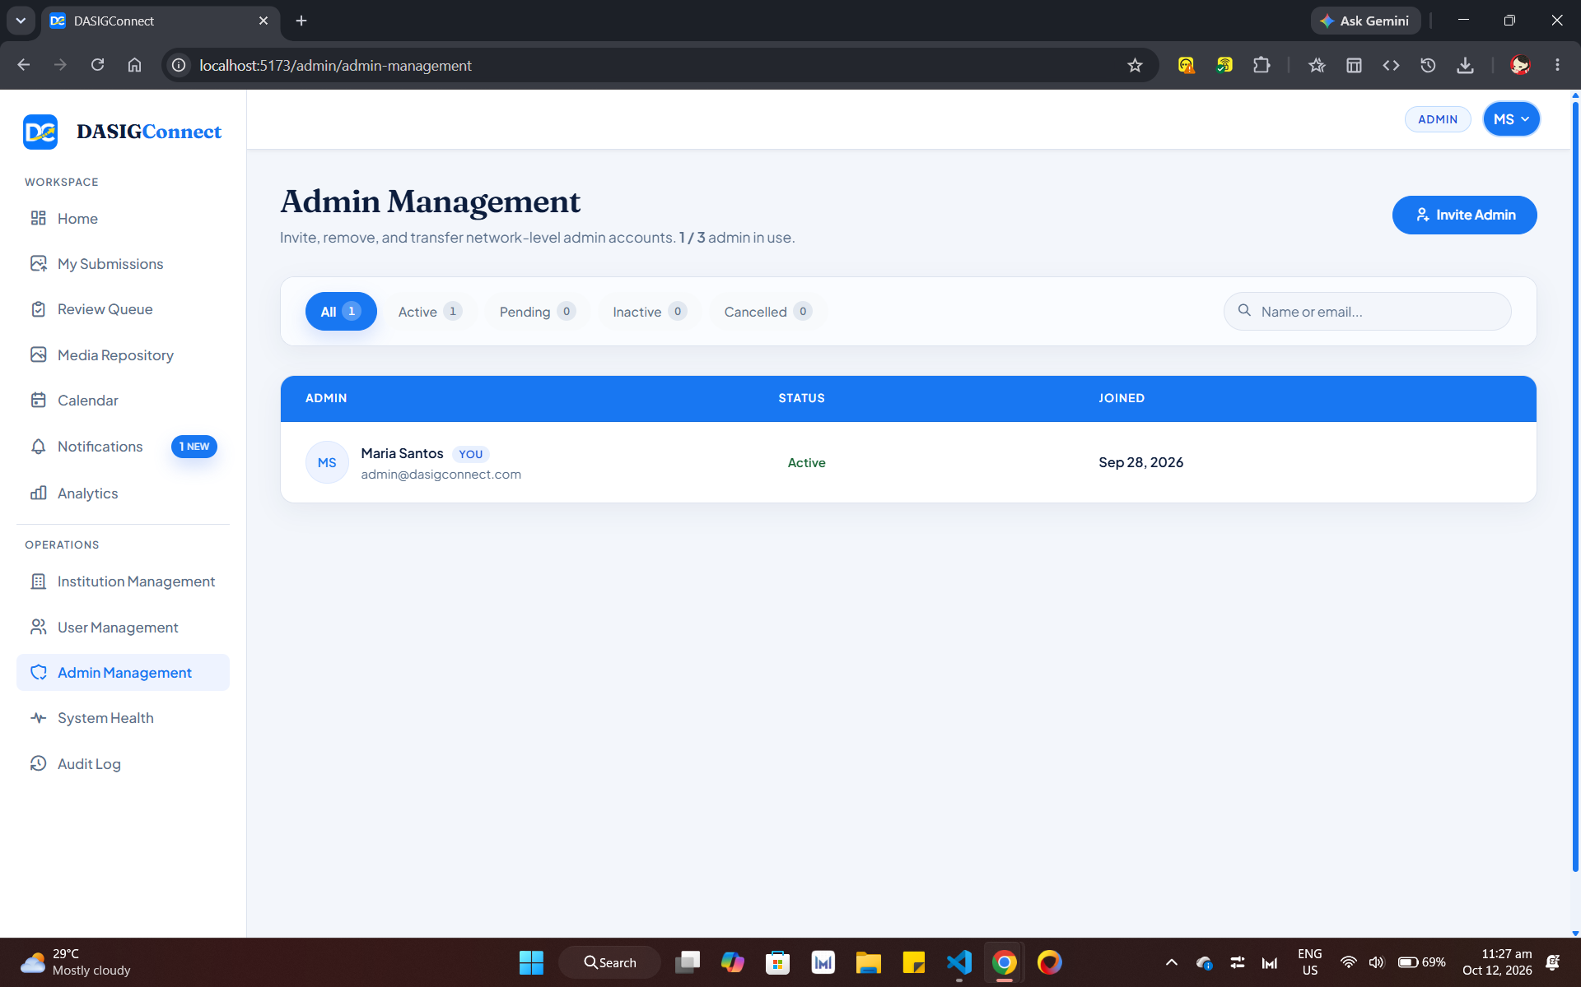
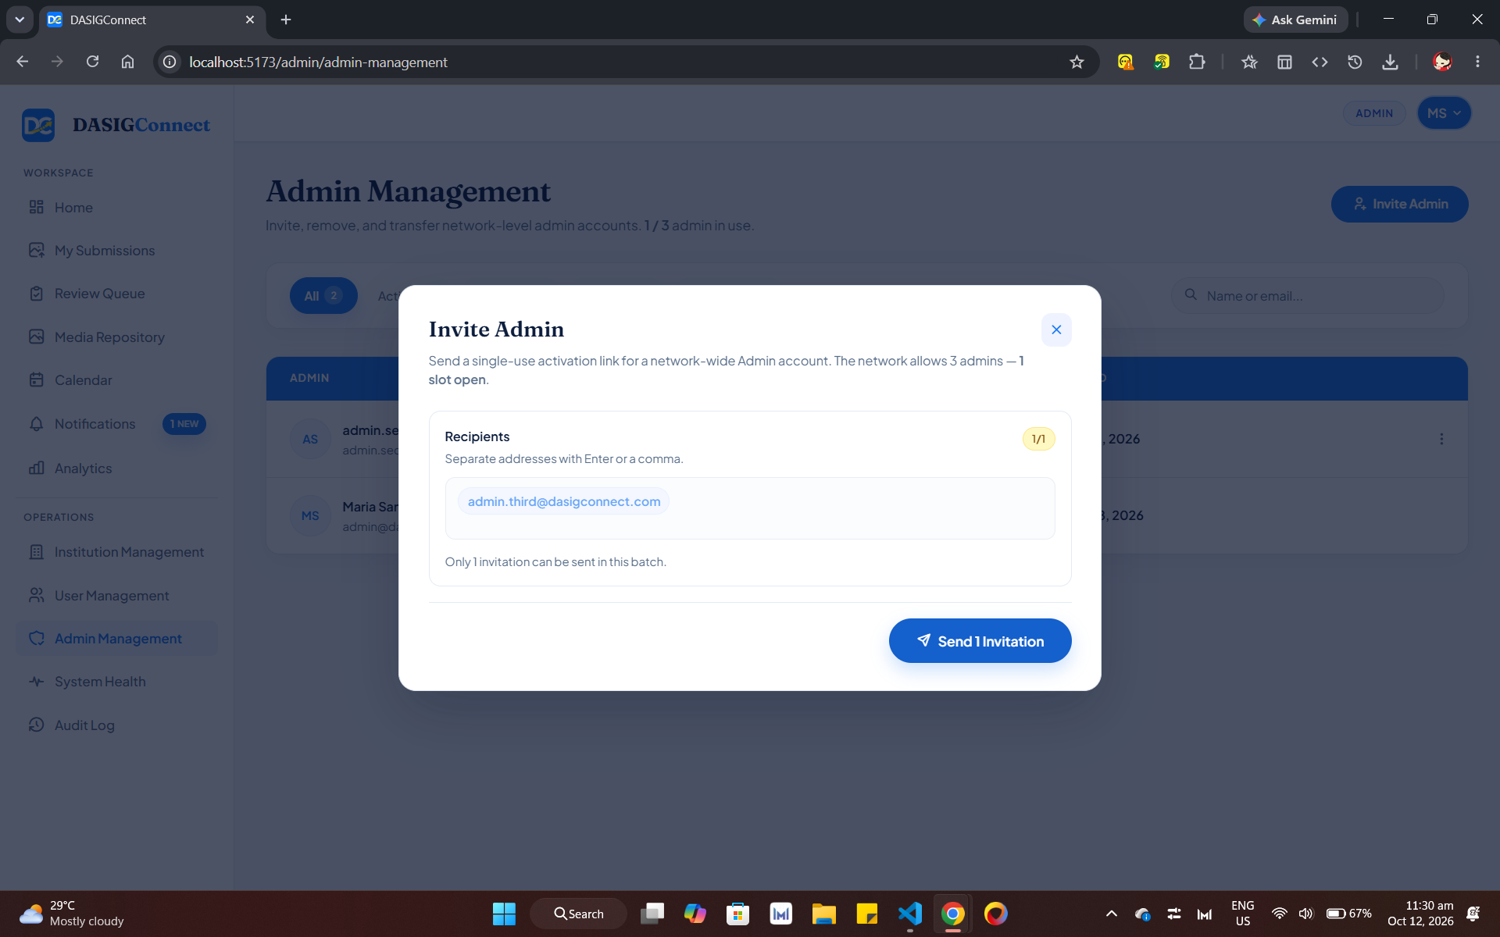
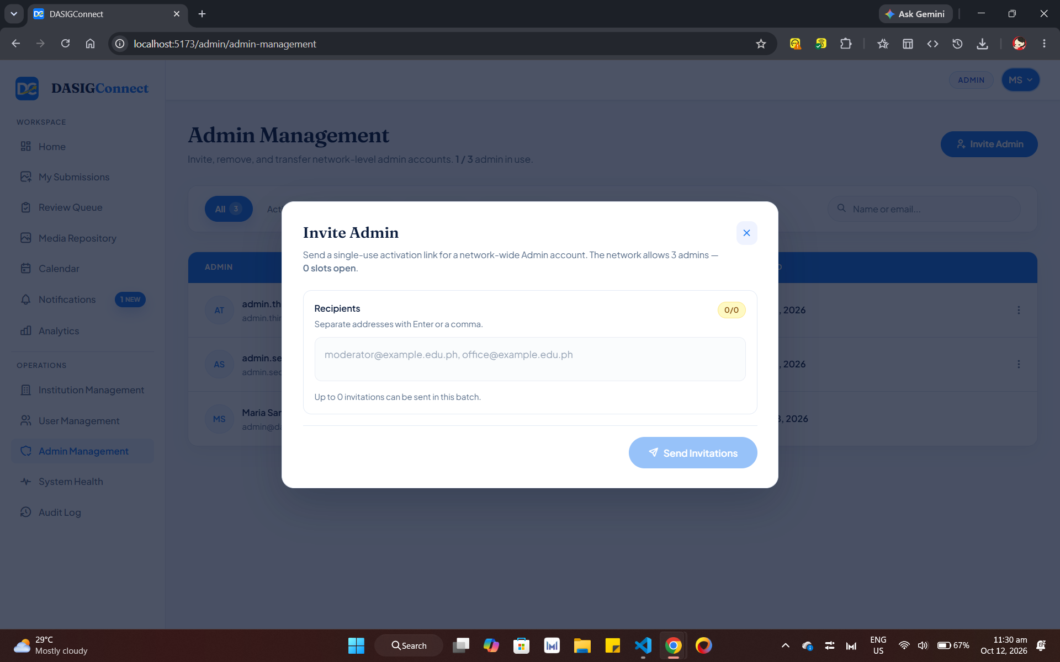
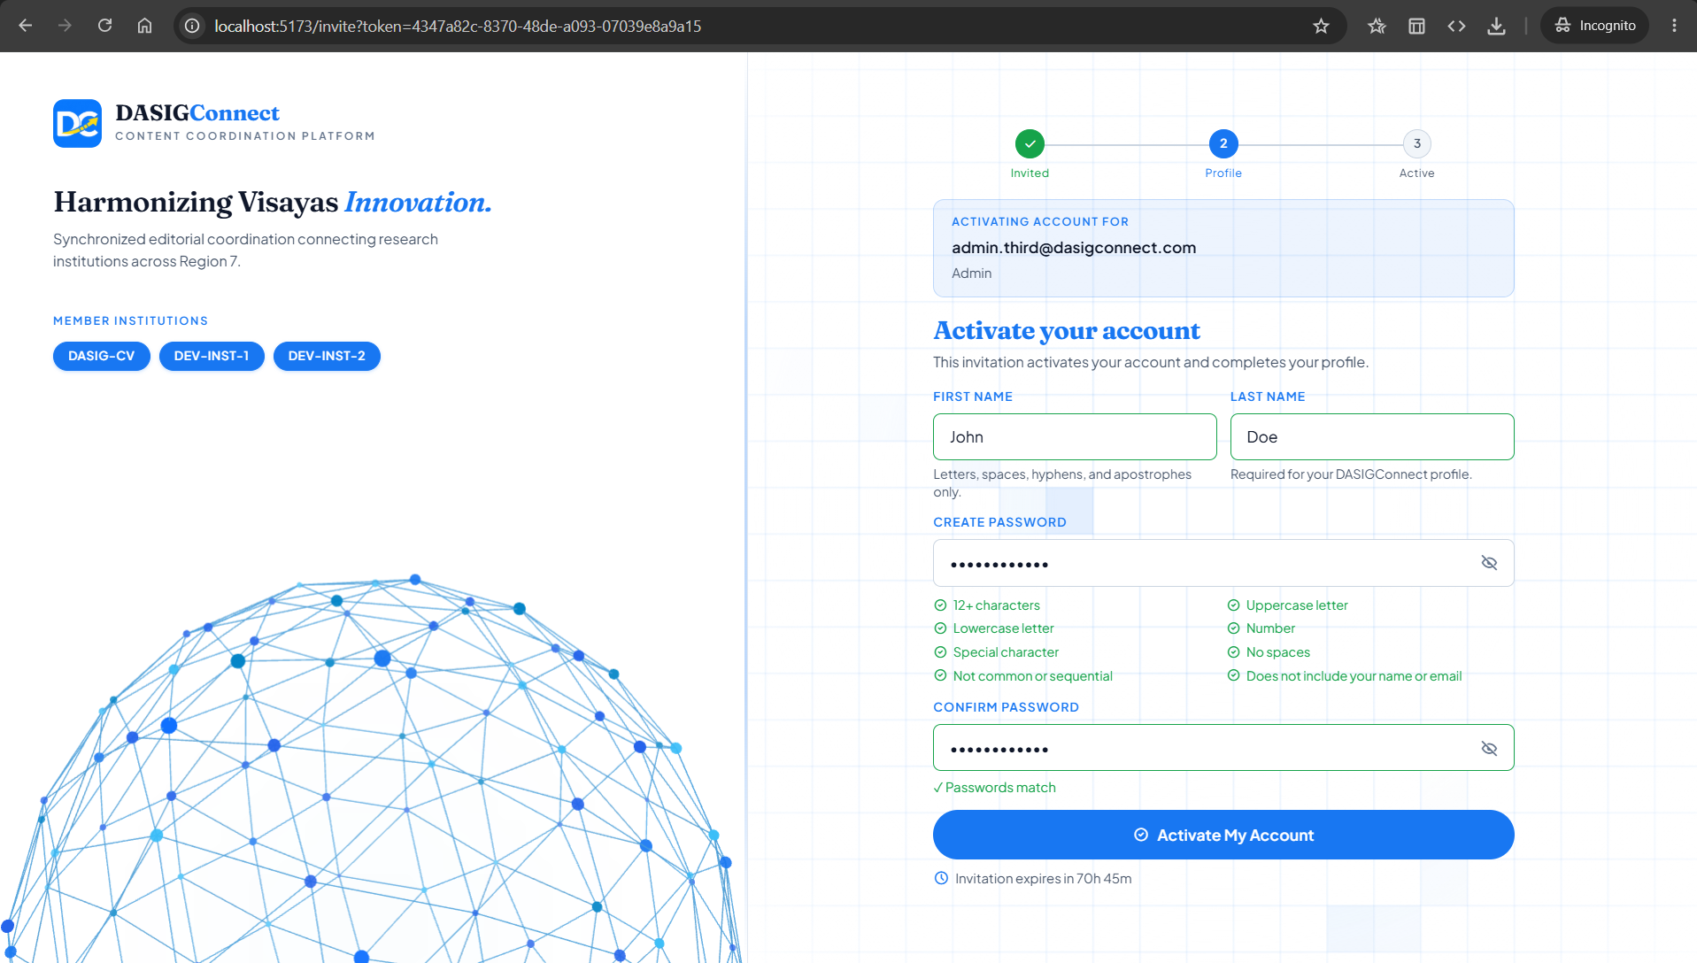
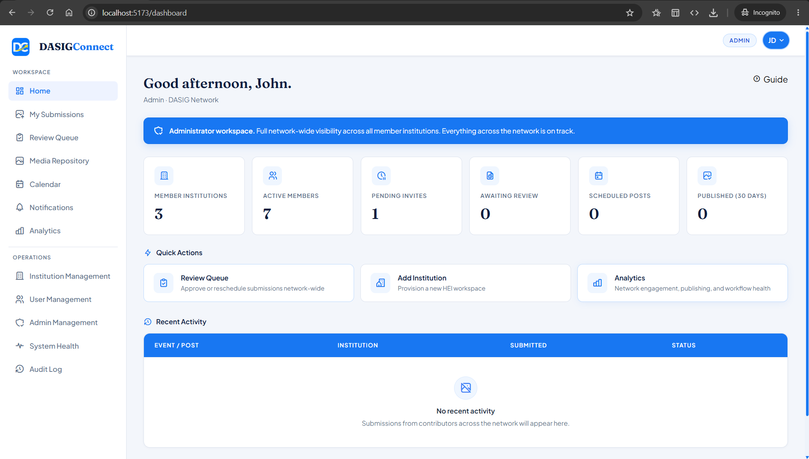
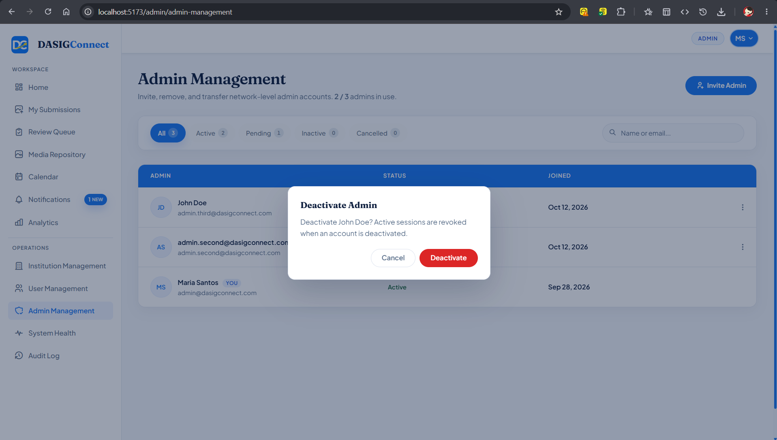
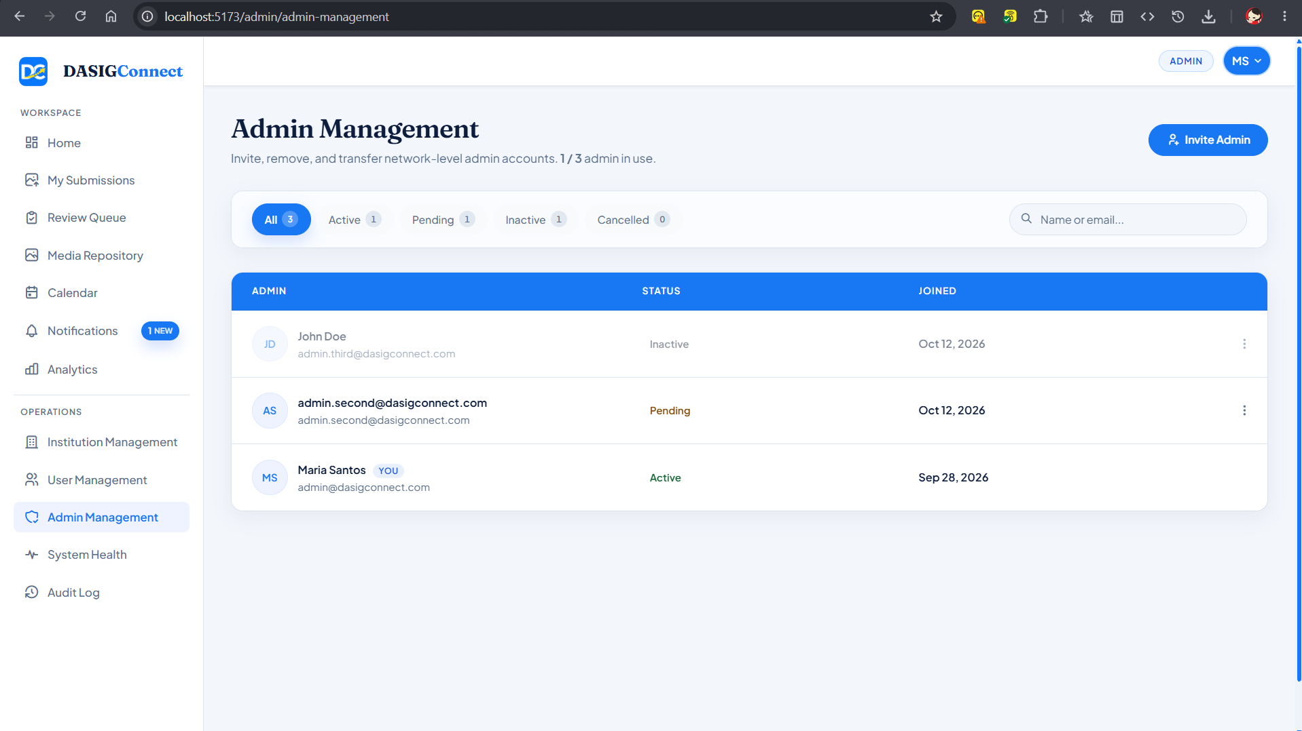
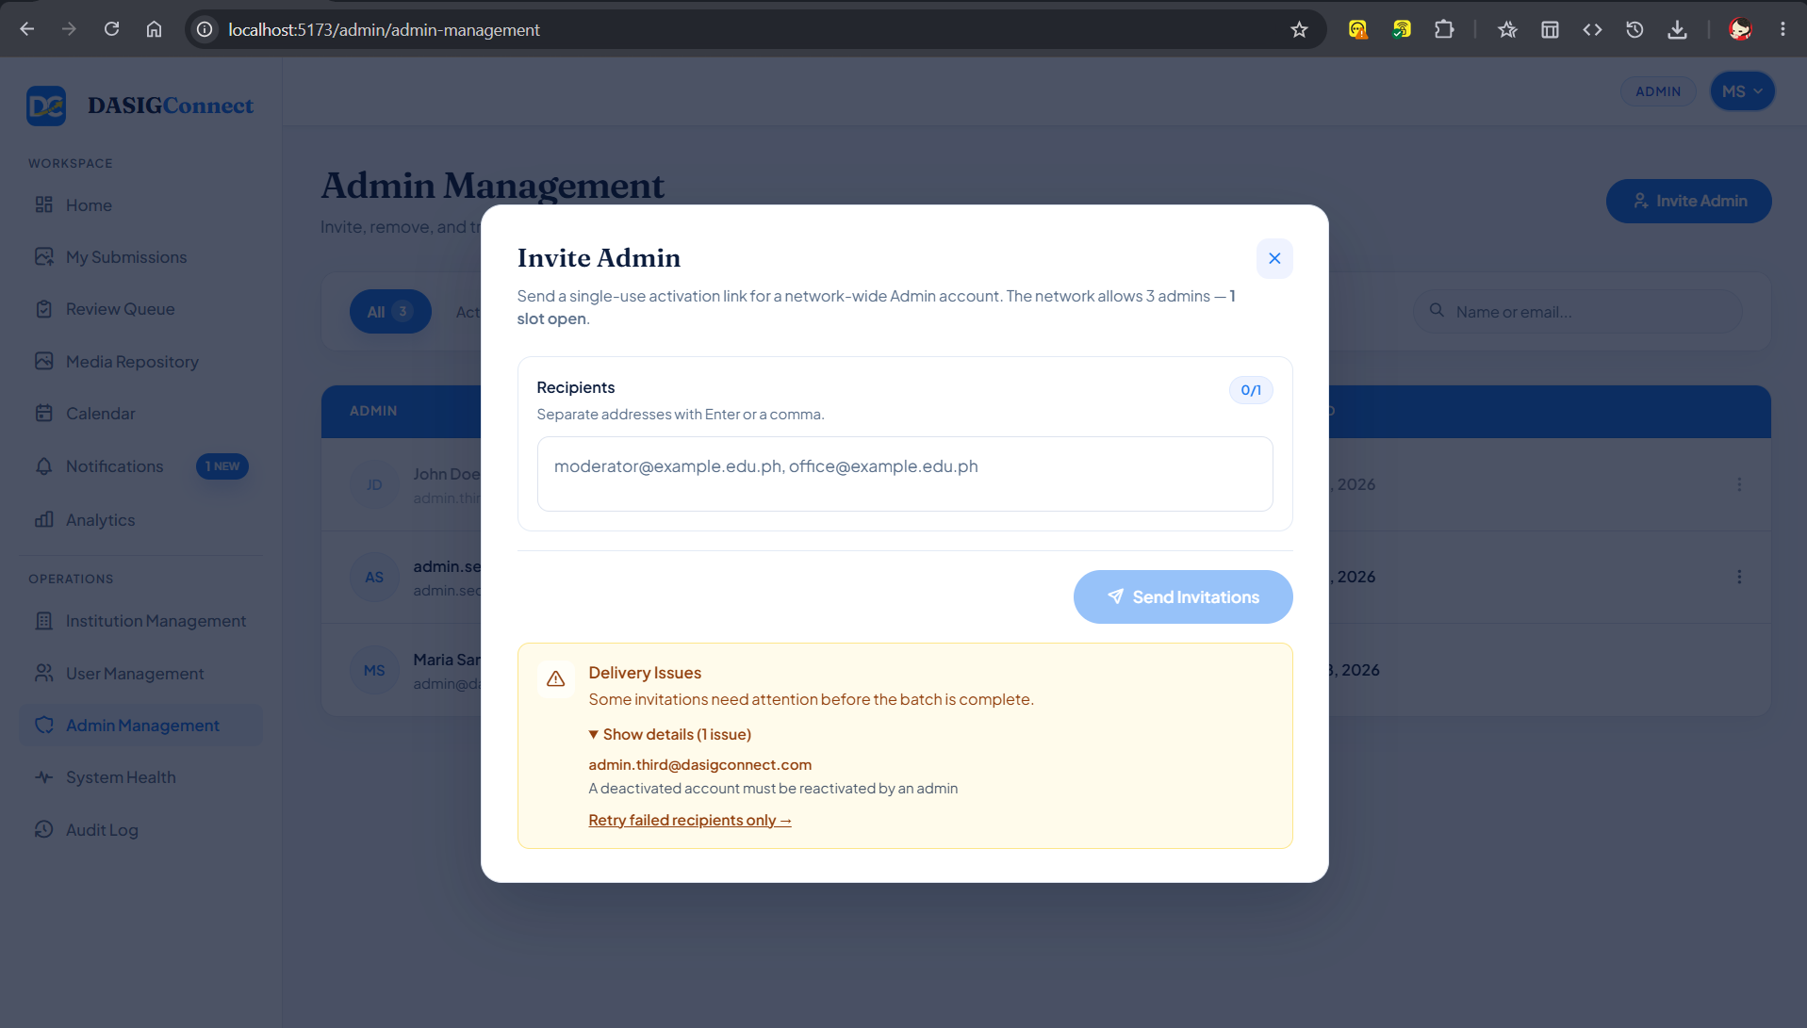

Screenshots for Test 2 (Case-2 — UC-1.1 A7, A8 Admin Promotion & Admin Owner Transfer)
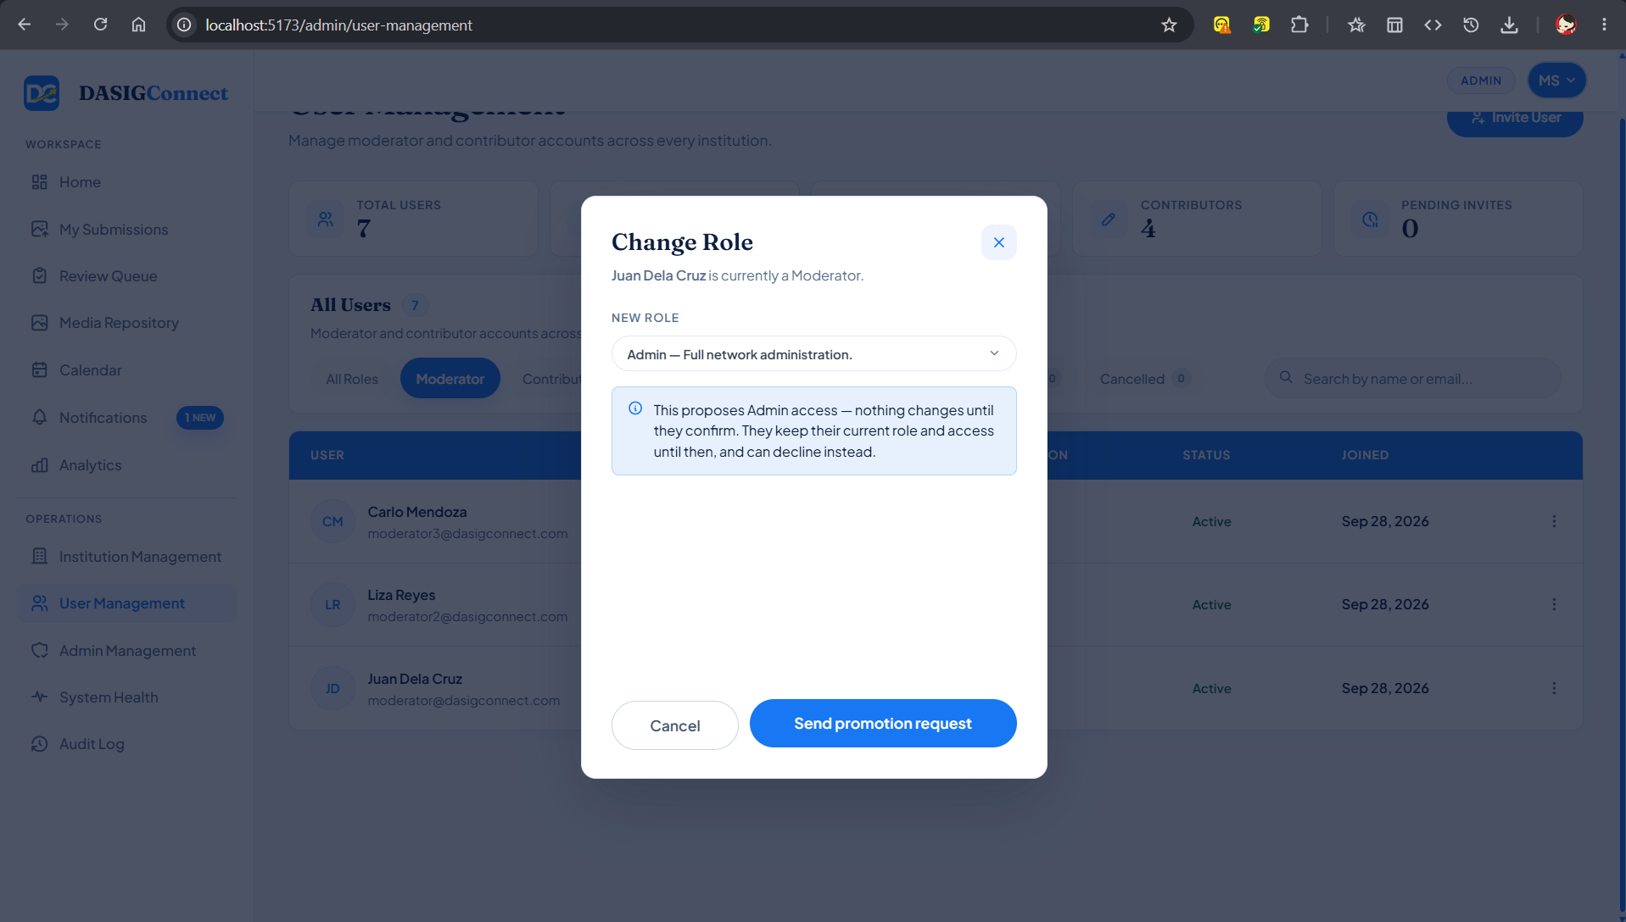
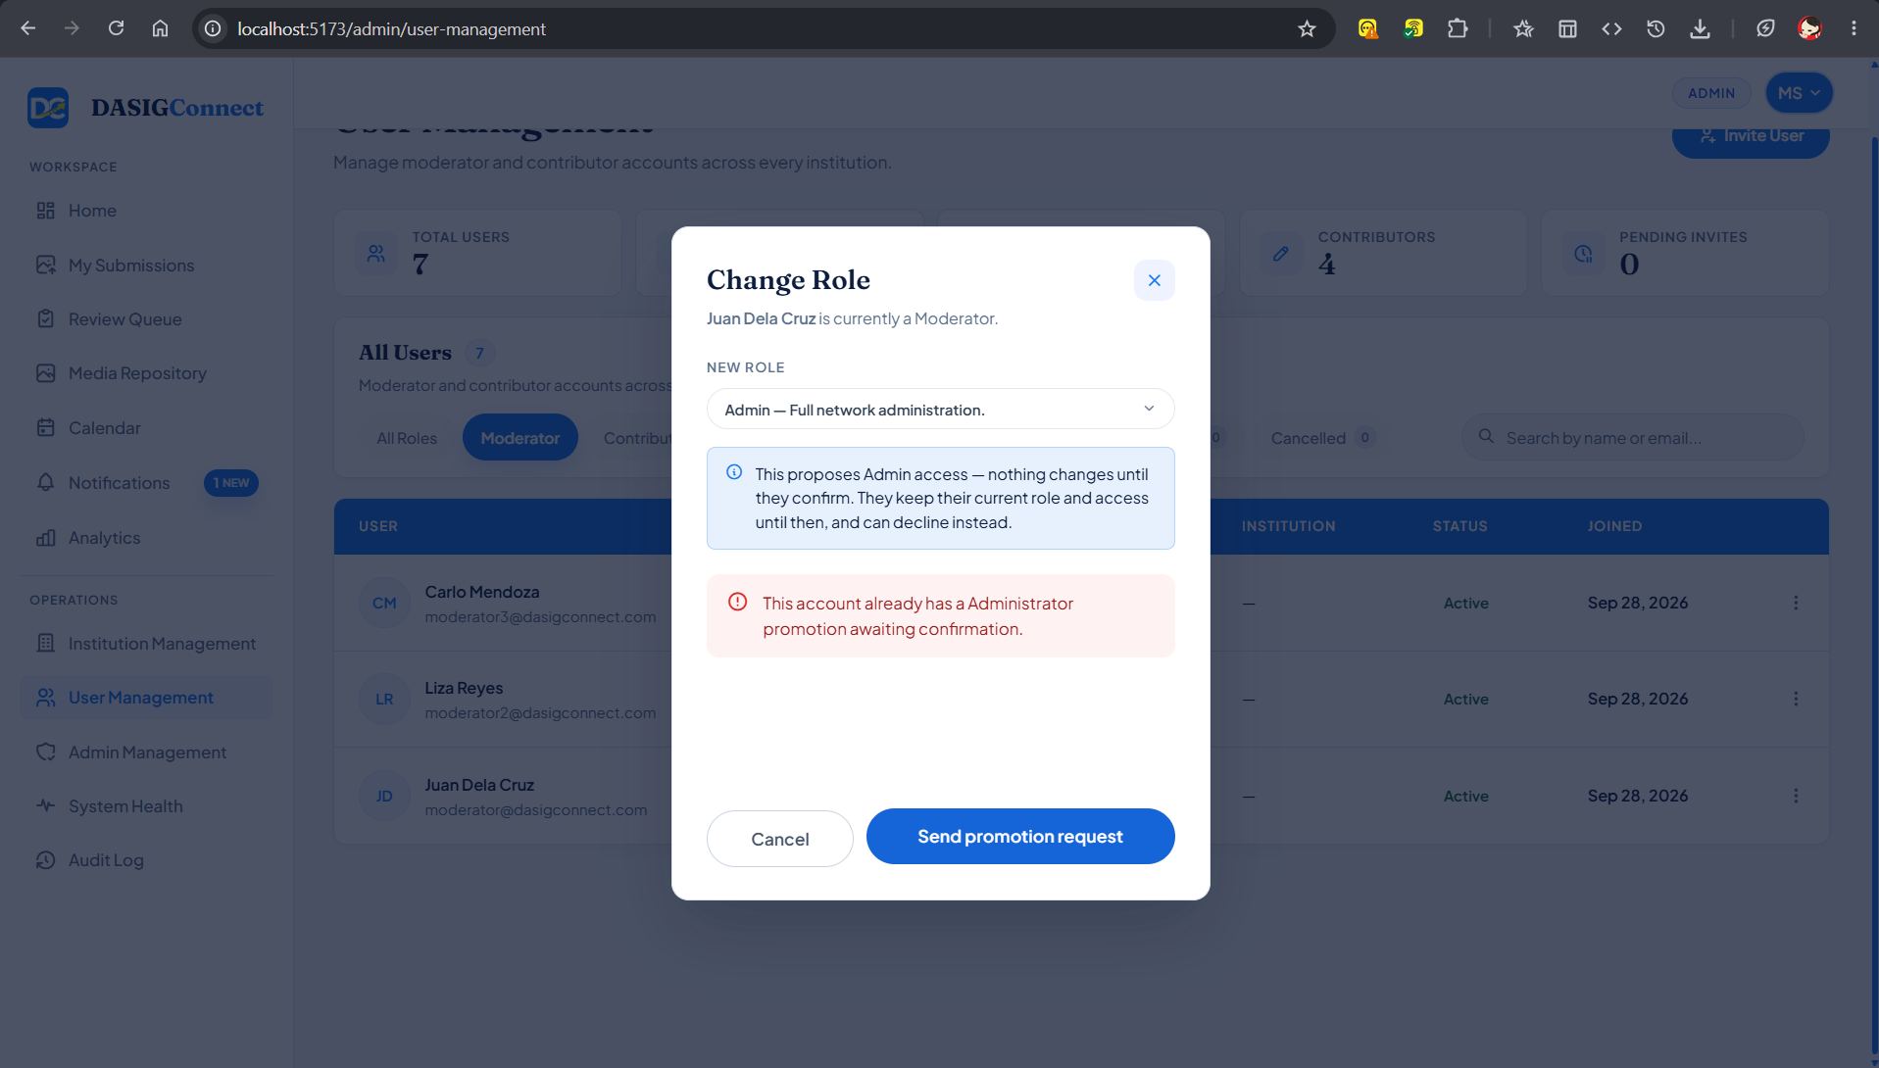
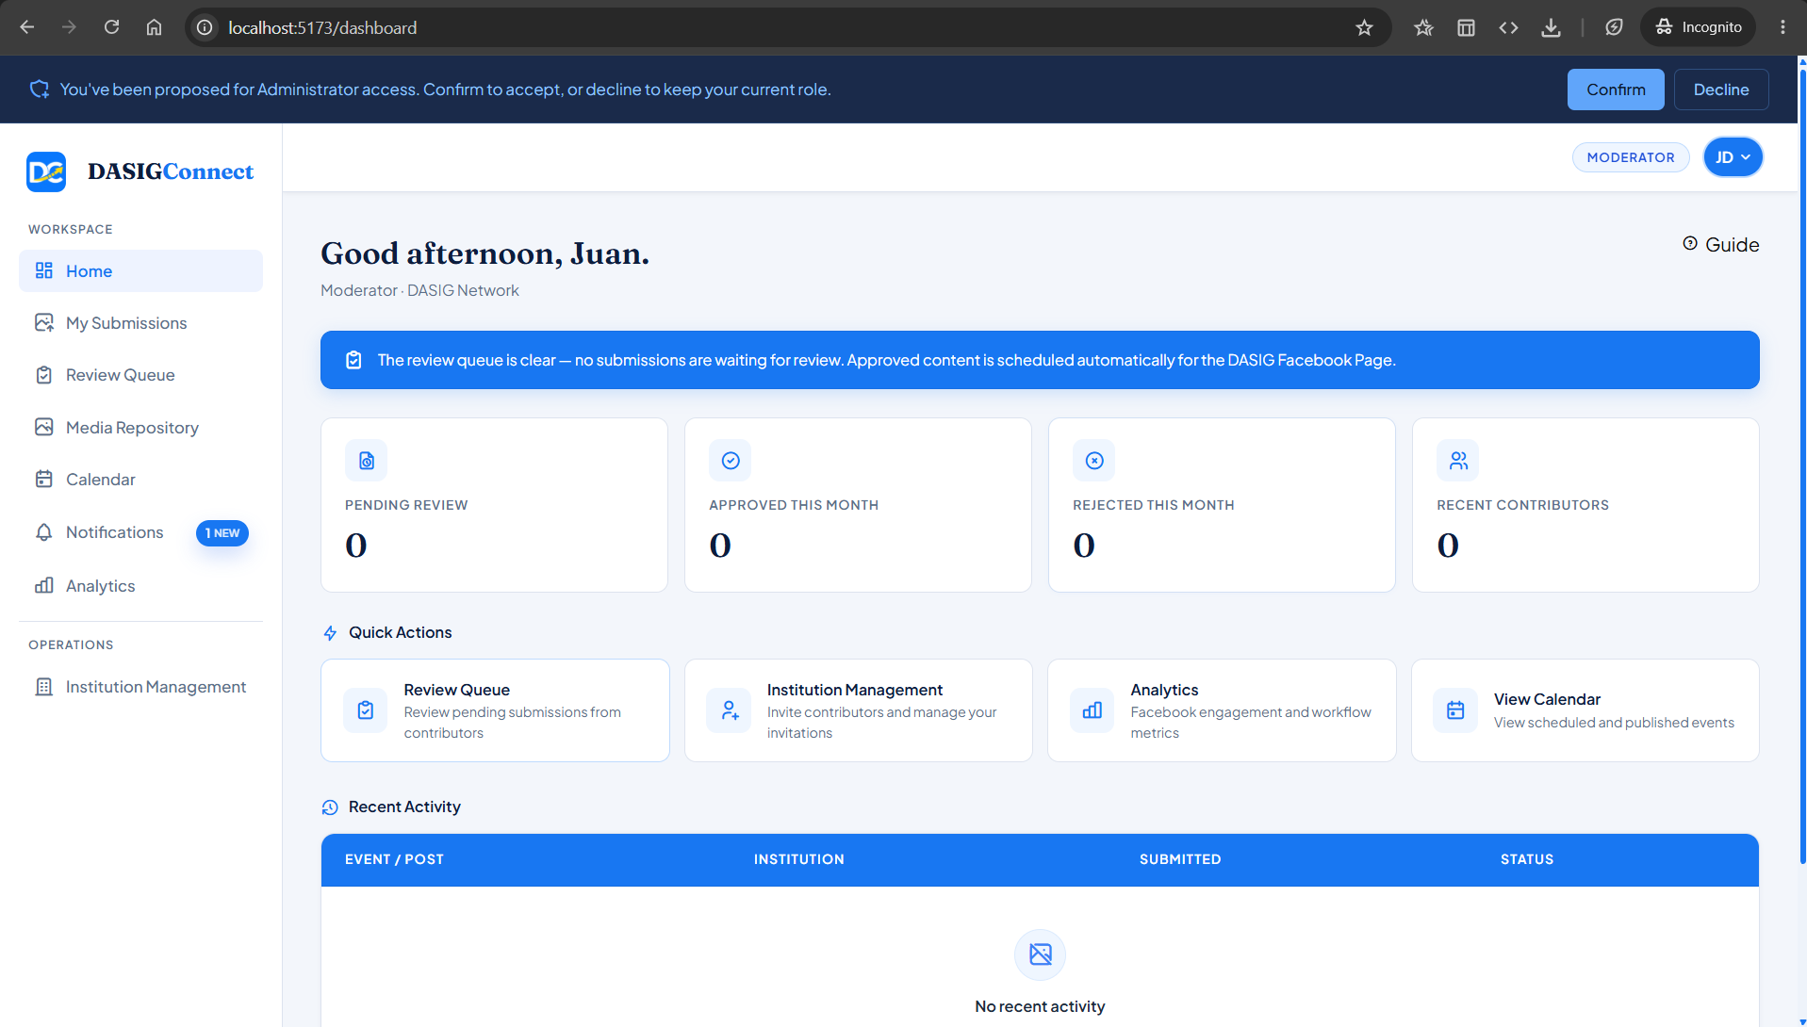
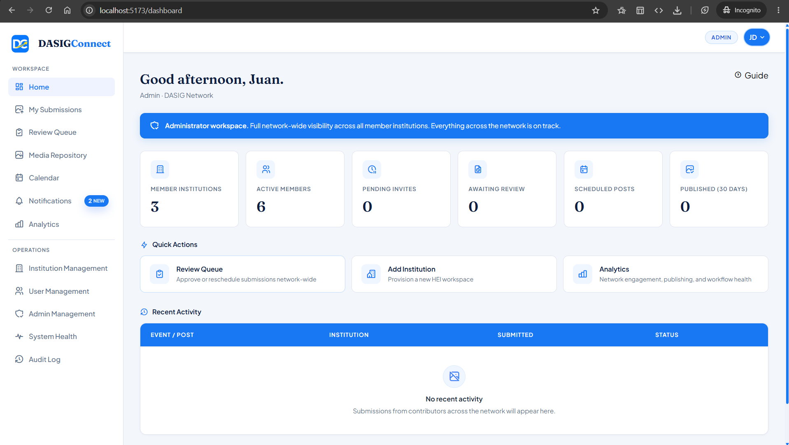

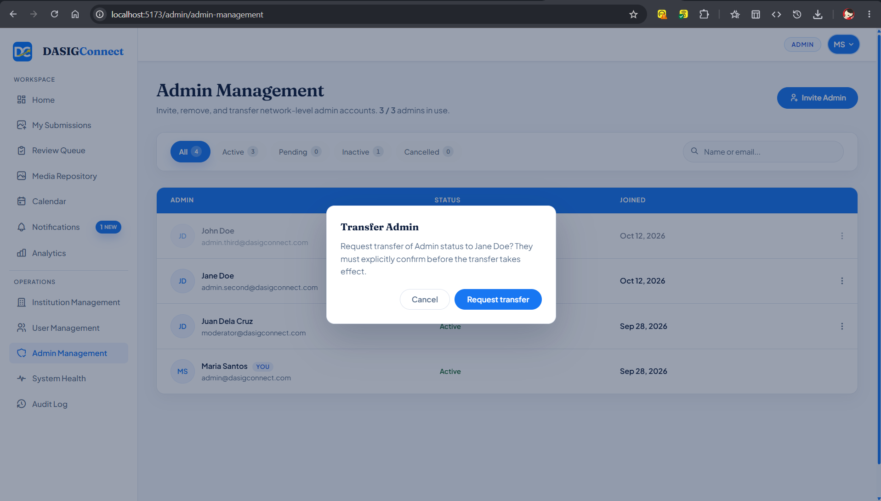
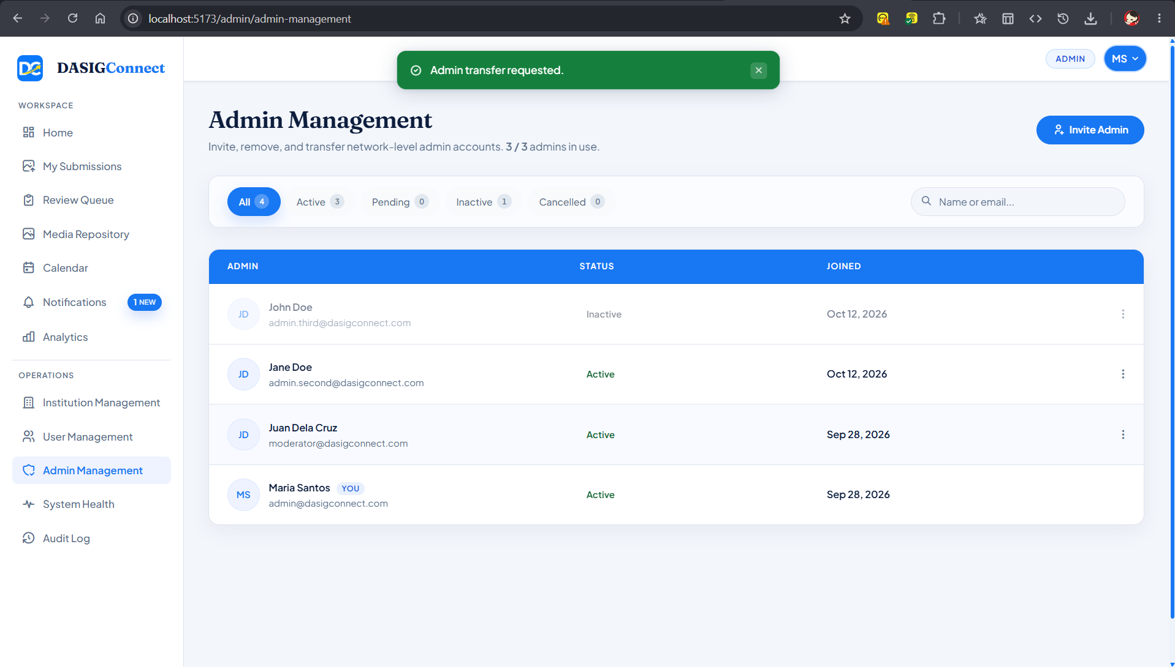
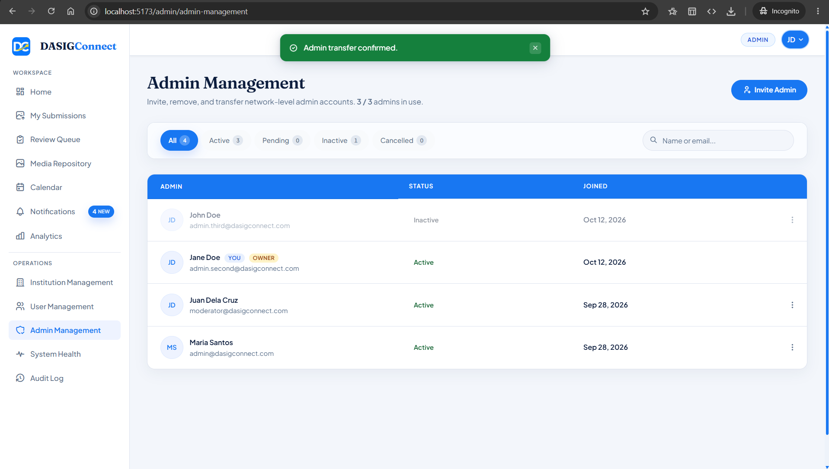

Screenshots for Test 3 (Case-3 — UC-1.2 Institution Lifecycle & Protected Institution)
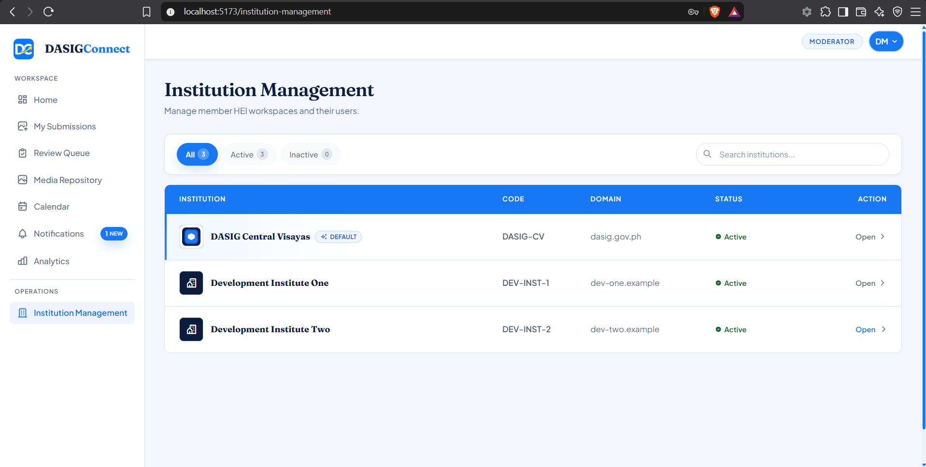
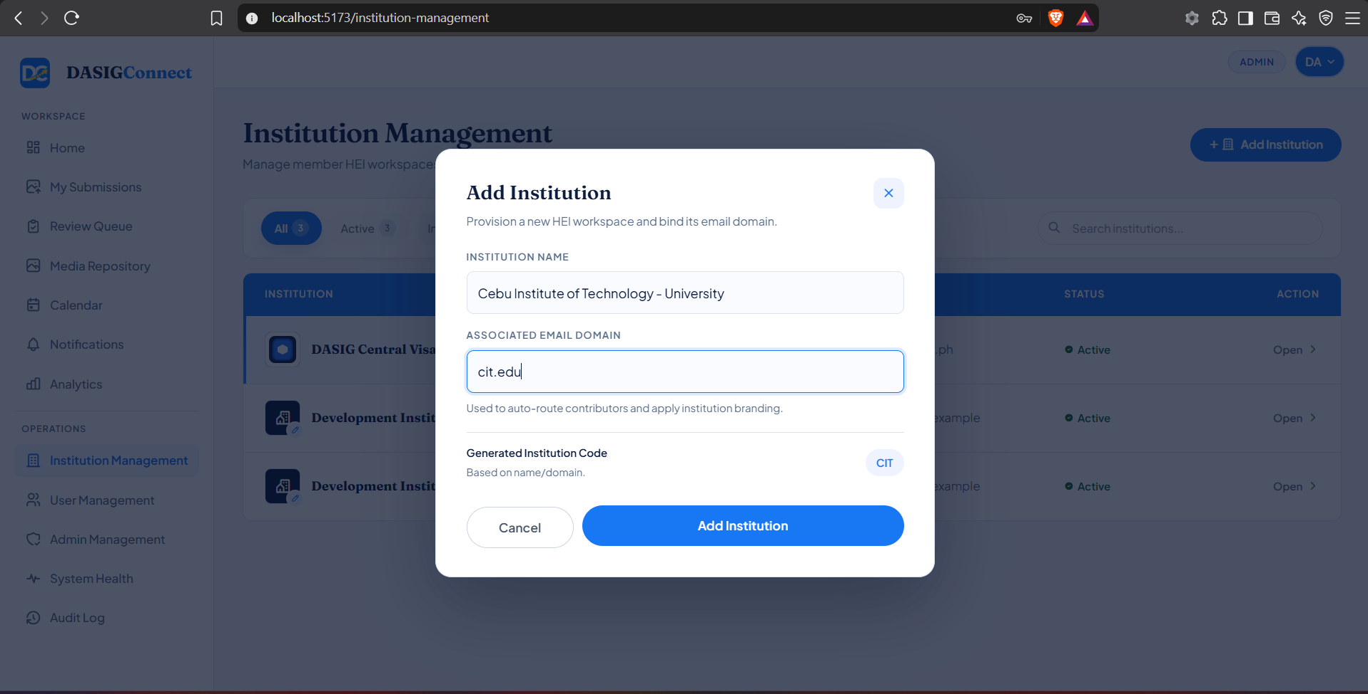
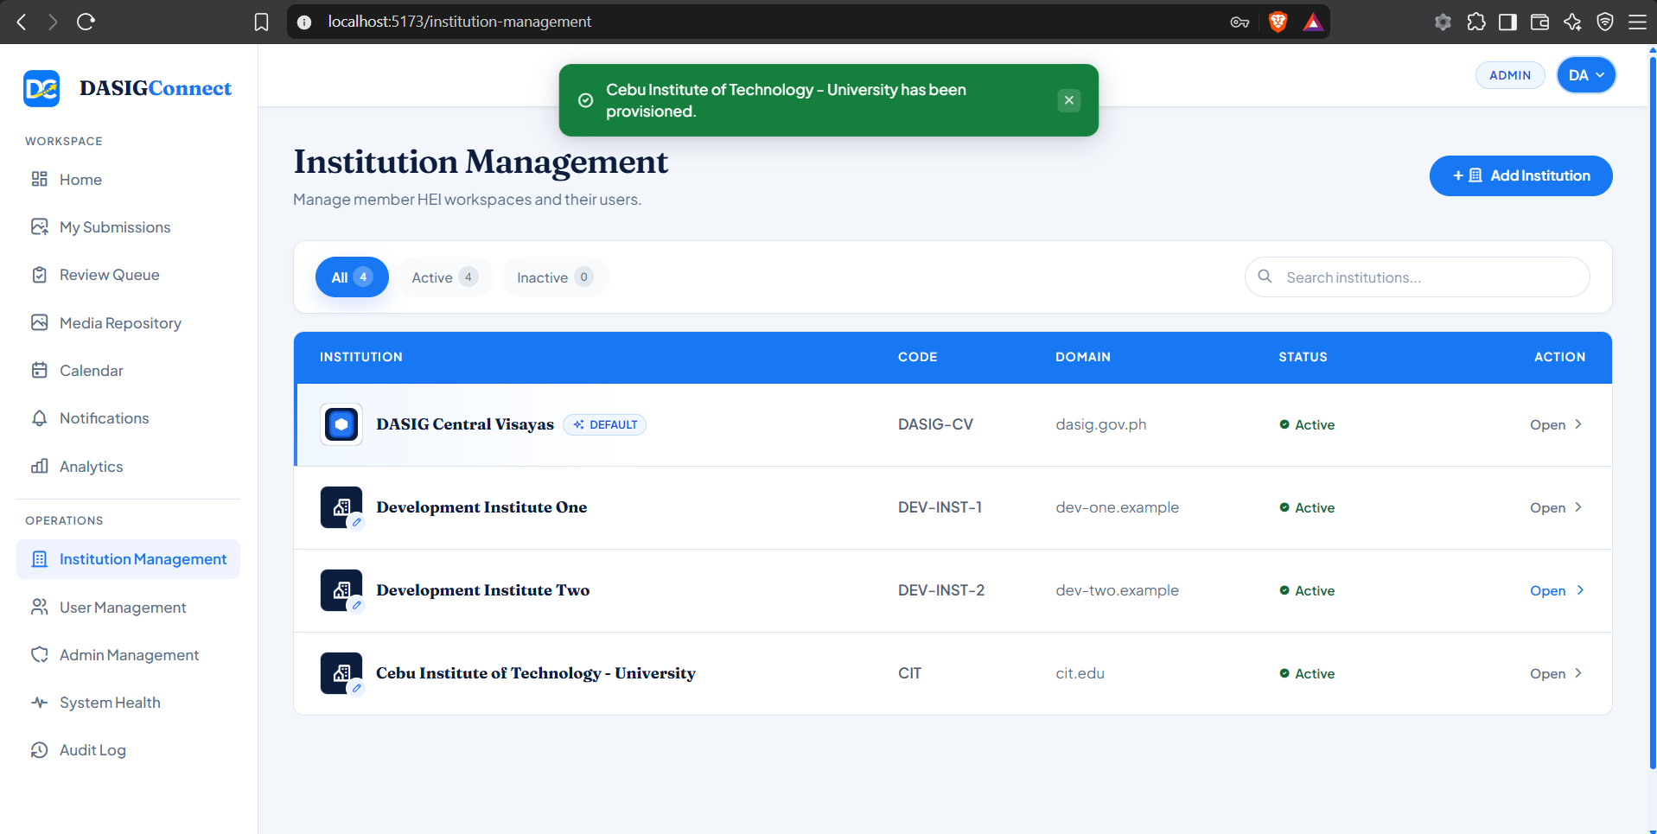
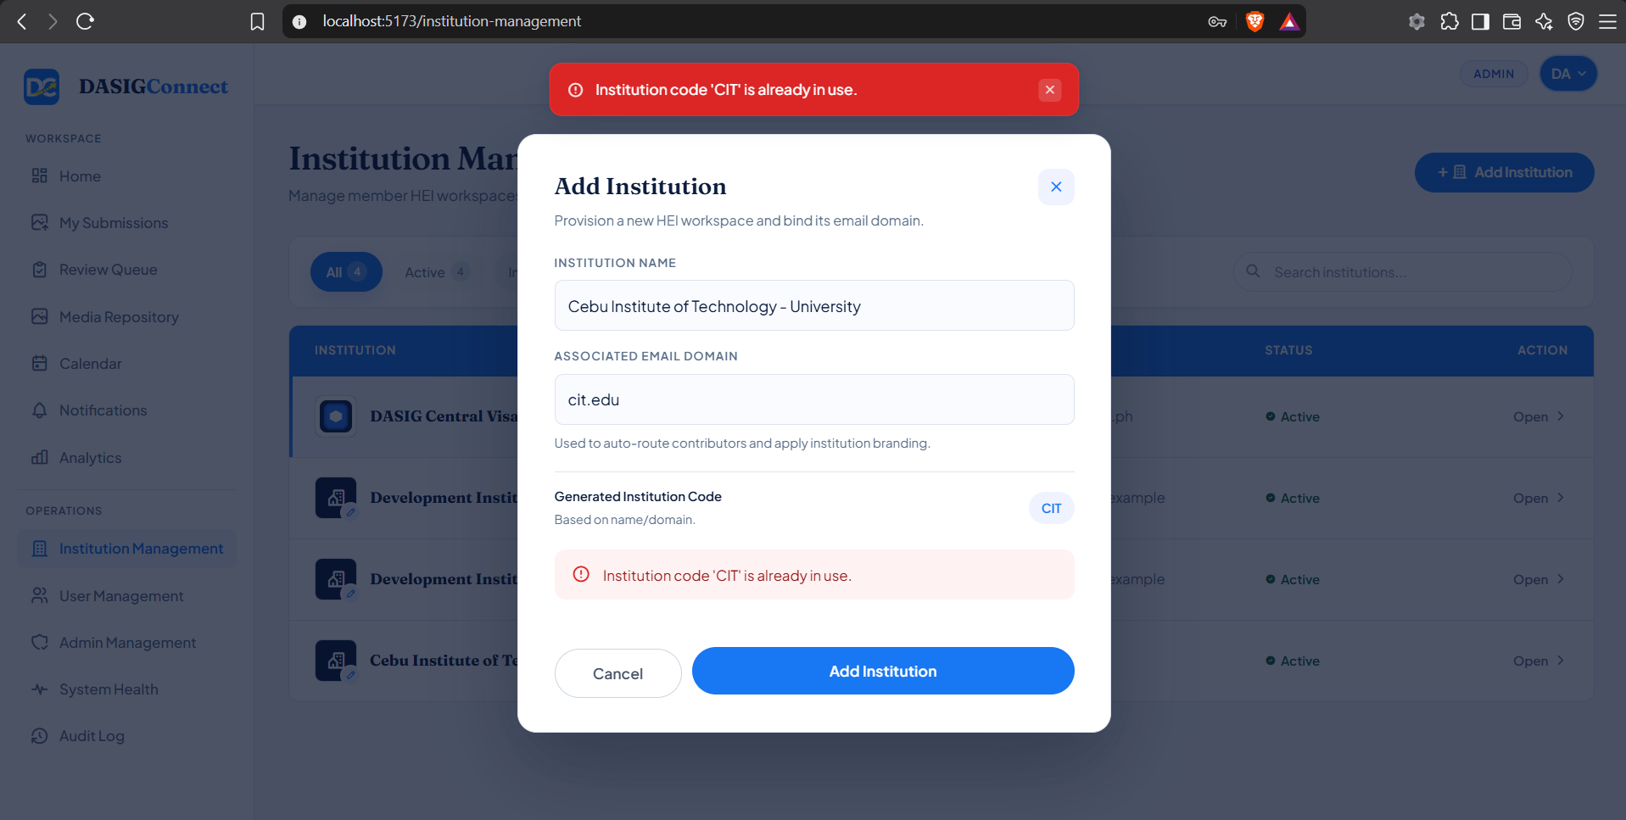
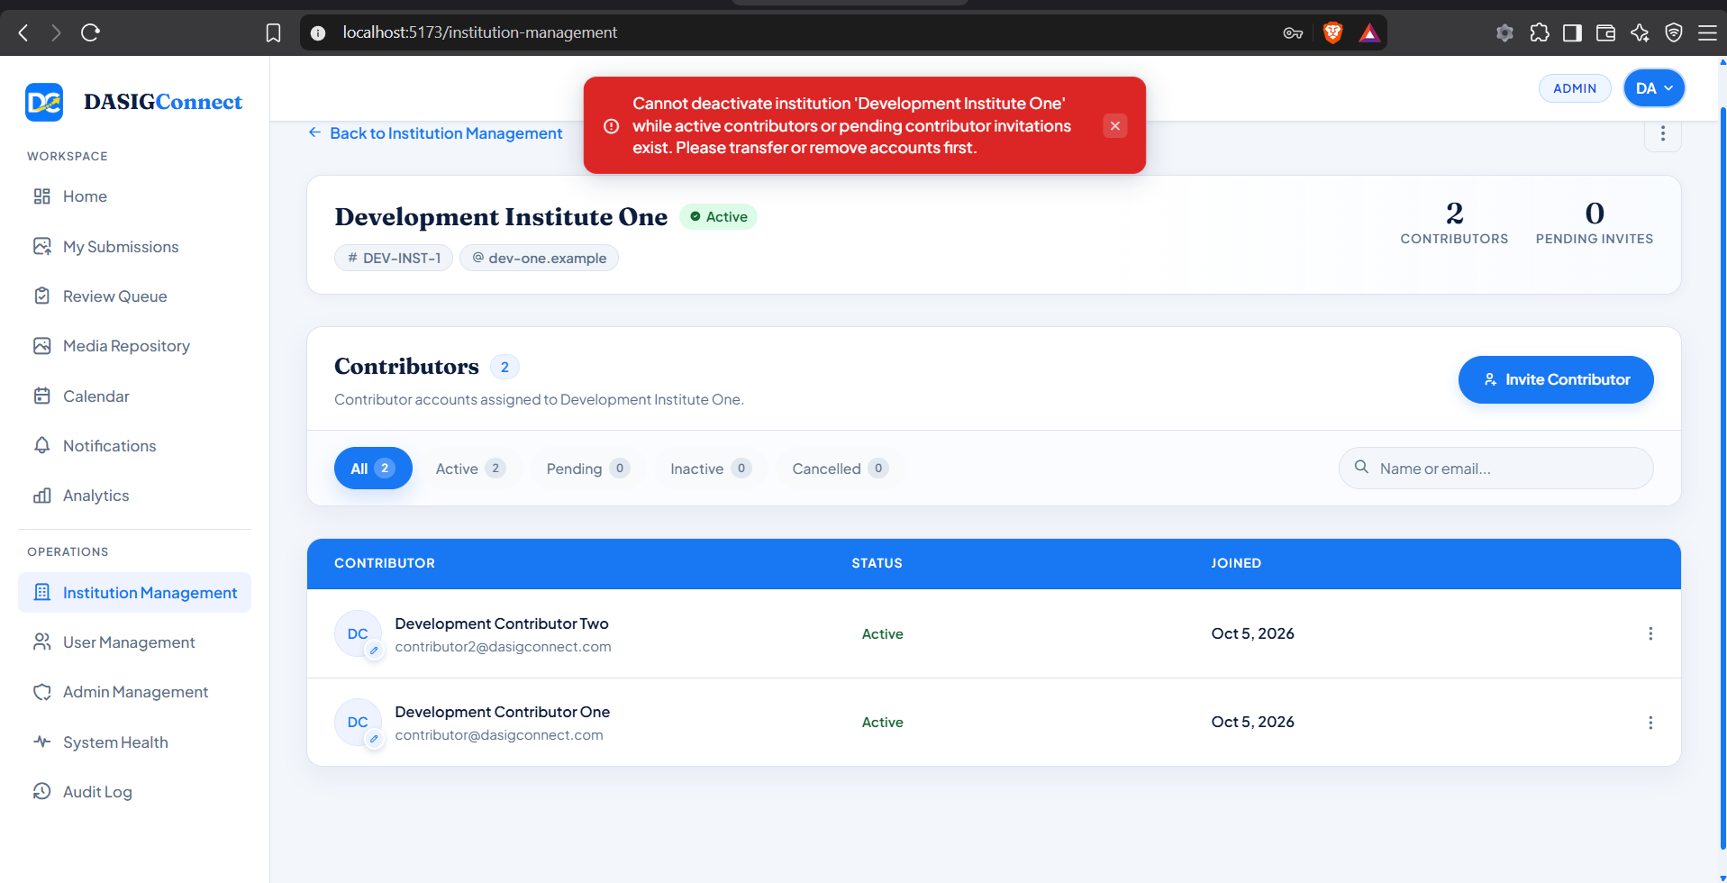
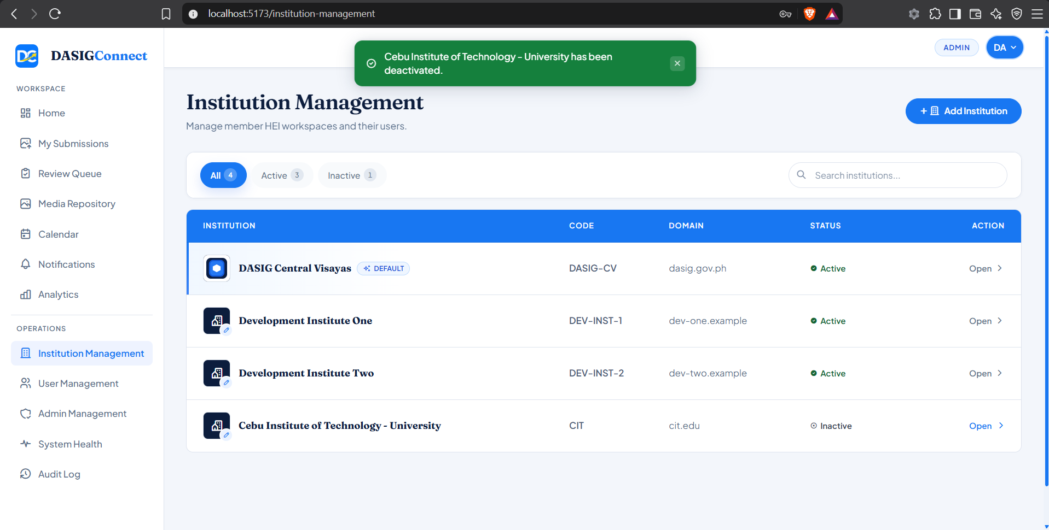
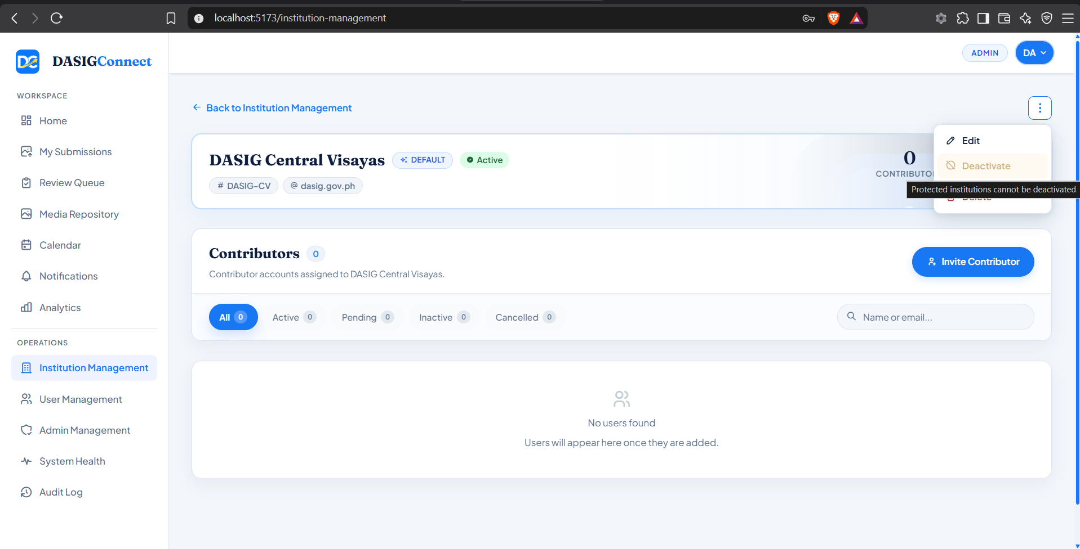
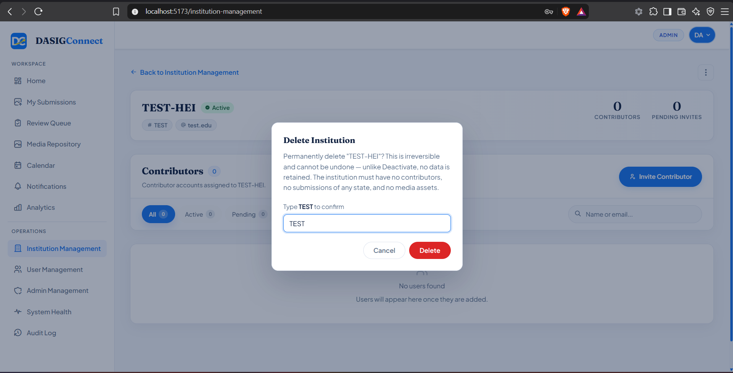
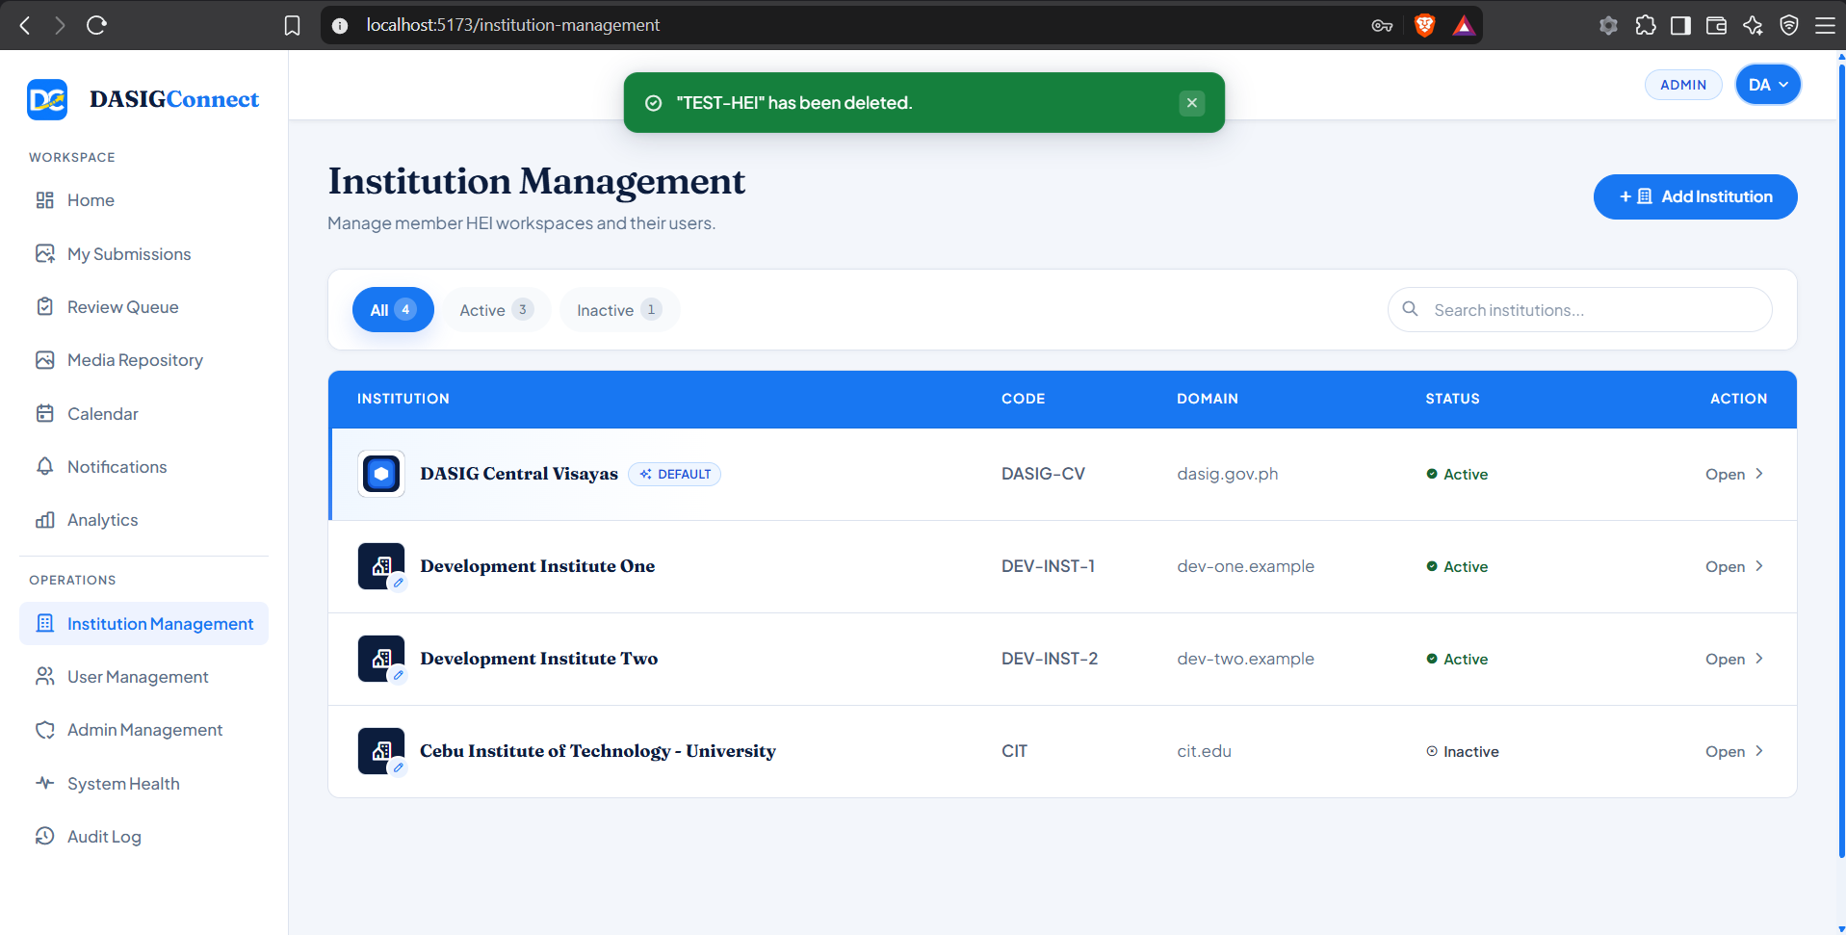

Screenshots for Test 4 (Case-4 — UC-1.3 Contributor Account Provisioning & Footprint-Aware Deletion)
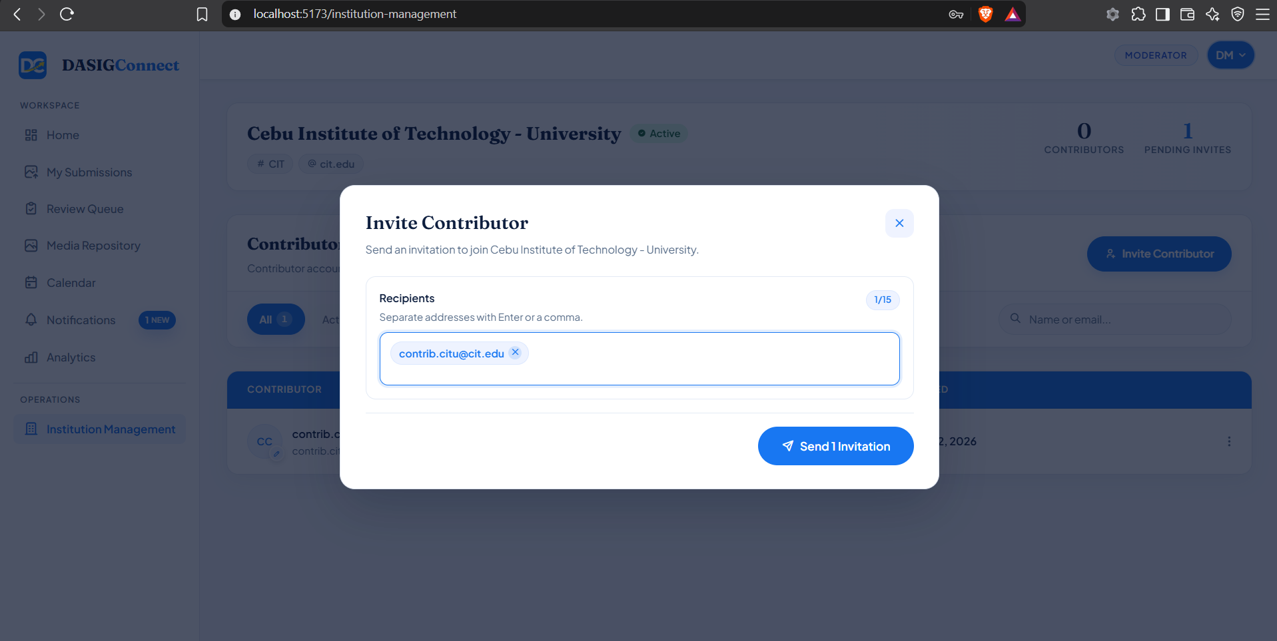

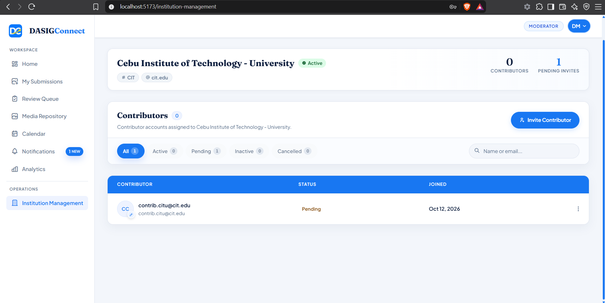
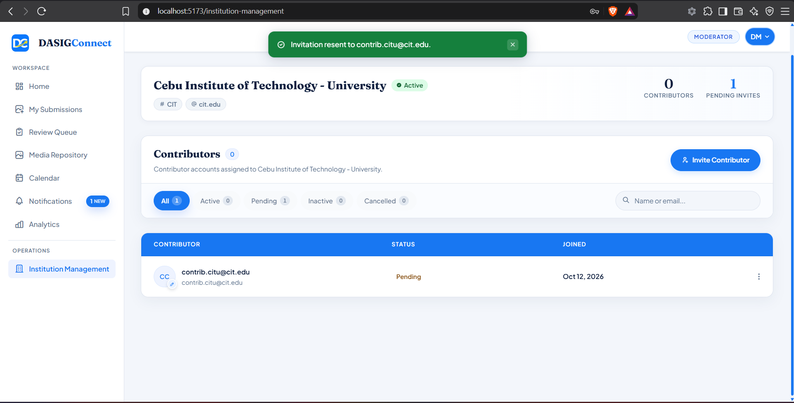
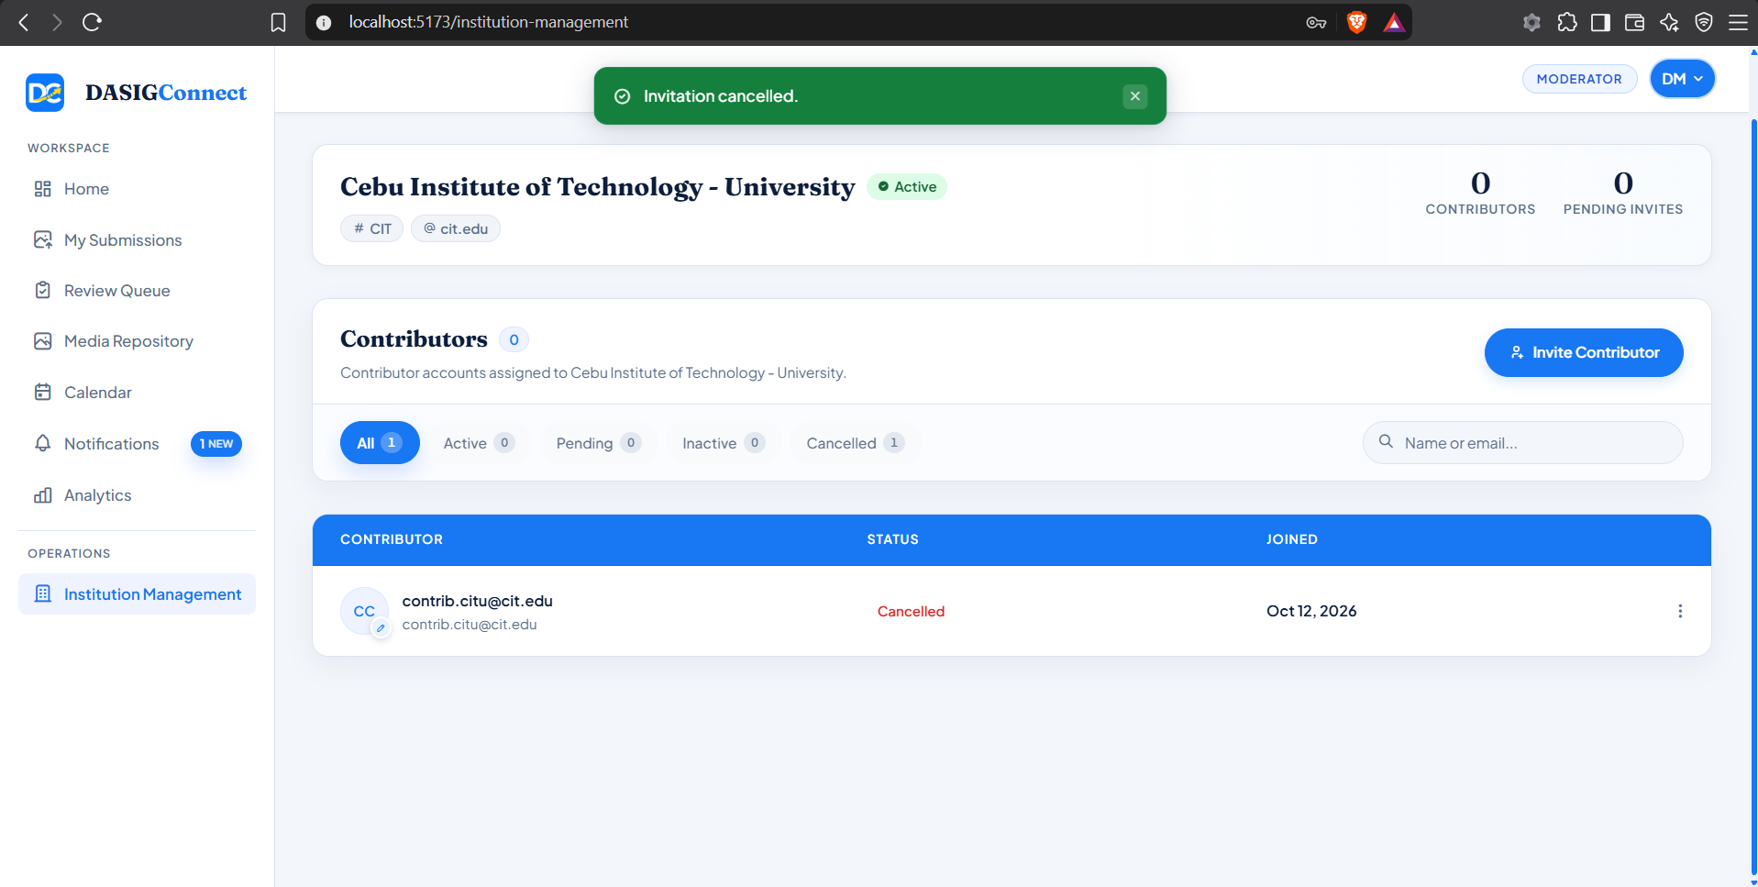
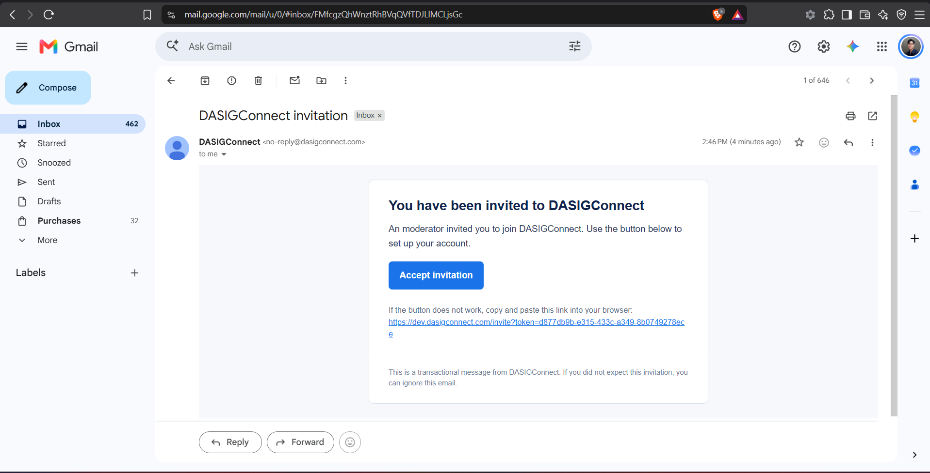
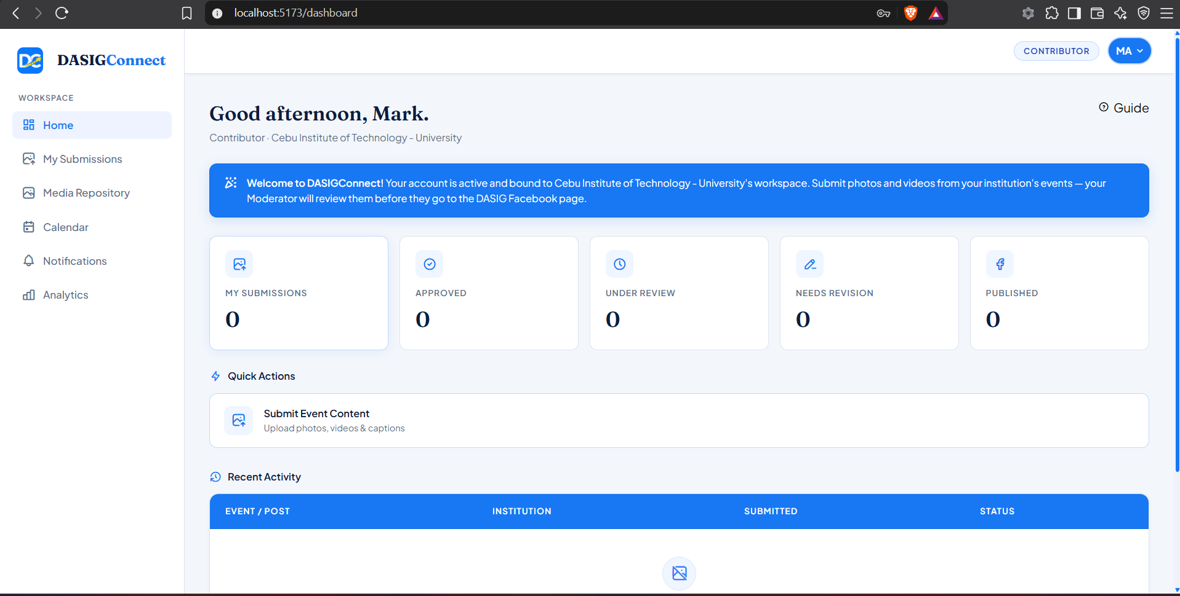
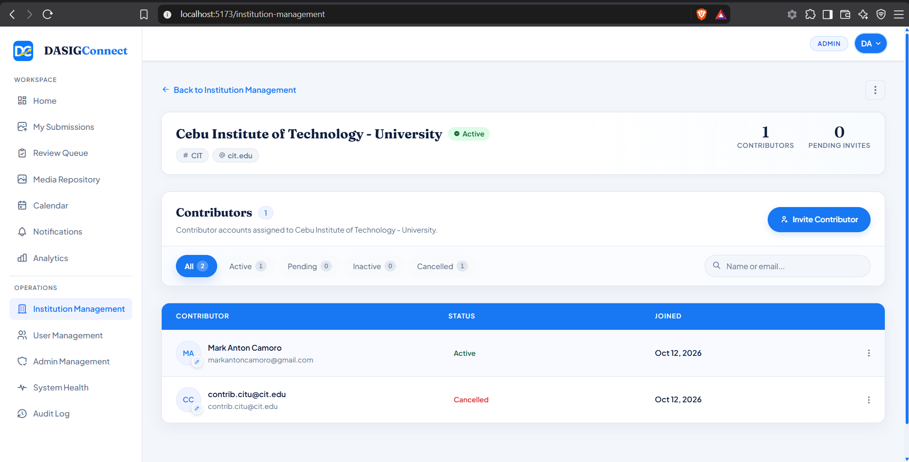
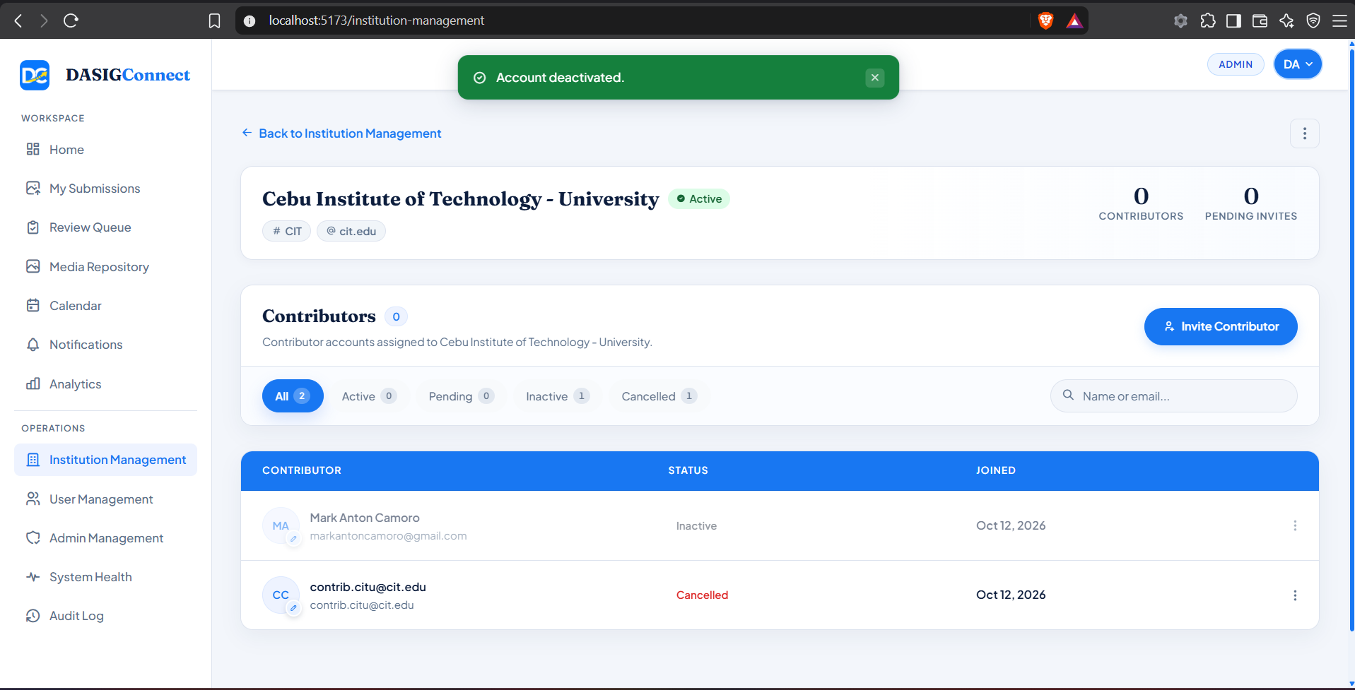
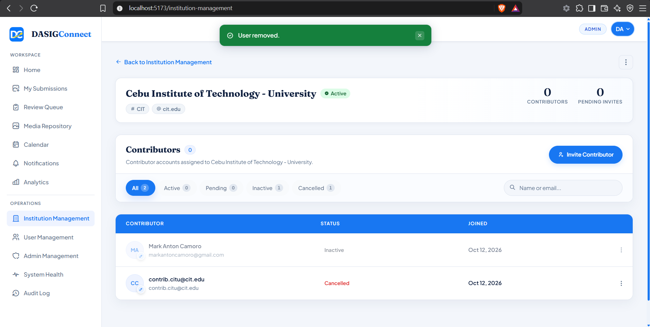
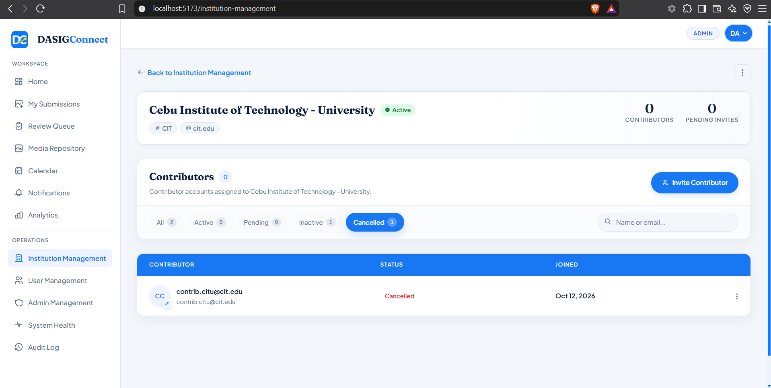

Screenshots for Test 5 (Case-5 — UC-1.4 Login, Lockout, Password Policy & Session Revocation)
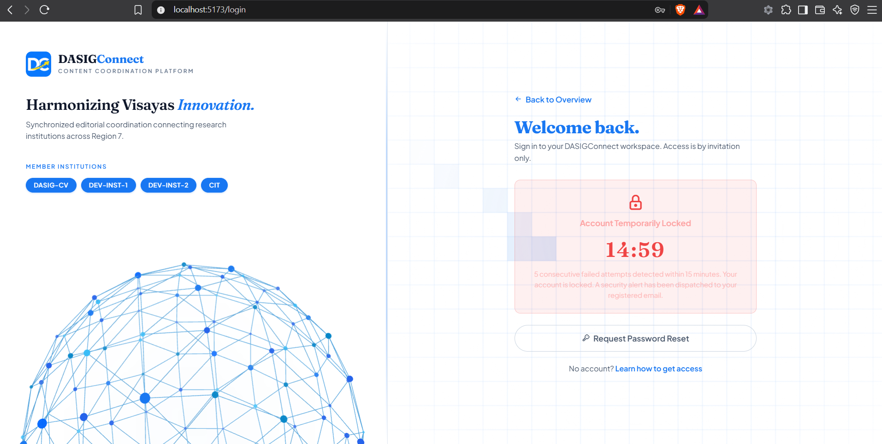
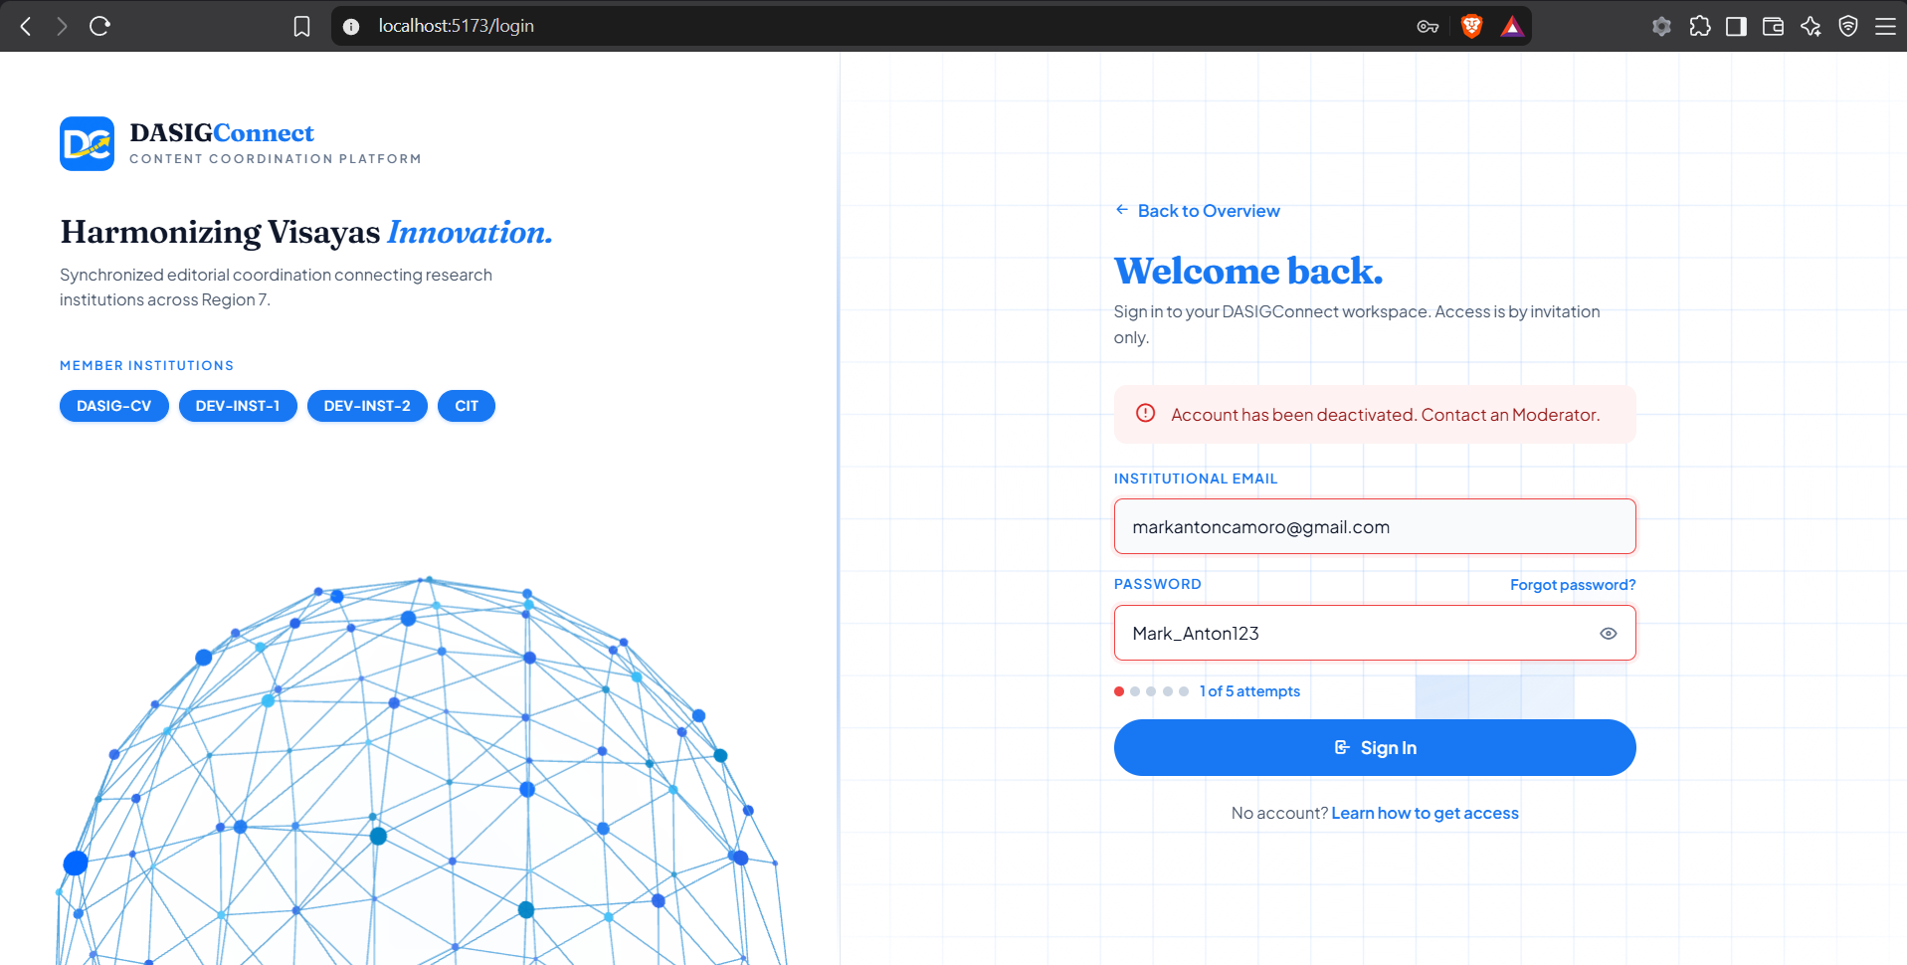
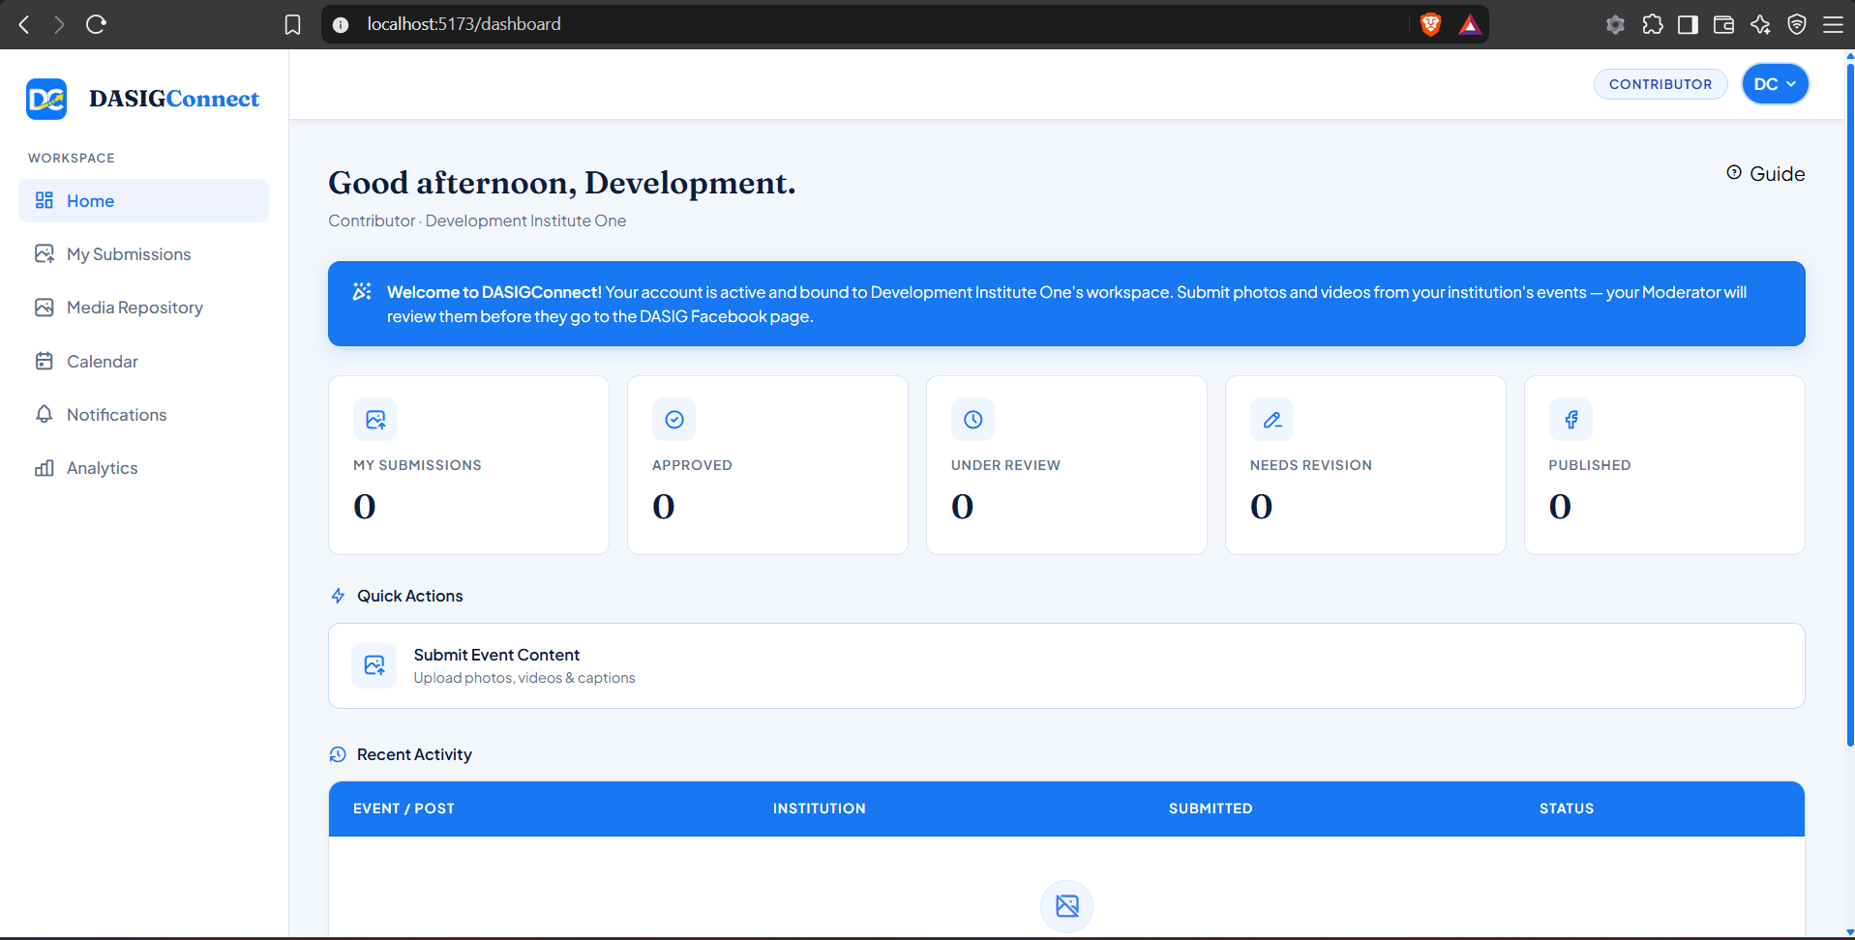
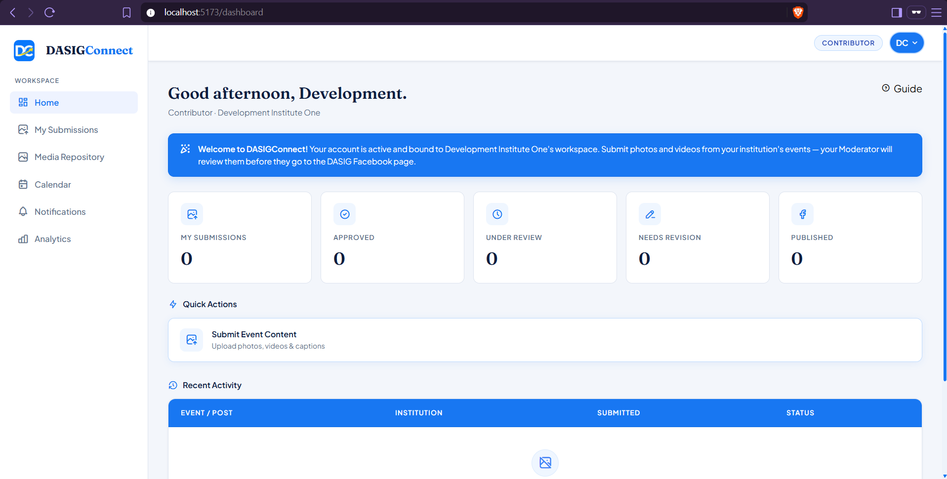
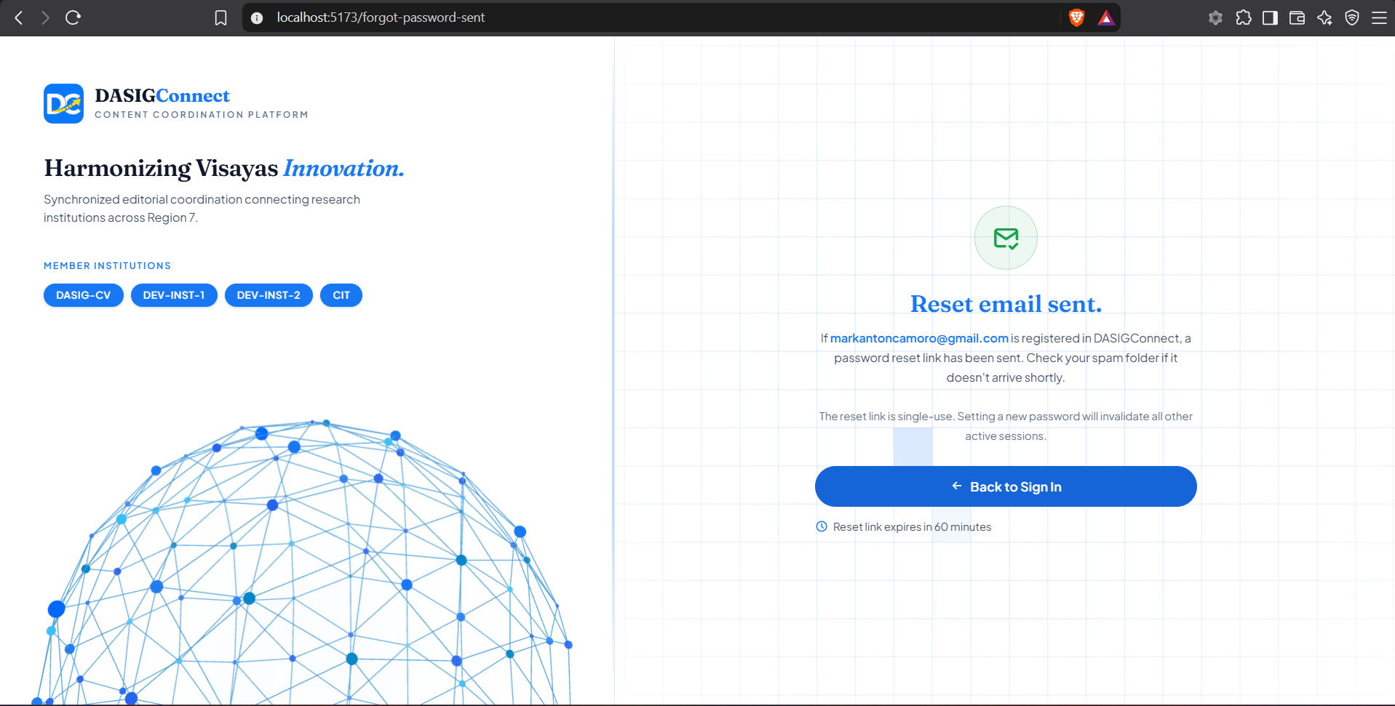
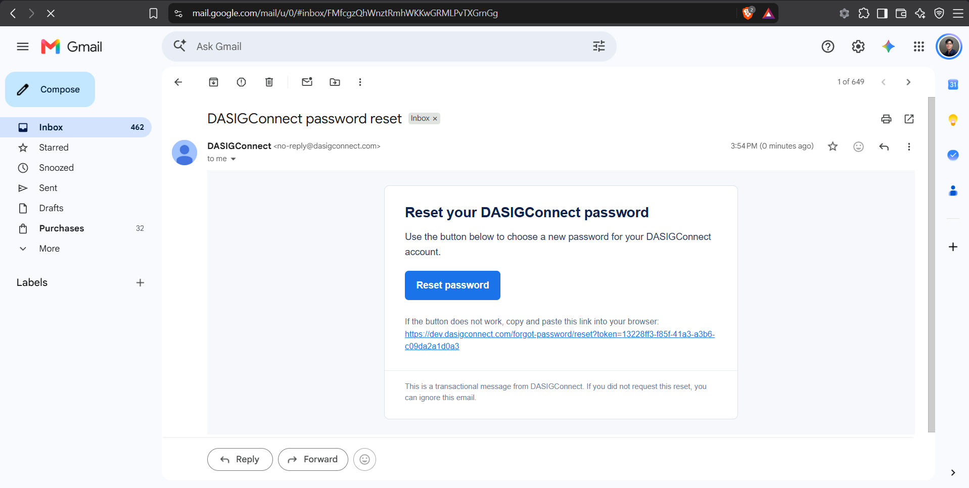

Screenshots for Test 6 (Case-6 — UC-1.5 Three-Step Post Composer, Readiness & Templates)
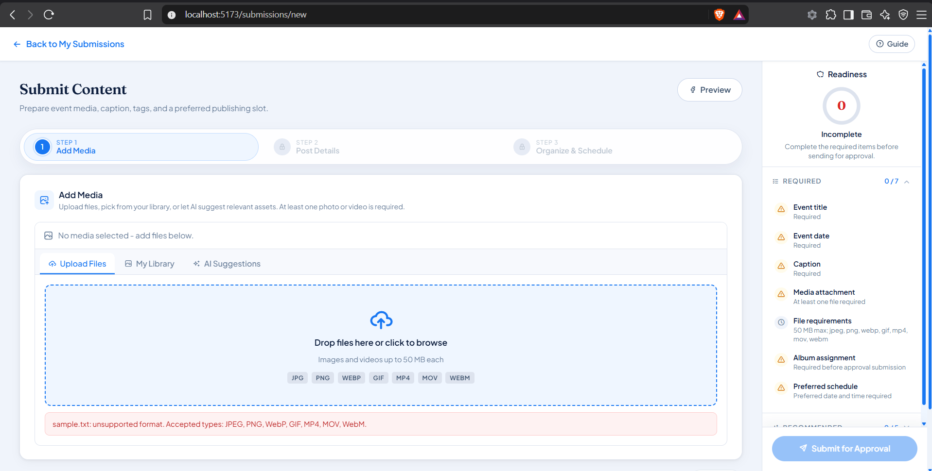
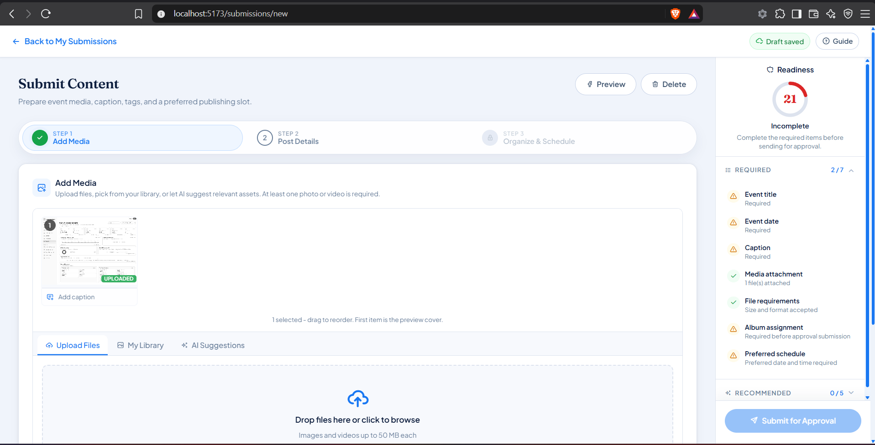
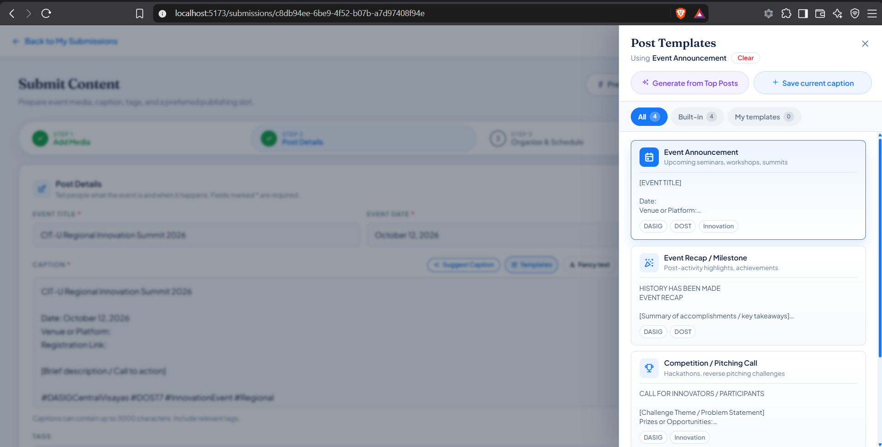
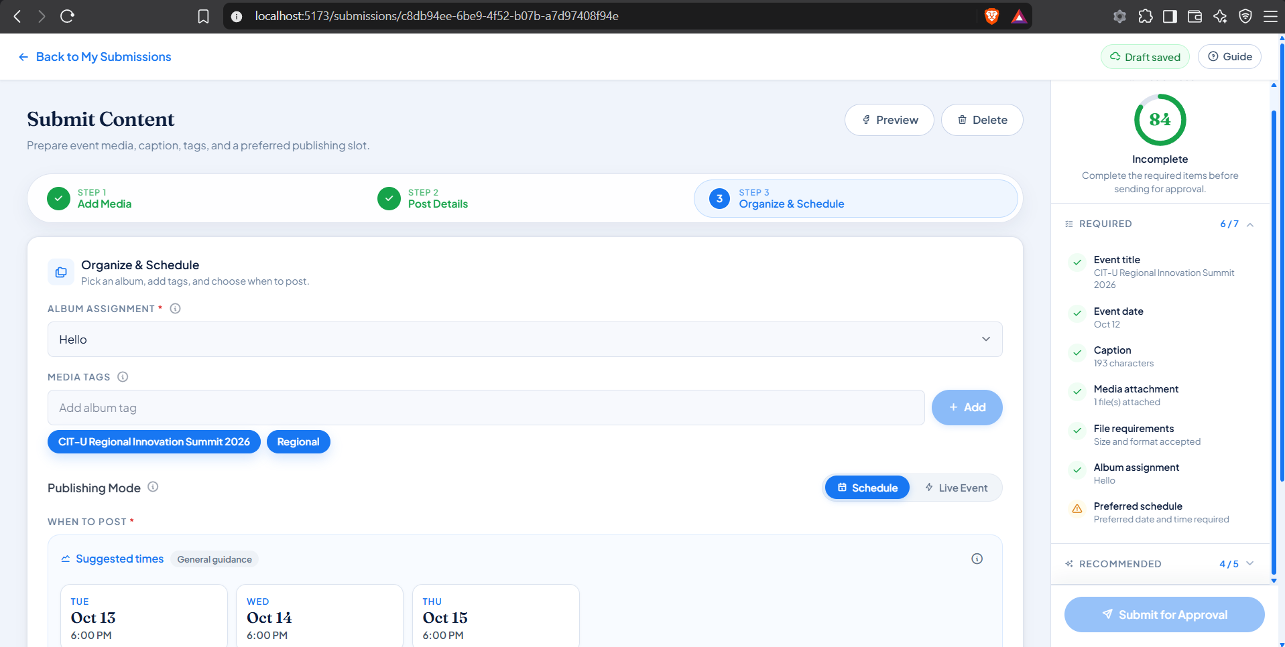

Screenshots for Test 7 (Case-7 — UC-1.5 A10 Generate Template from Top Posts)
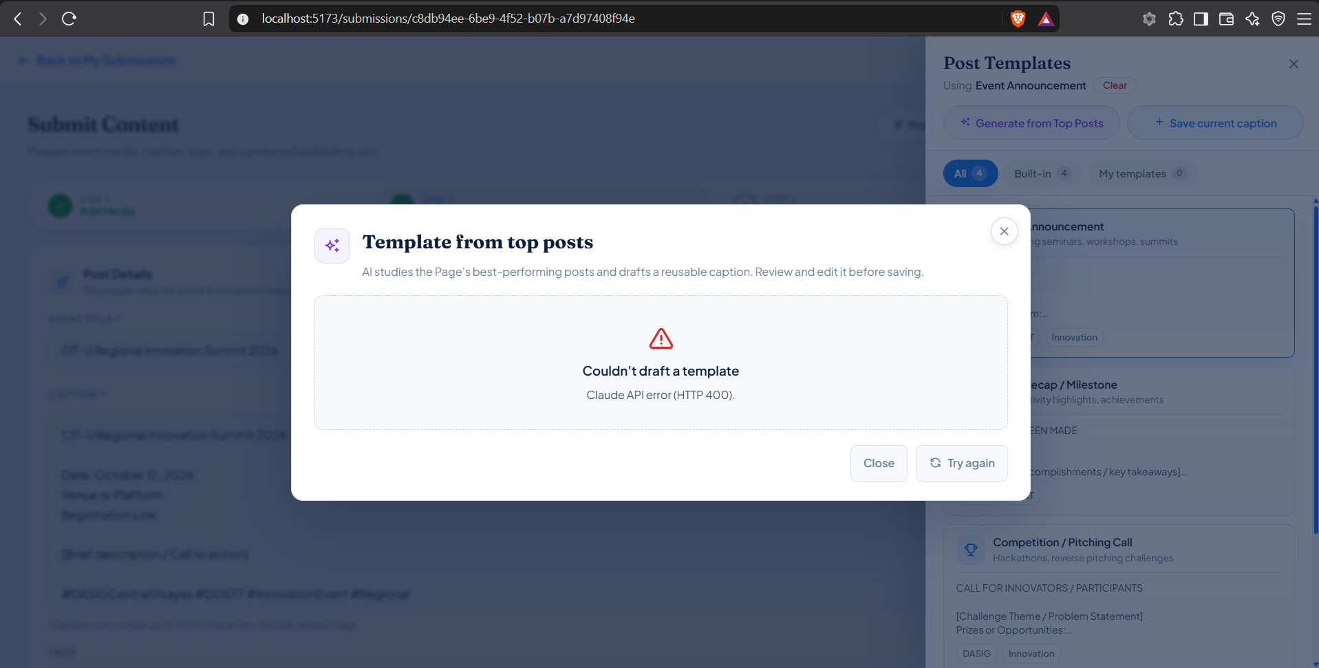

Screenshots for Test 8 (Case-8 — UC-1.6 AI Caption Generation, Writing Check & Fancy Text)
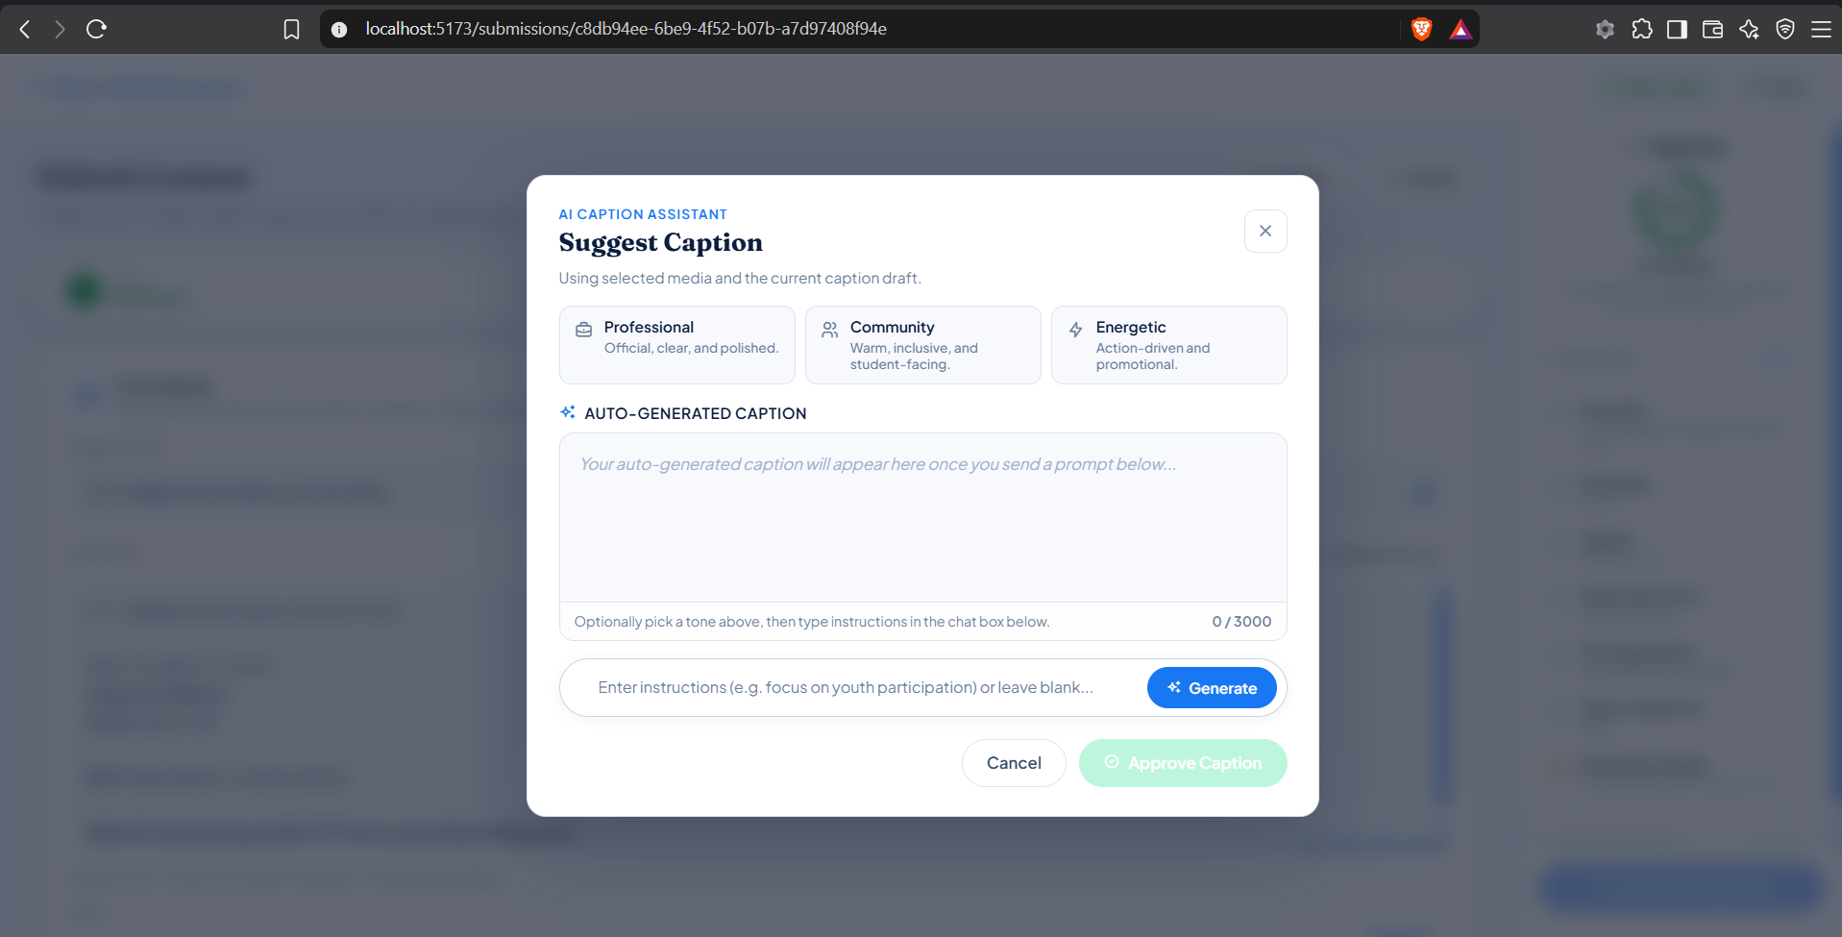
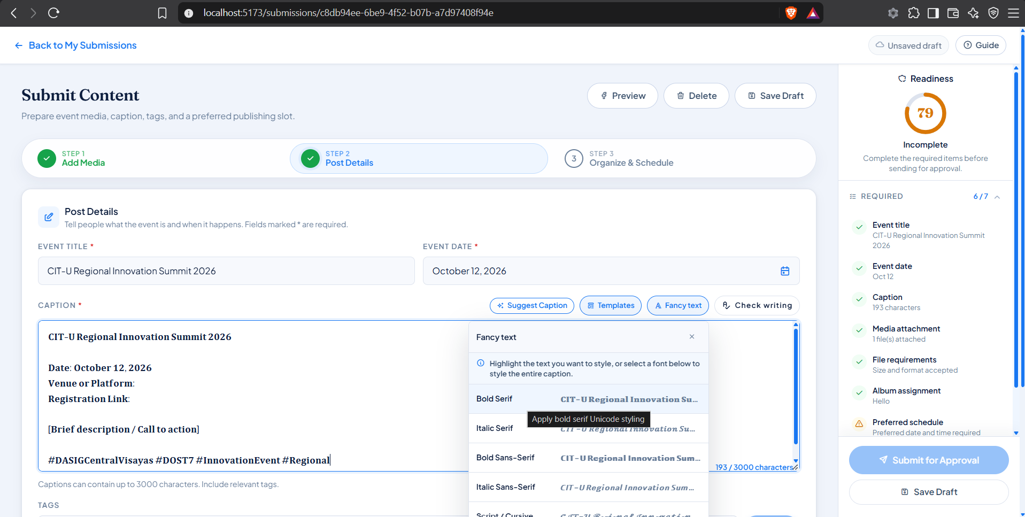

Screenshots for Test 9 (Case-9 — UC-1.7 Media Attachment Rules, AI Suggestions & Album Auto-Match)
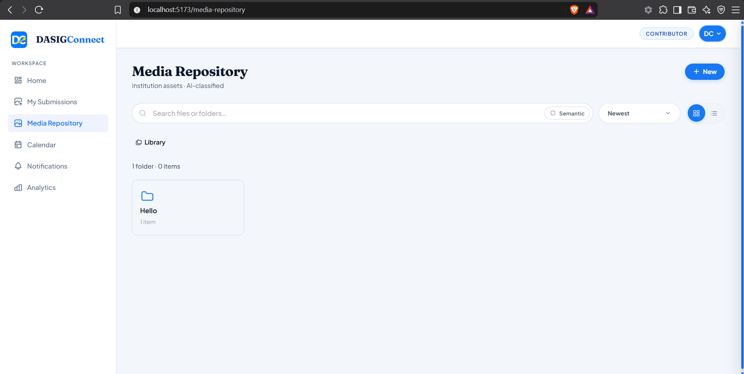
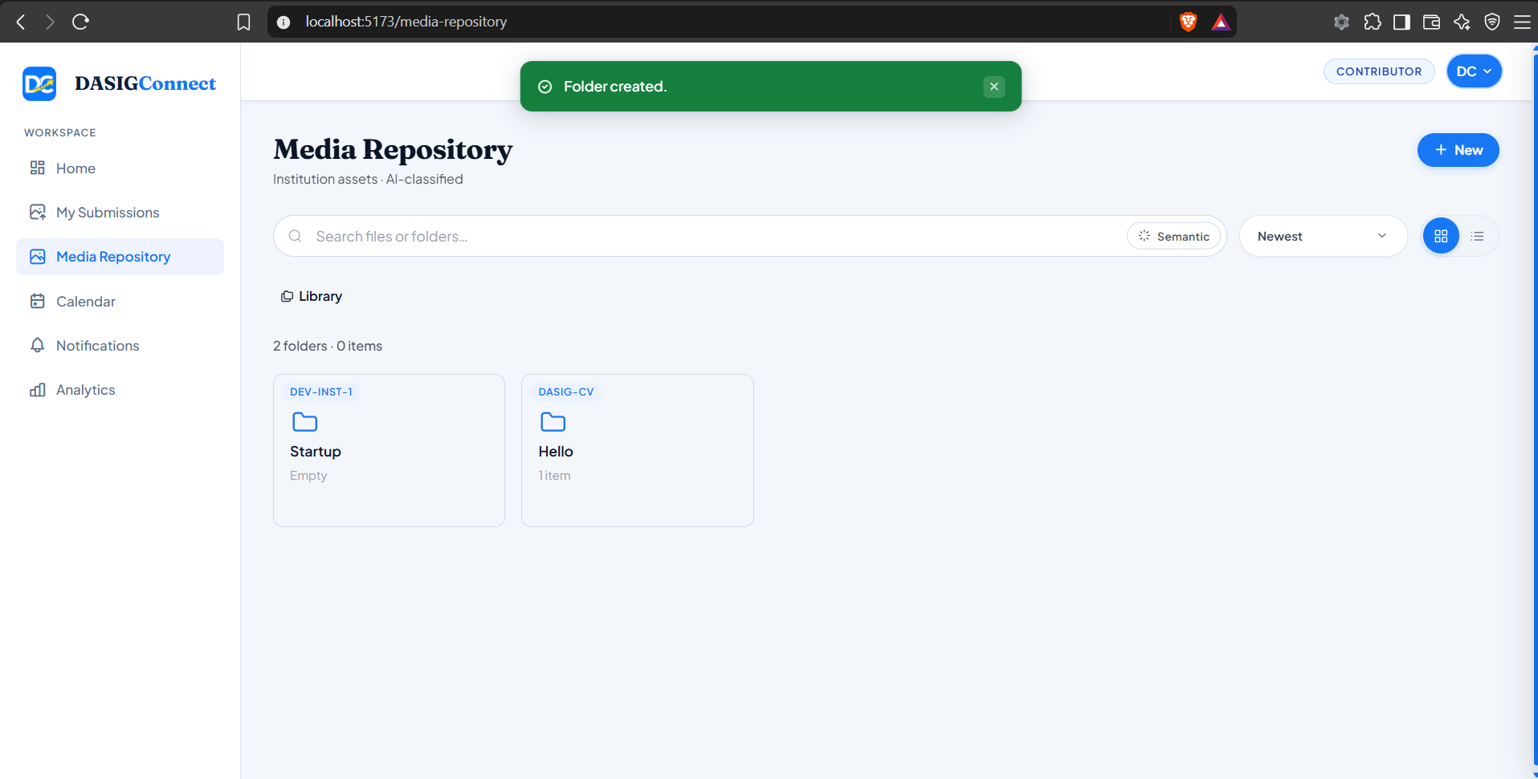
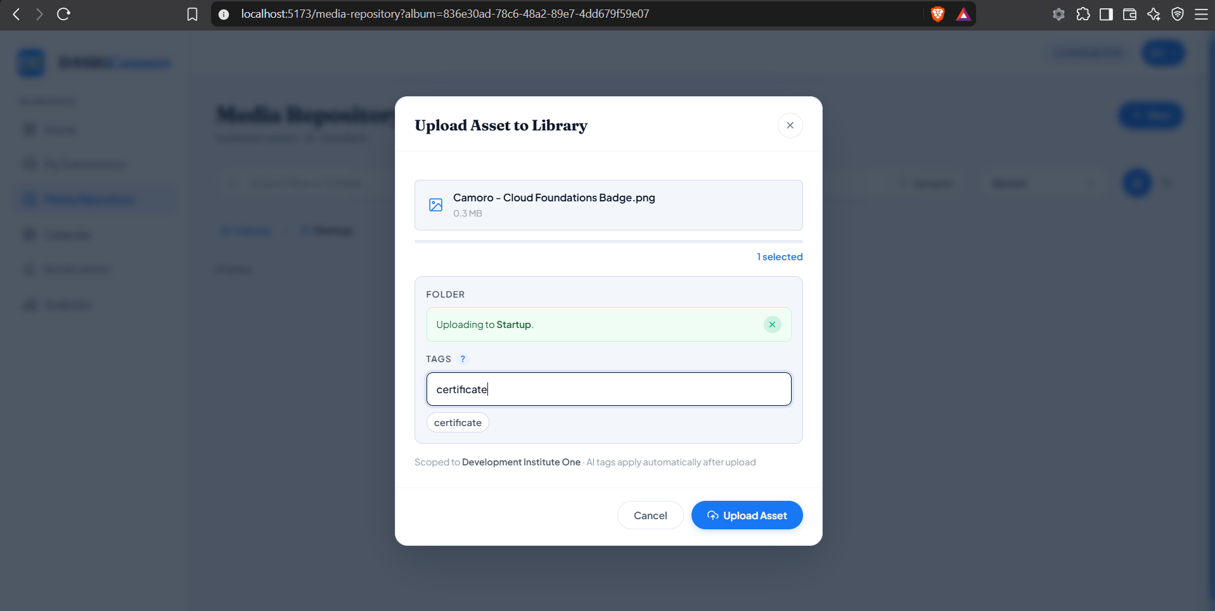

Screenshots for Test 10 (Case-10 — UC-1.8 Peak-Hour Engagement Recommendations)
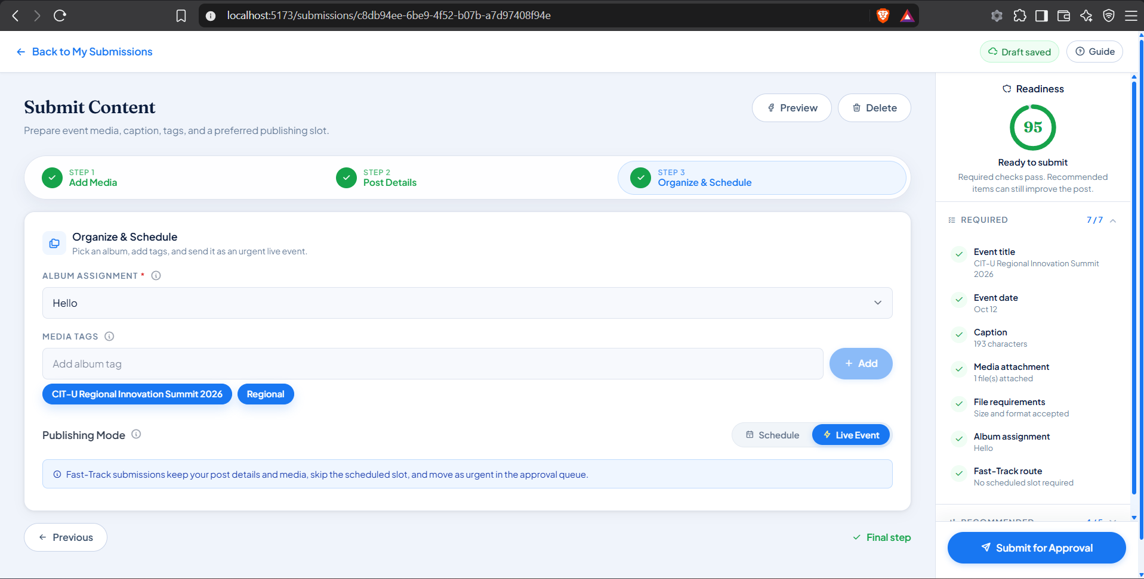
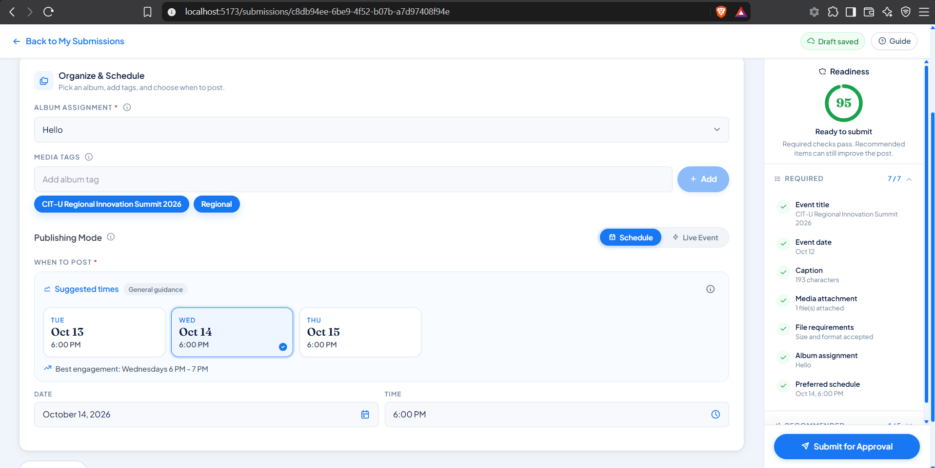

Screenshots for Test 11 (Case-11 — UC-1.9 Draft Submission, Withdrawal & Fast-Track Sorting)
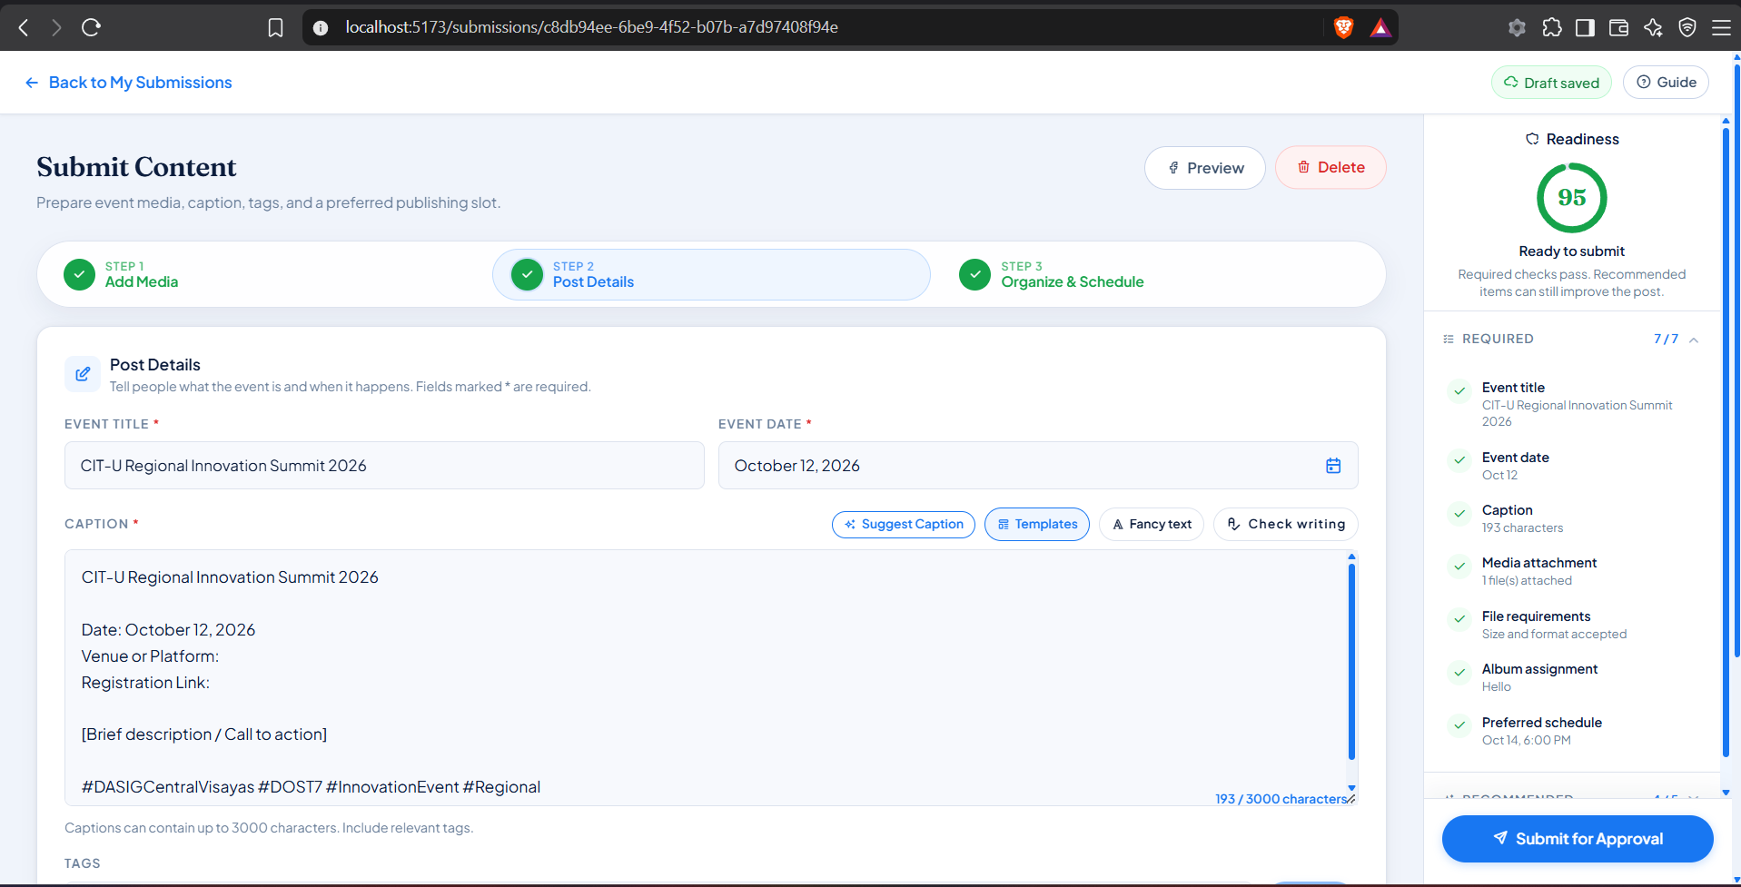
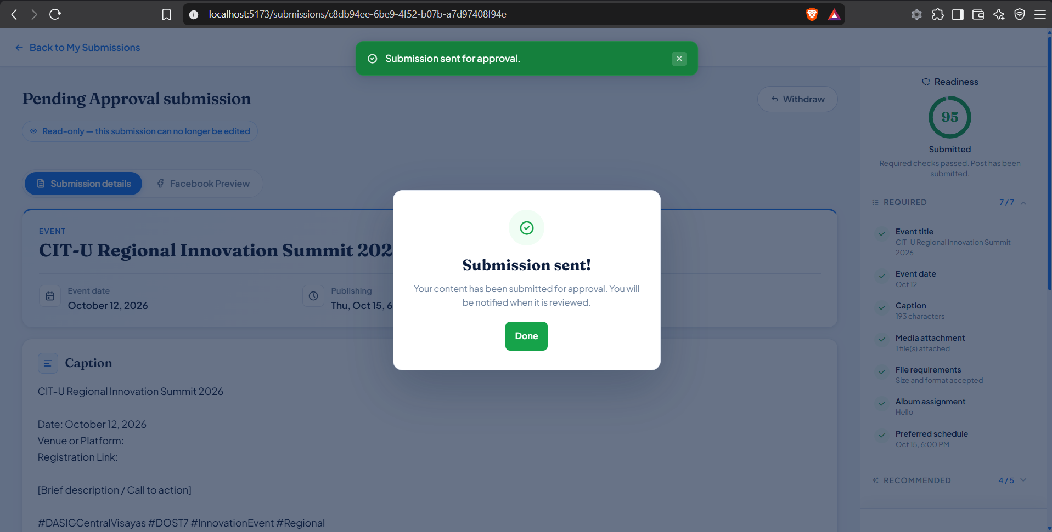
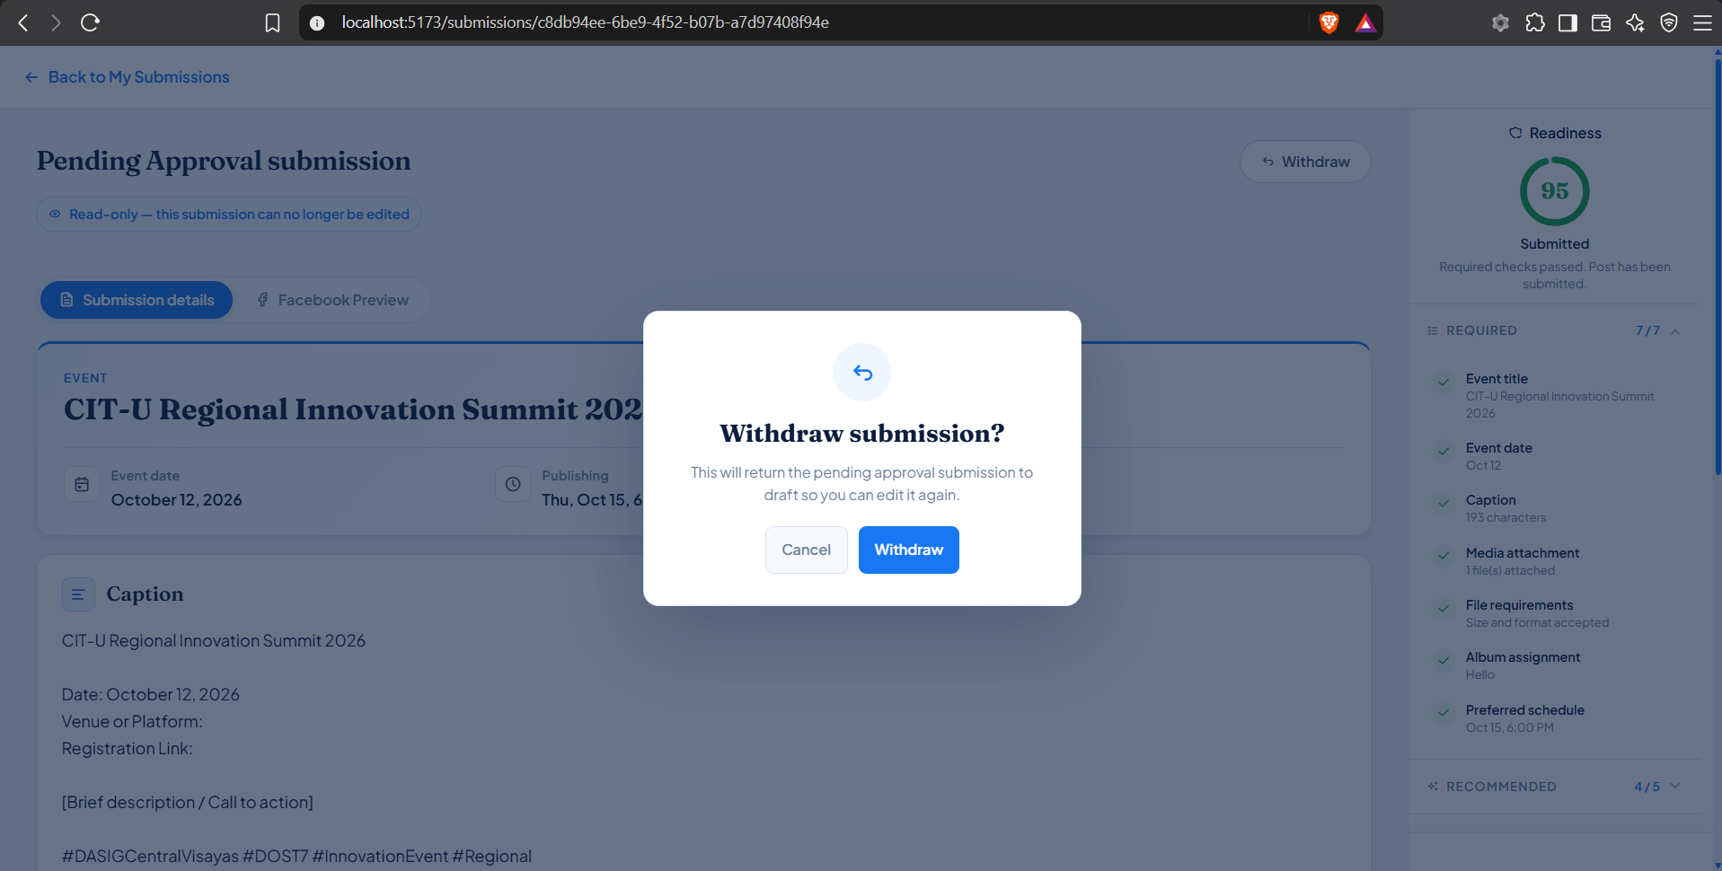
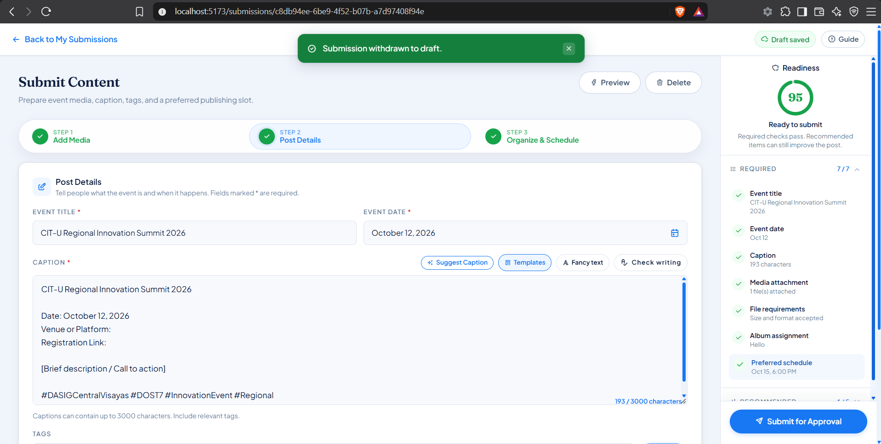

Screenshots for Test 12 (Case-12 — UC-1.10 Moderator Account Management & Lateral Role Change)
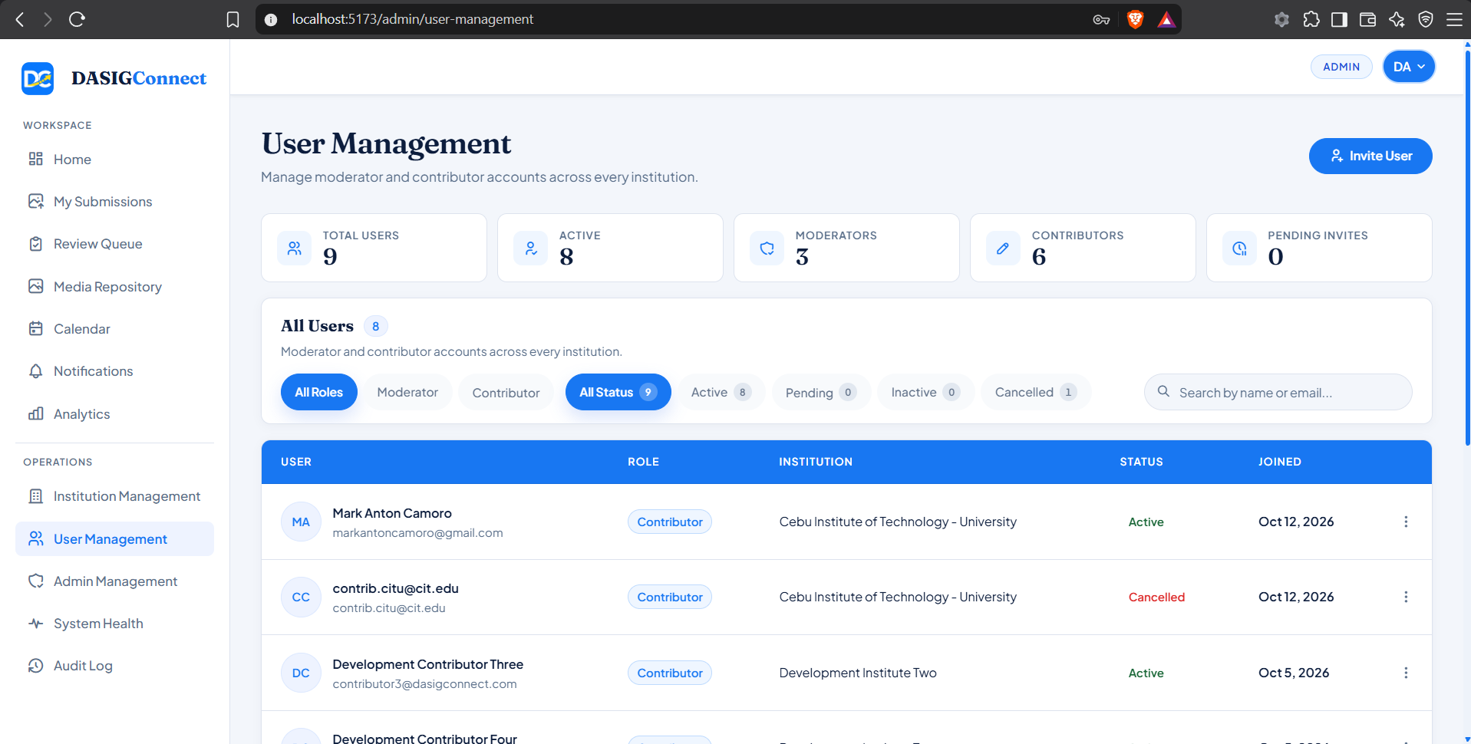
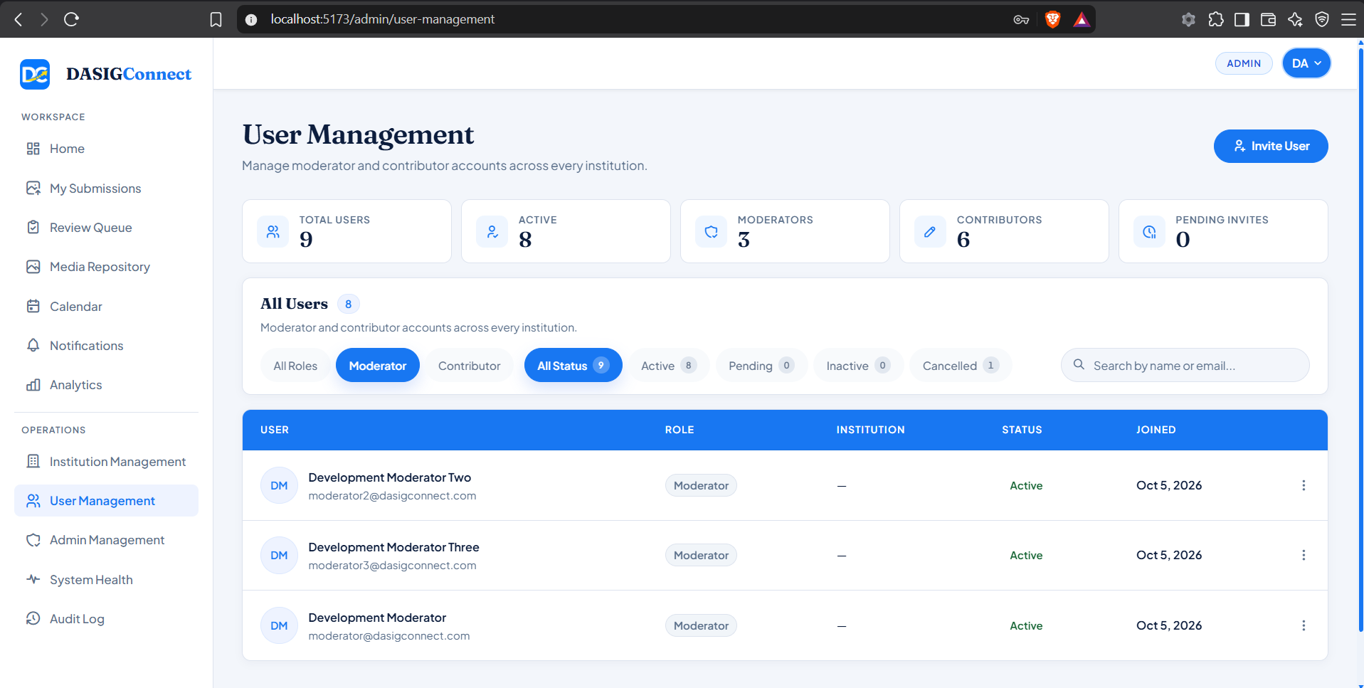
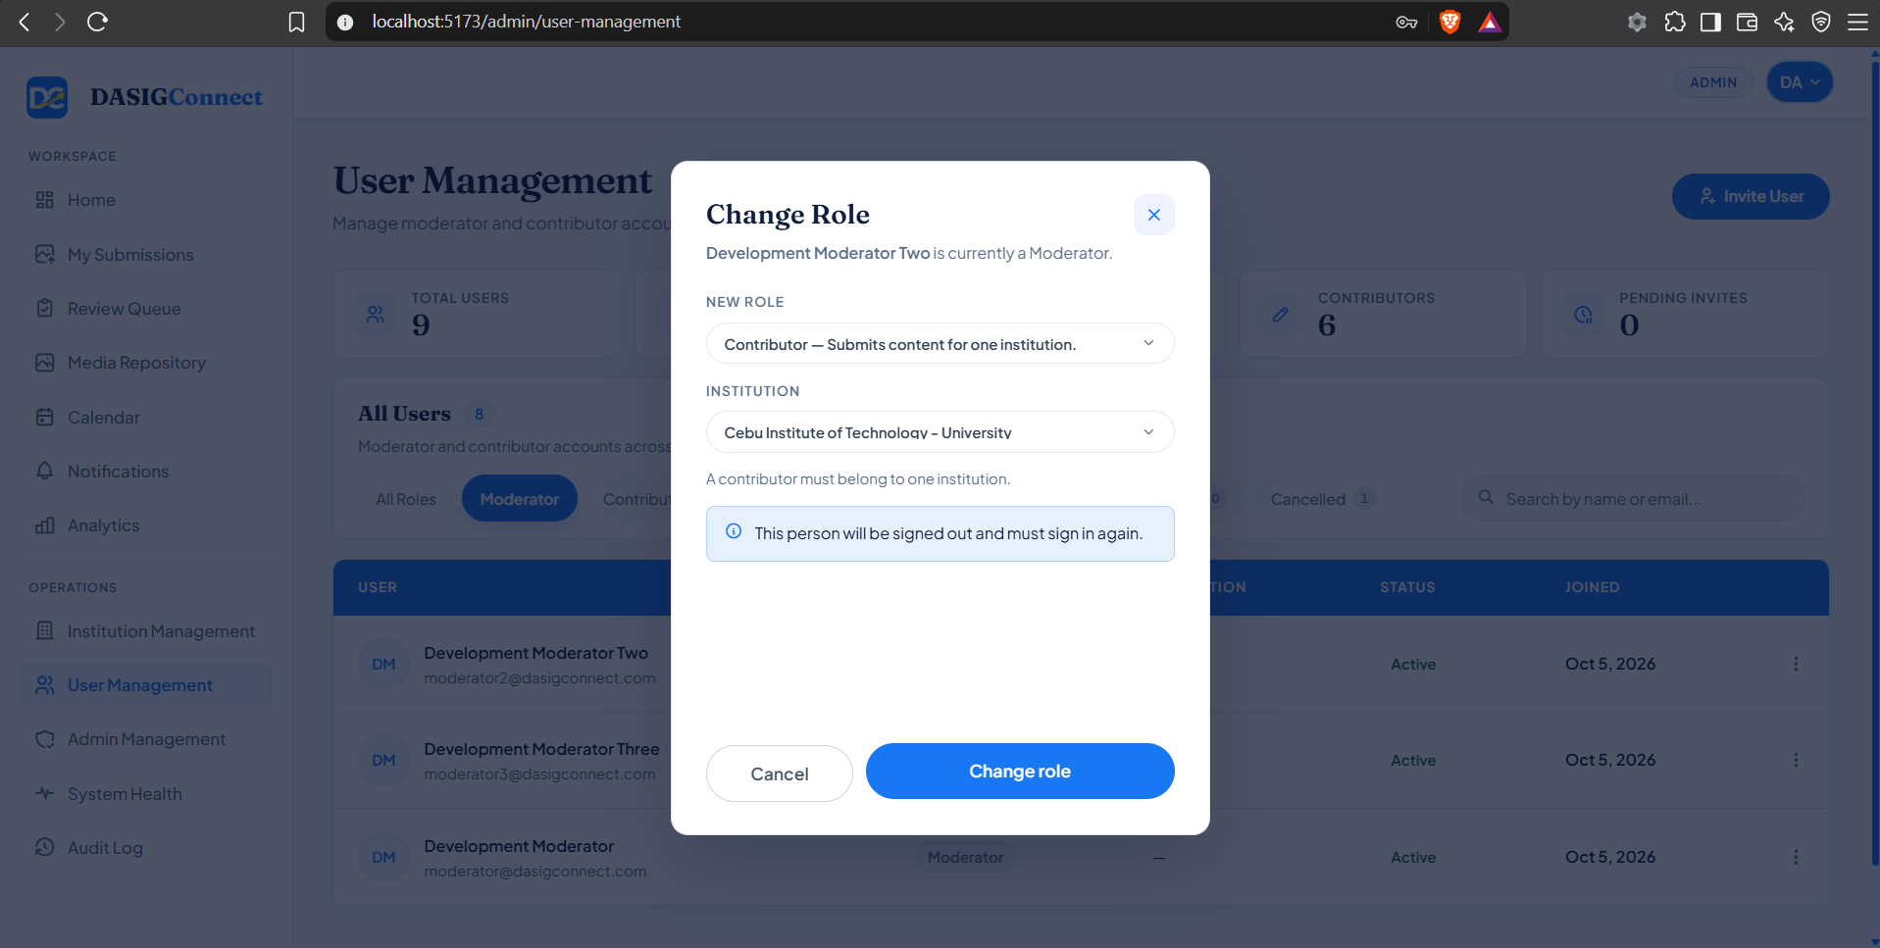
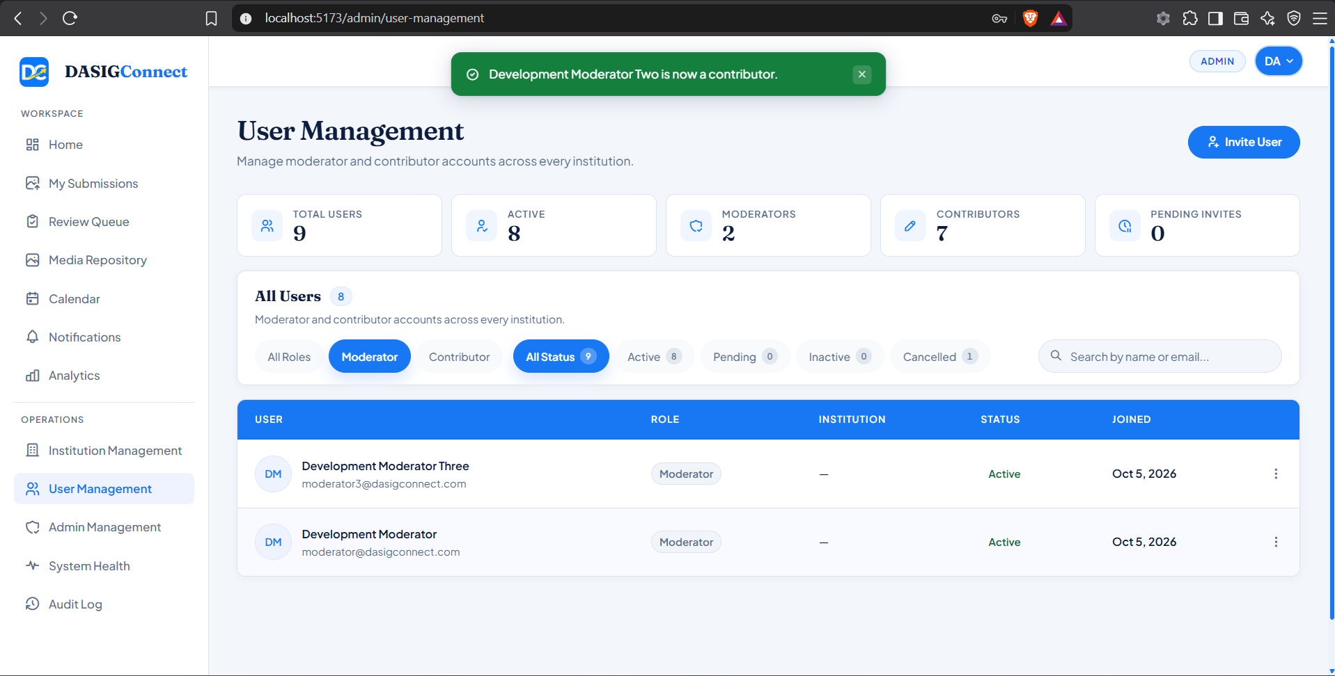
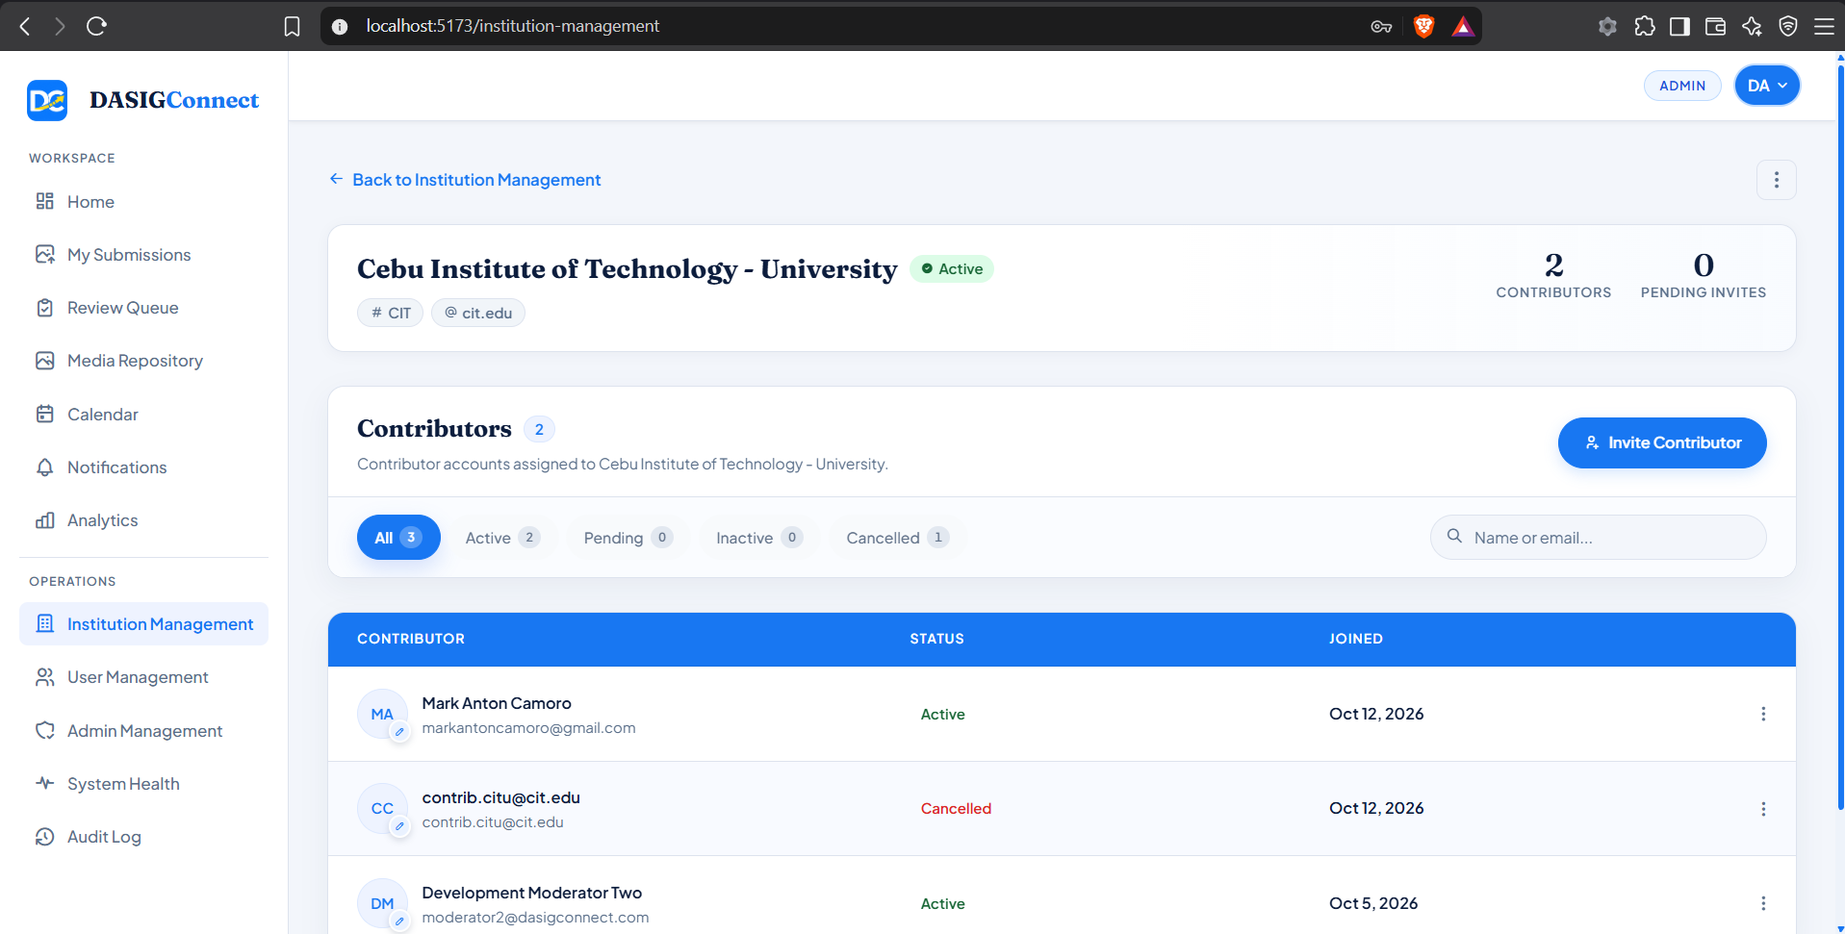

Screenshots for Test 13 (Case-13 — UC-2.1 Standalone Library Uploads, Nested Albums & Tag Floor)
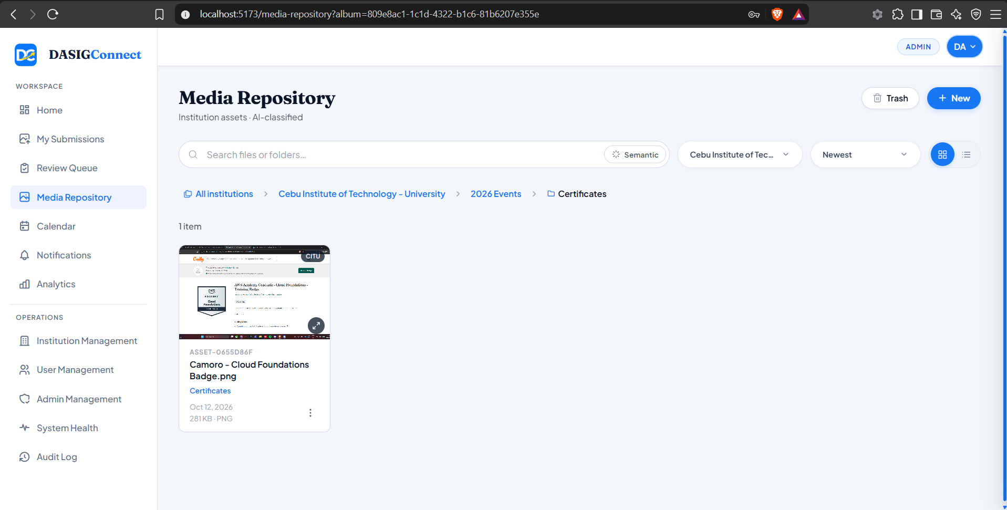

Screenshots for Test 14 (Case-14 — UC-2.2 Semantic Search, Keyword Fallback & Asset Detail Panel)
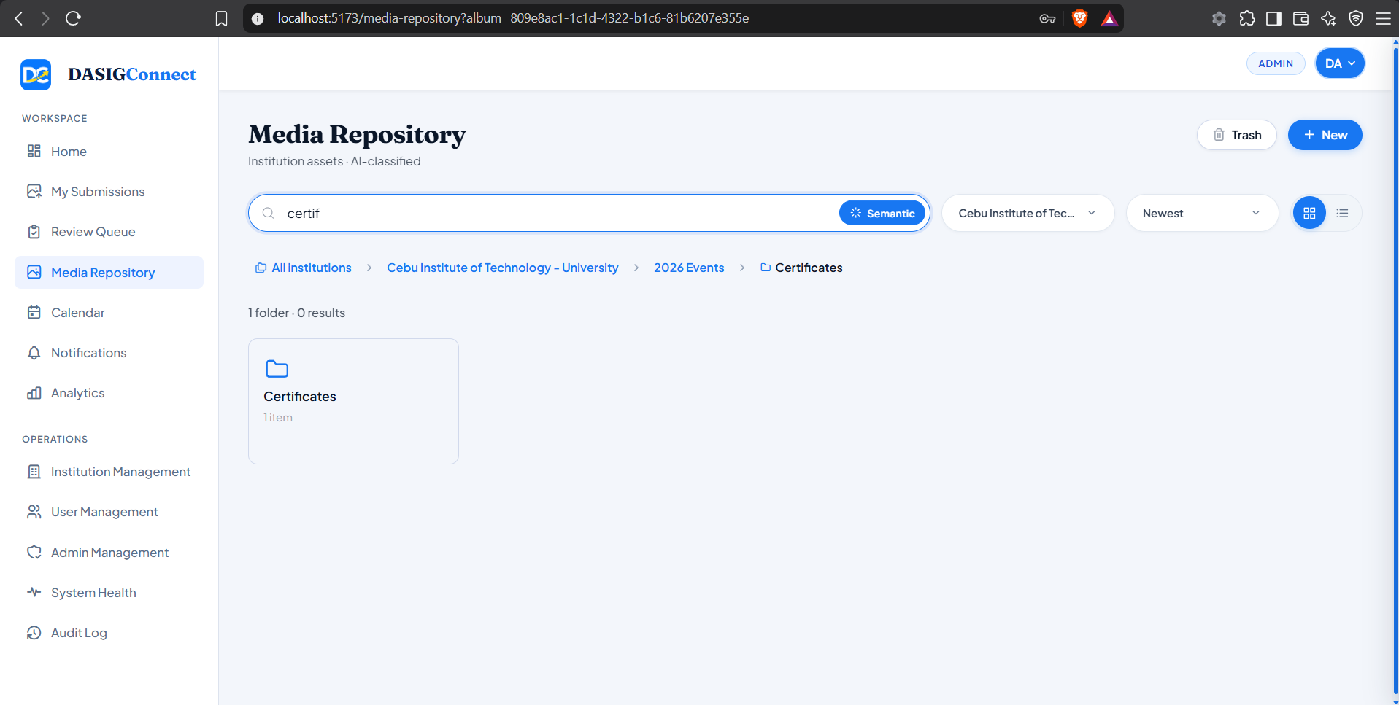

Screenshots for Test 15 (Case-15 — UC-2.3 Media History, Tiered Deletion & Duplicate Detection)
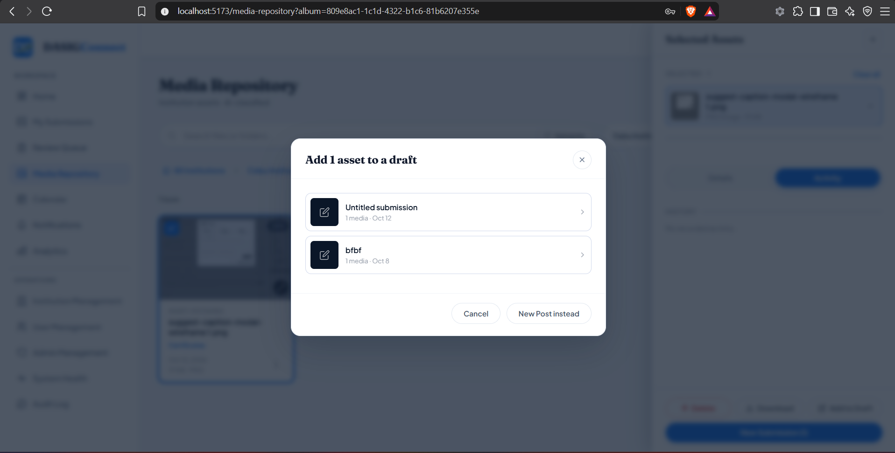
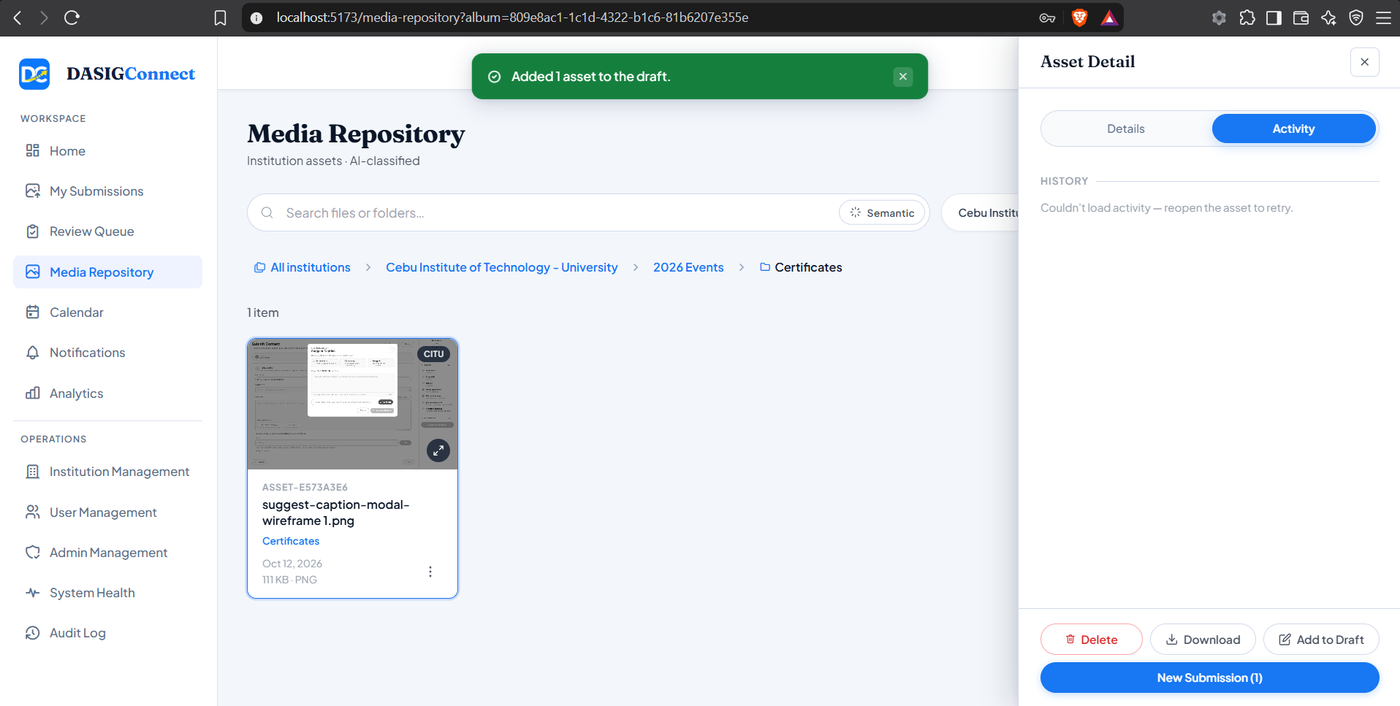
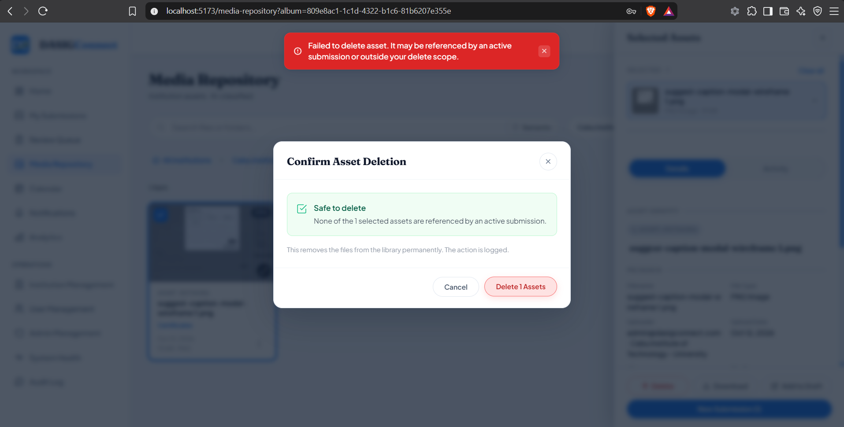
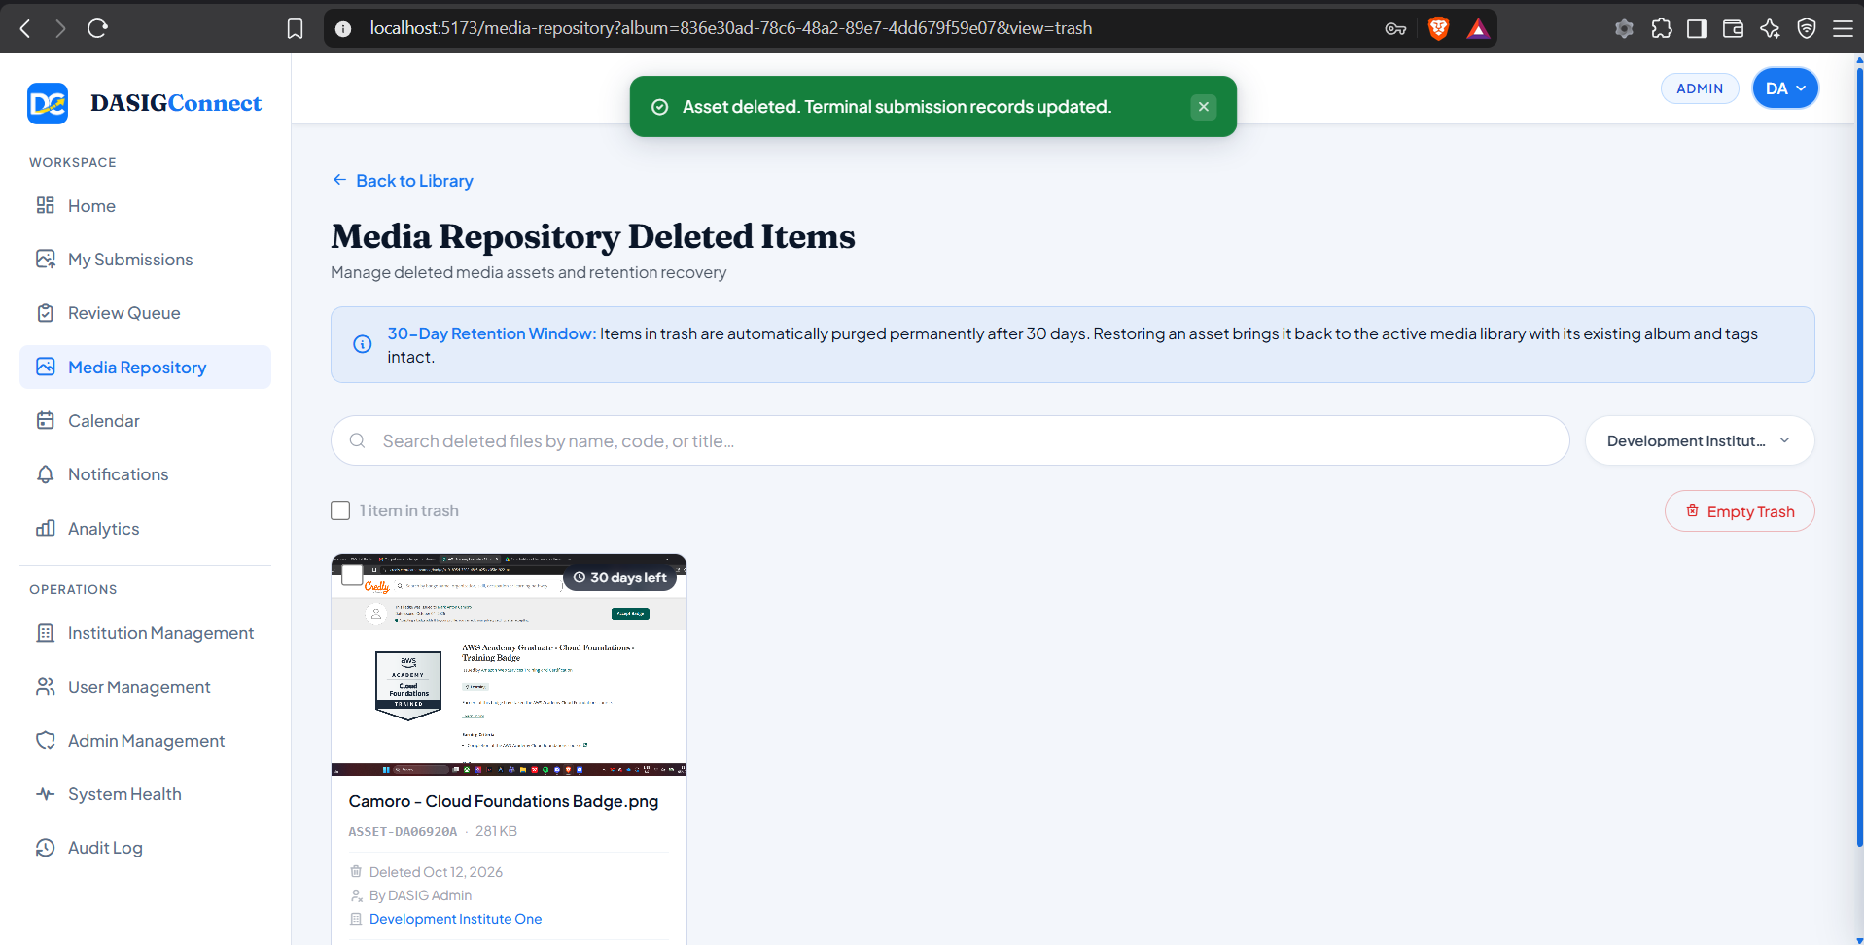

Screenshots for Test 16 (Case-16 — UC-2.4 Approval Workflow, 15-Min Lock & Self-Review Block)
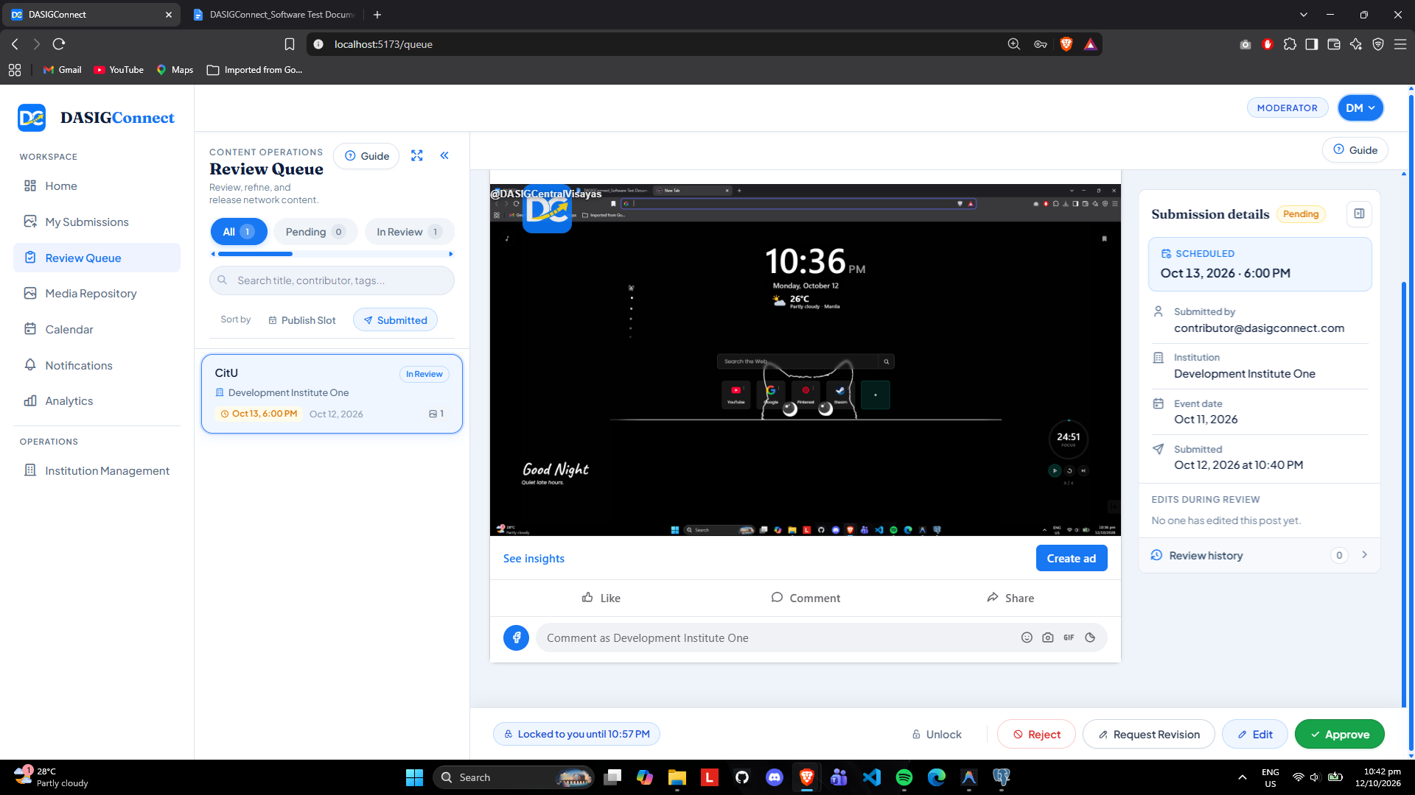

Moderator 2 Pov and the submission is locked.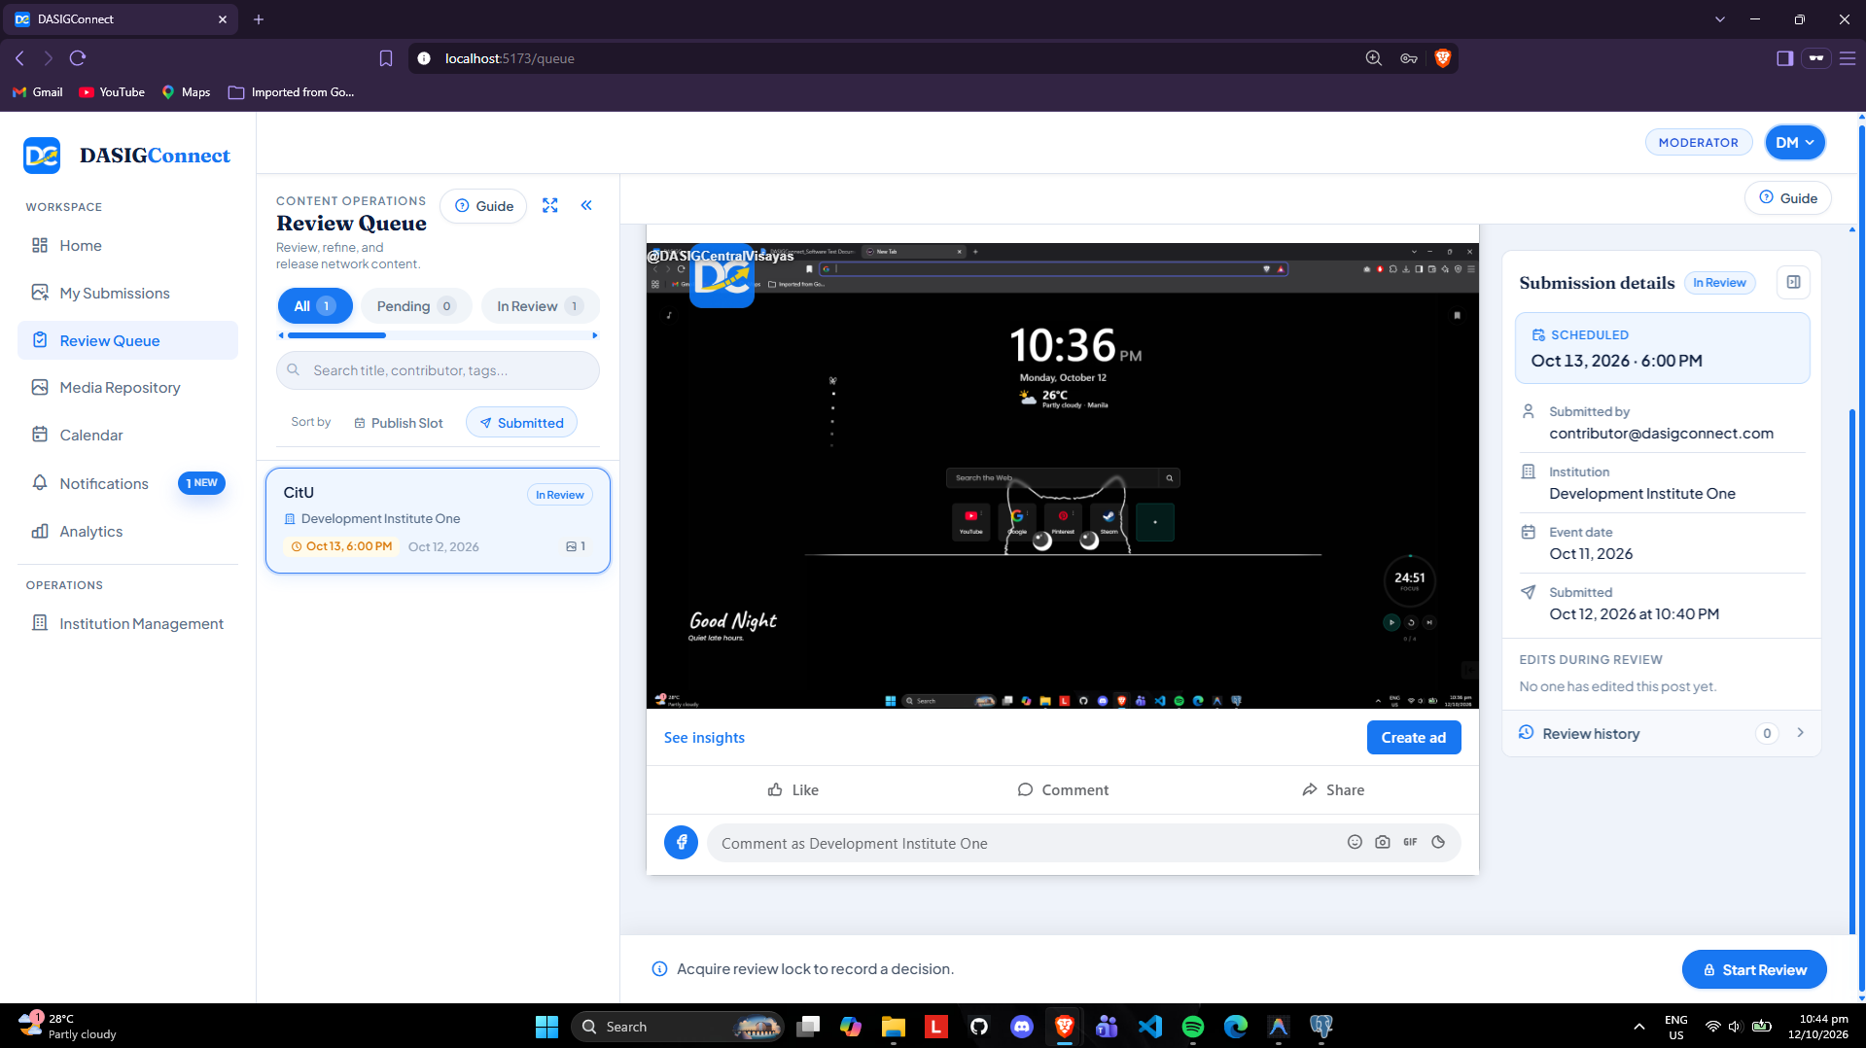

Screenshots for Test 17 (Case-17 — UC-2.4 A9–A15 Edit-During-Review Diffs & Late Publish Override)
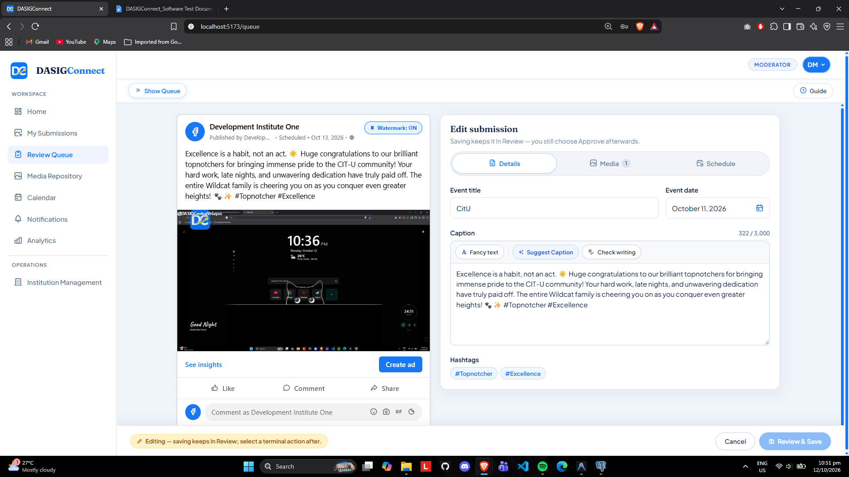
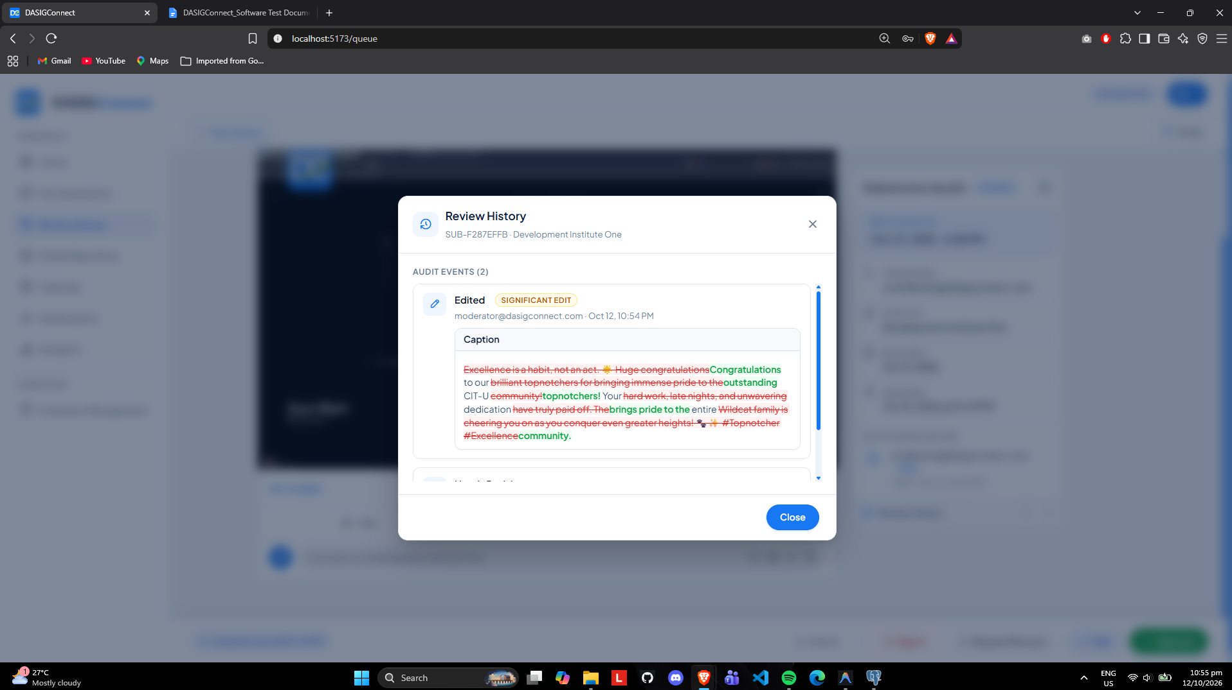

Screenshots for Test 18 (Case-18 — UC-2.5 Automated Brand Watermarking & Derivative Purge)
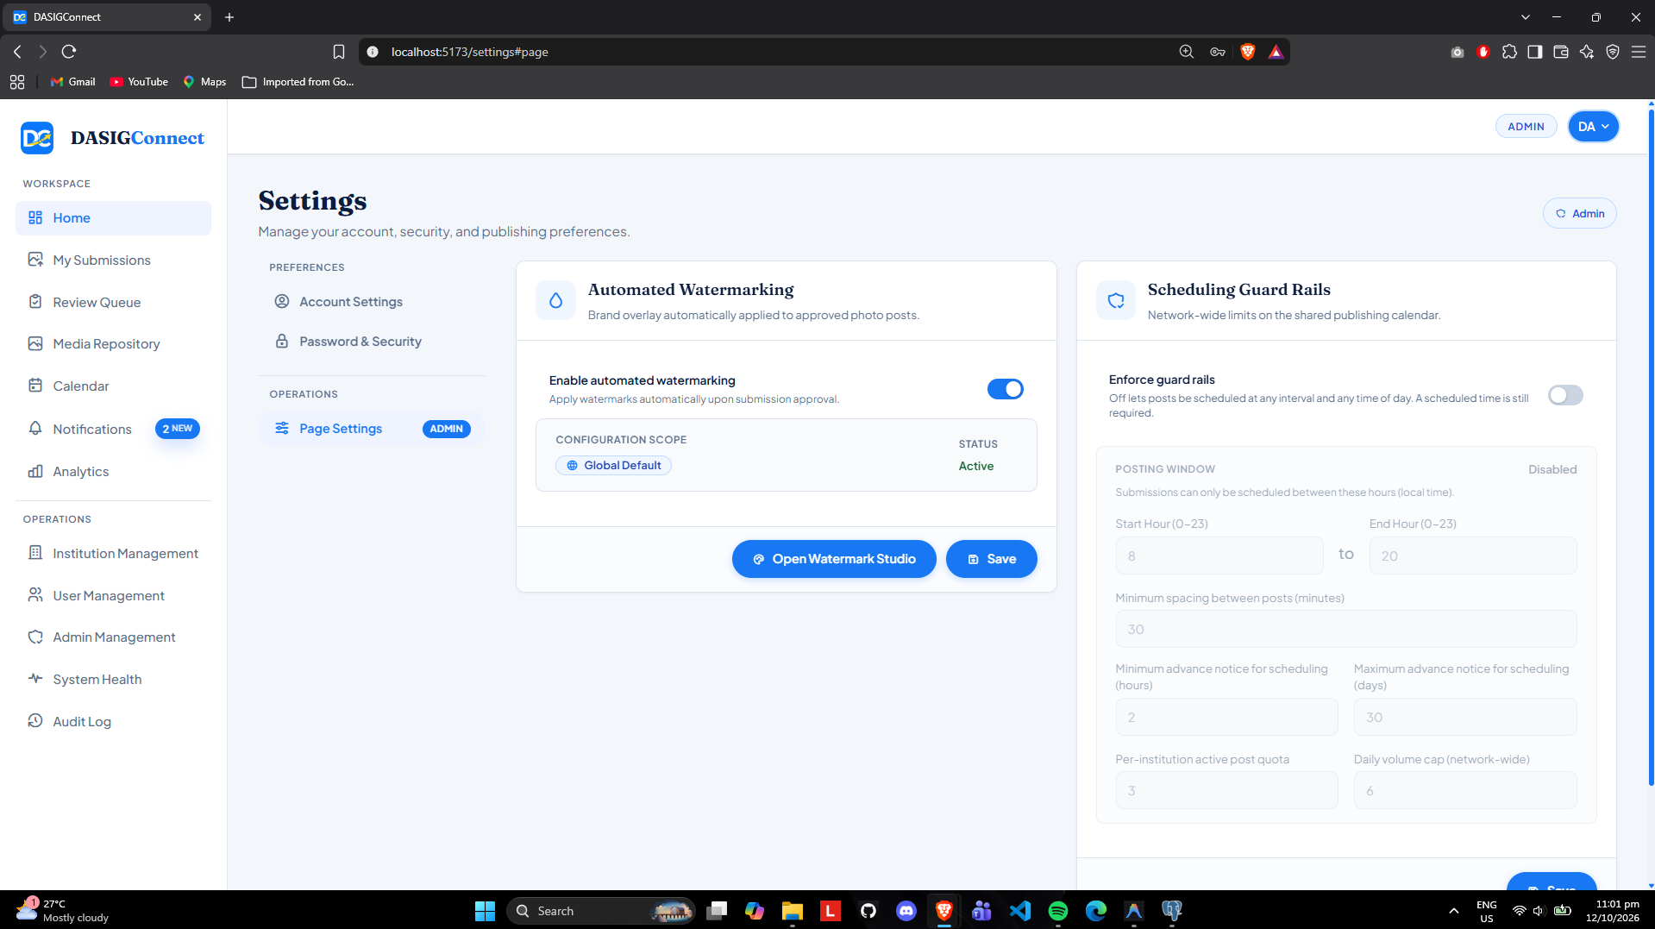
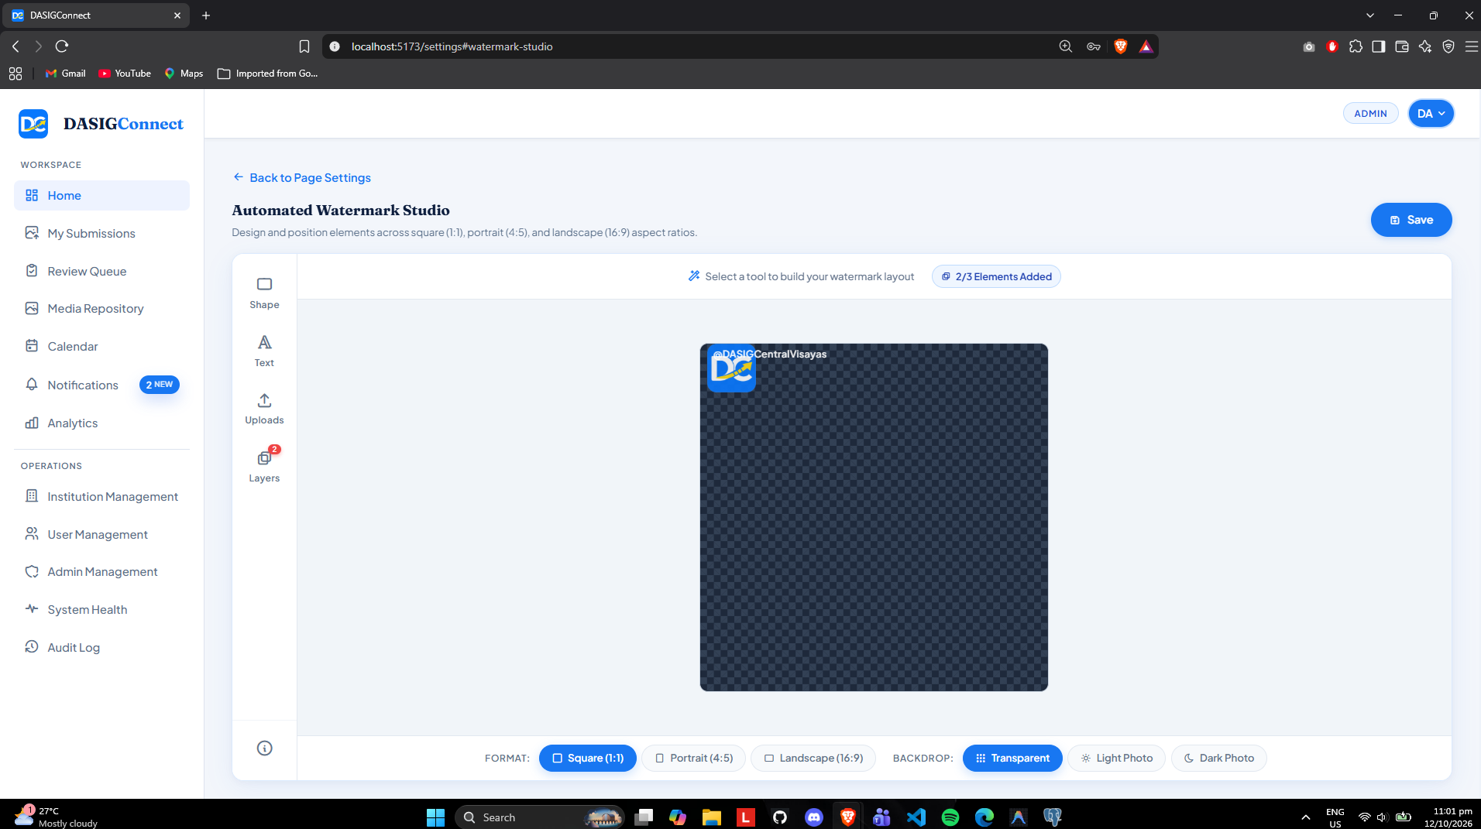
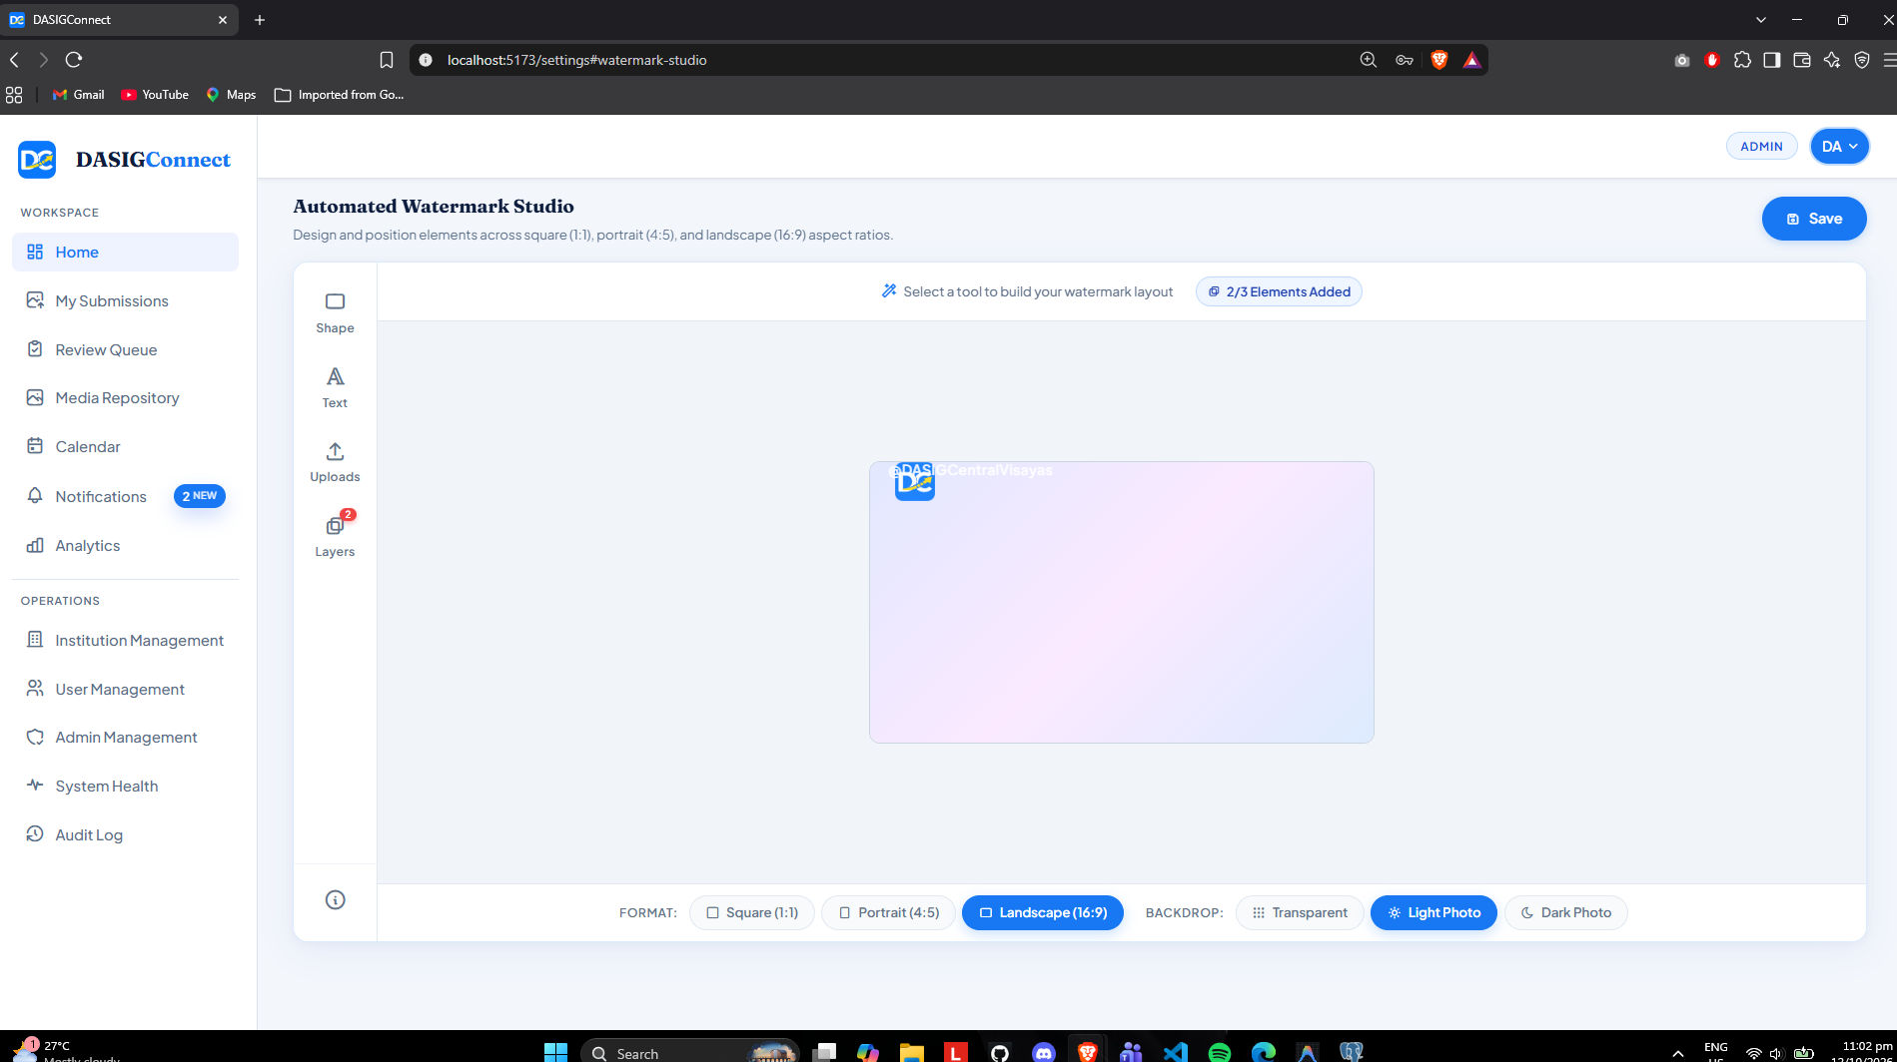

Screenshots for Test 19 (Case-19 — UC-3.1 Master Calendar, Moderator Caps & GiST Conflict Constraint)
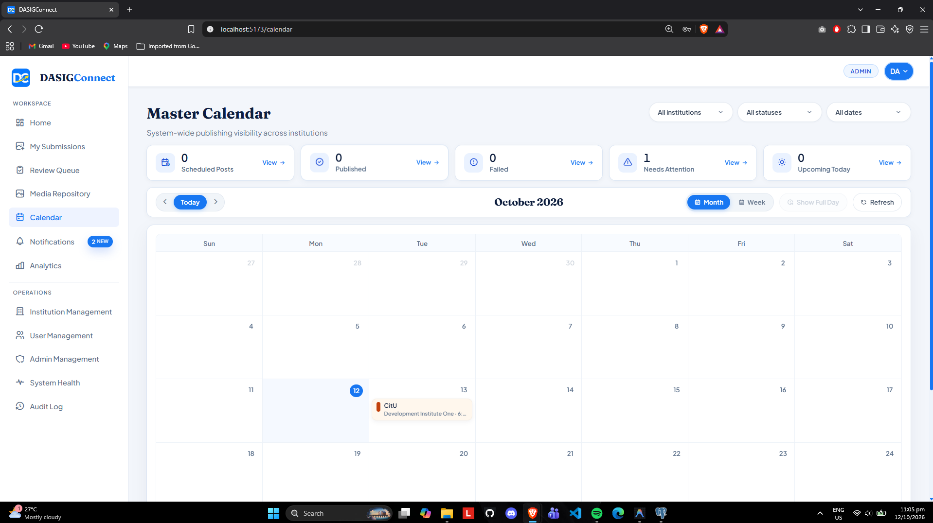
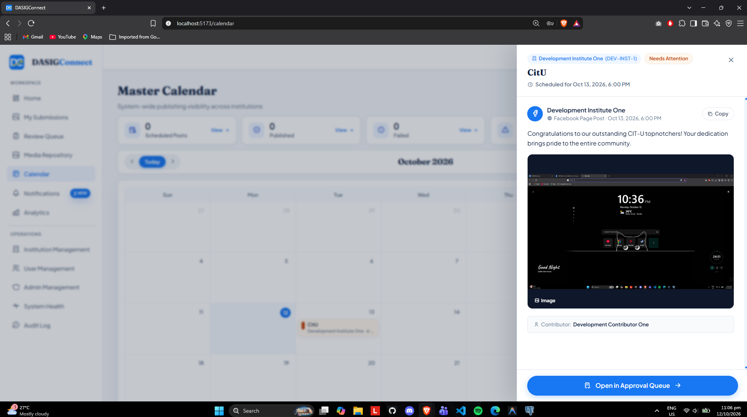

Screenshots for Test 20 (Case-20 — UC-3.2 Automated Facebook Publishing & Atomic Claim)
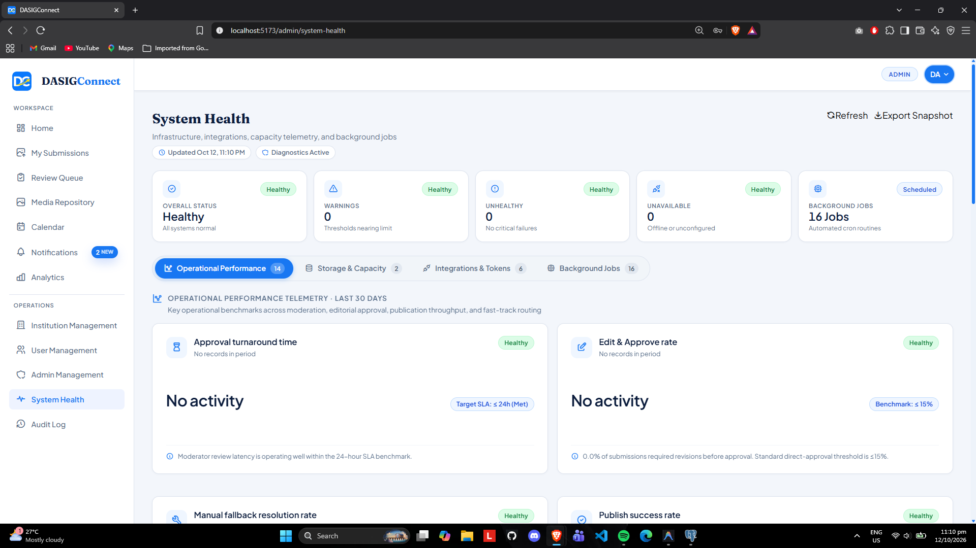
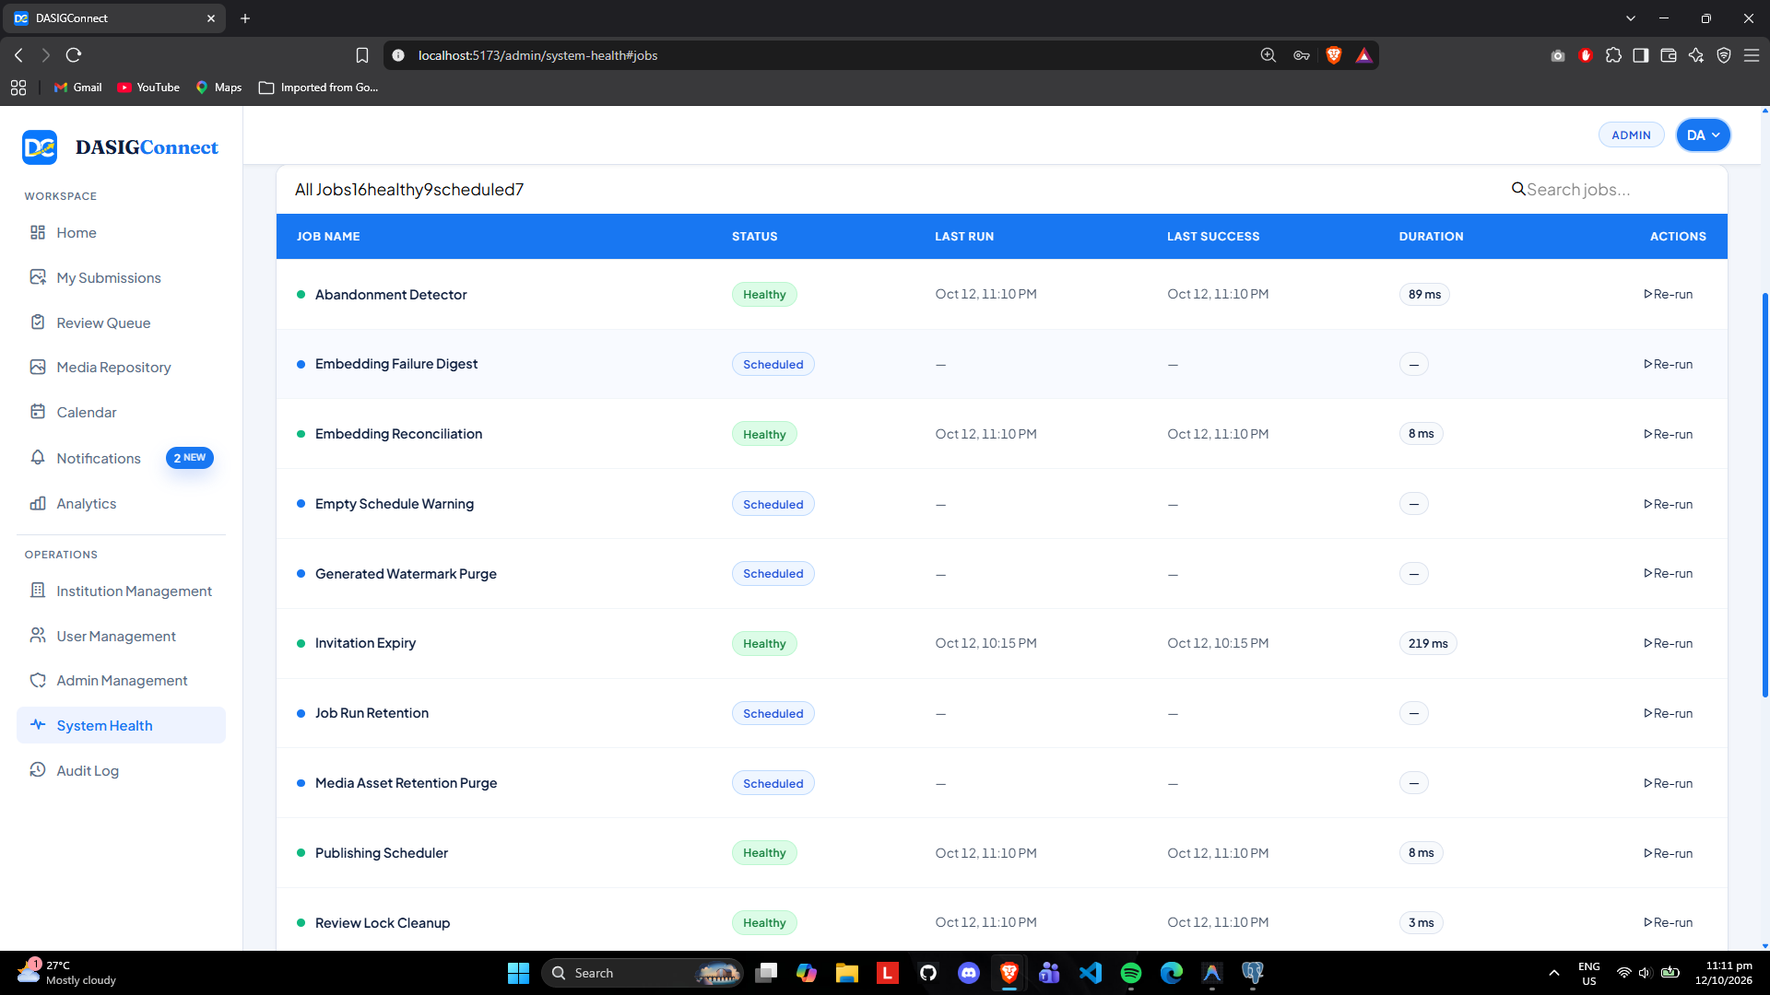
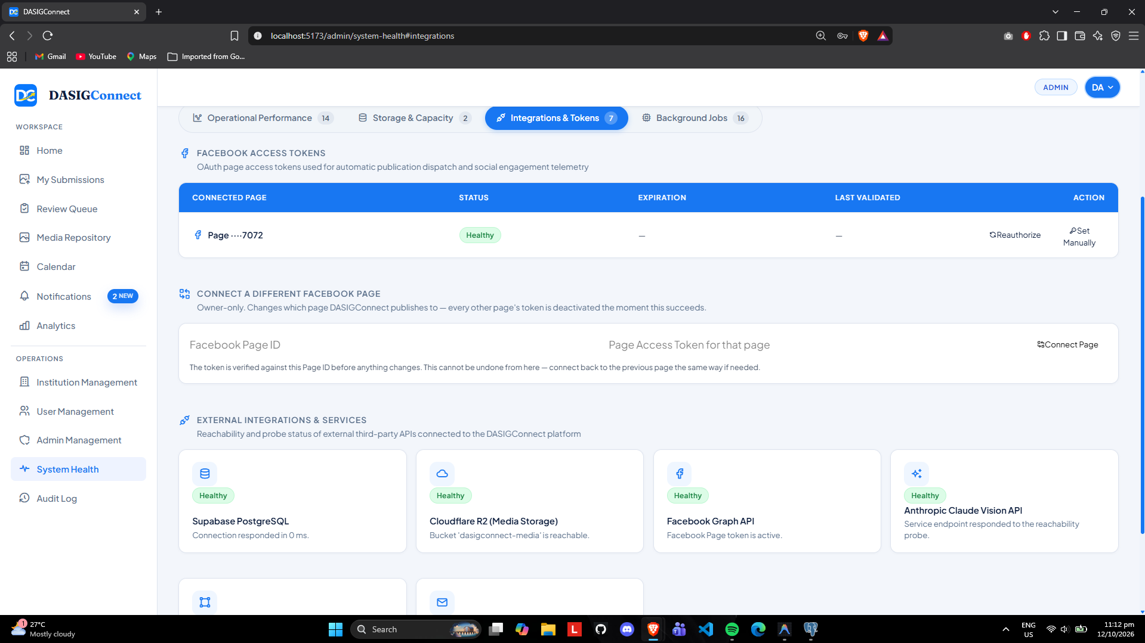

Screenshots for Test 21 (Case-21 — UC-3.2 A2 Stale Sweep & Manual Publishing Fallback)
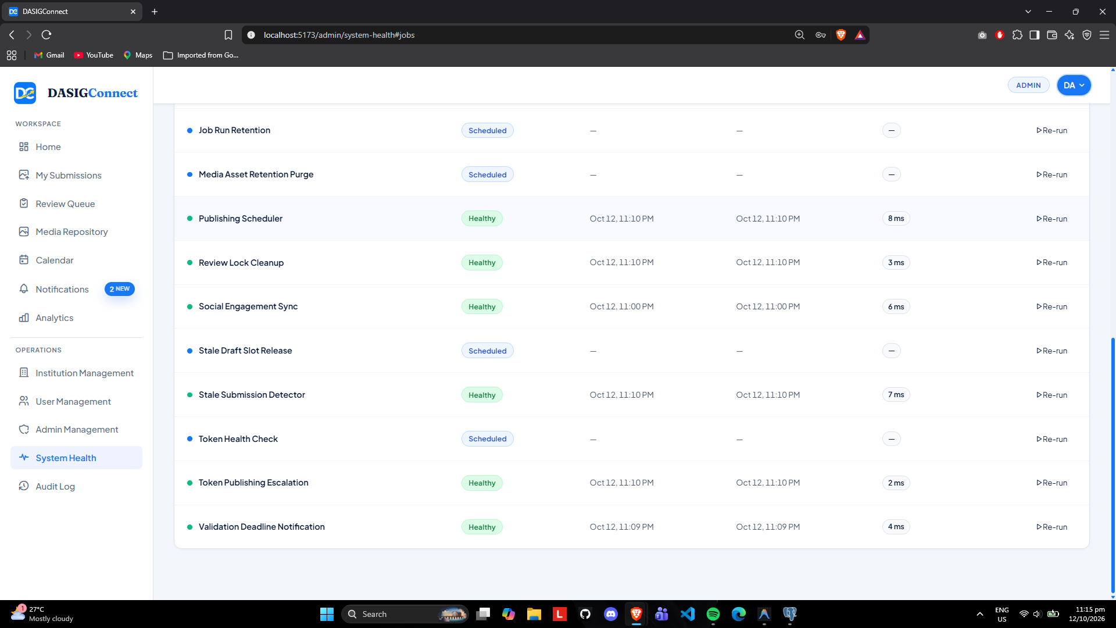
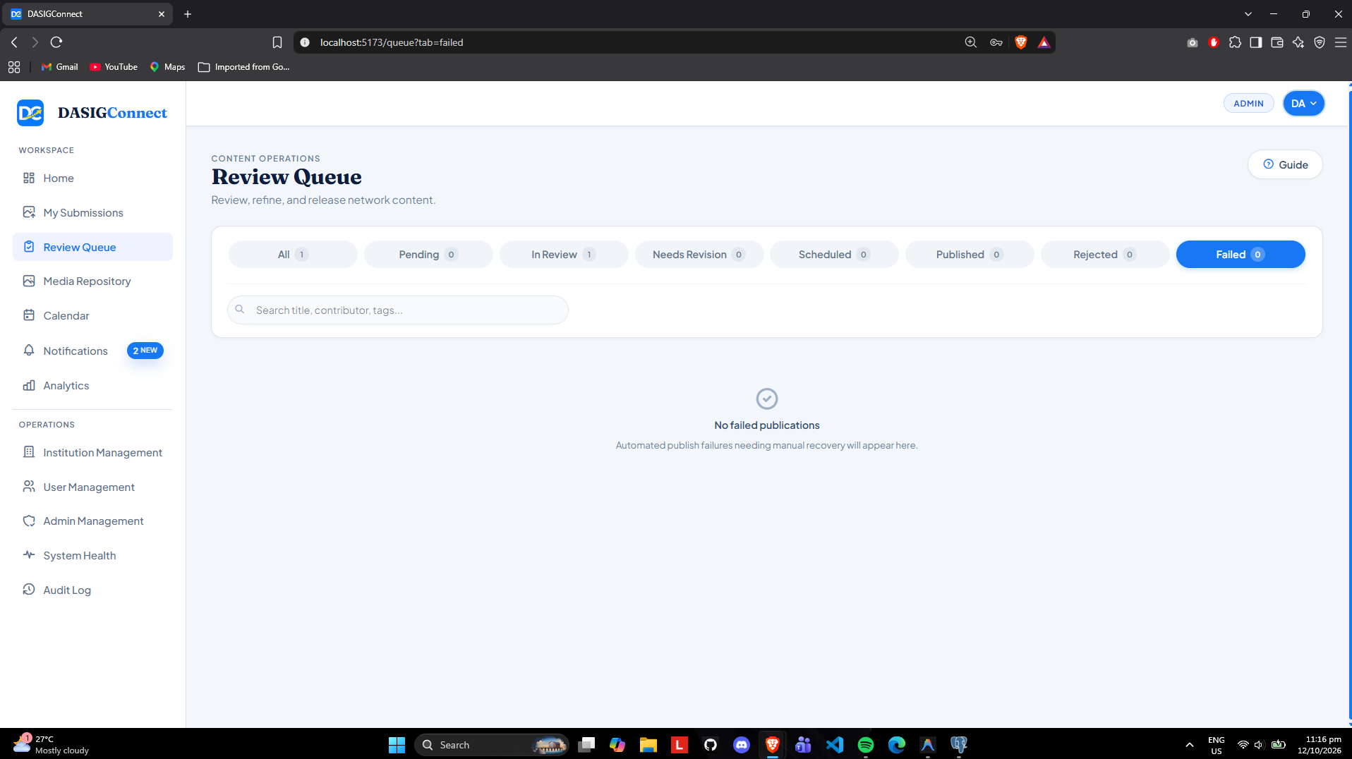

Screenshots for Test 22 (Case-22 — UC-3.3 Real-Time SSE Notifications & Cross-Session Sync)
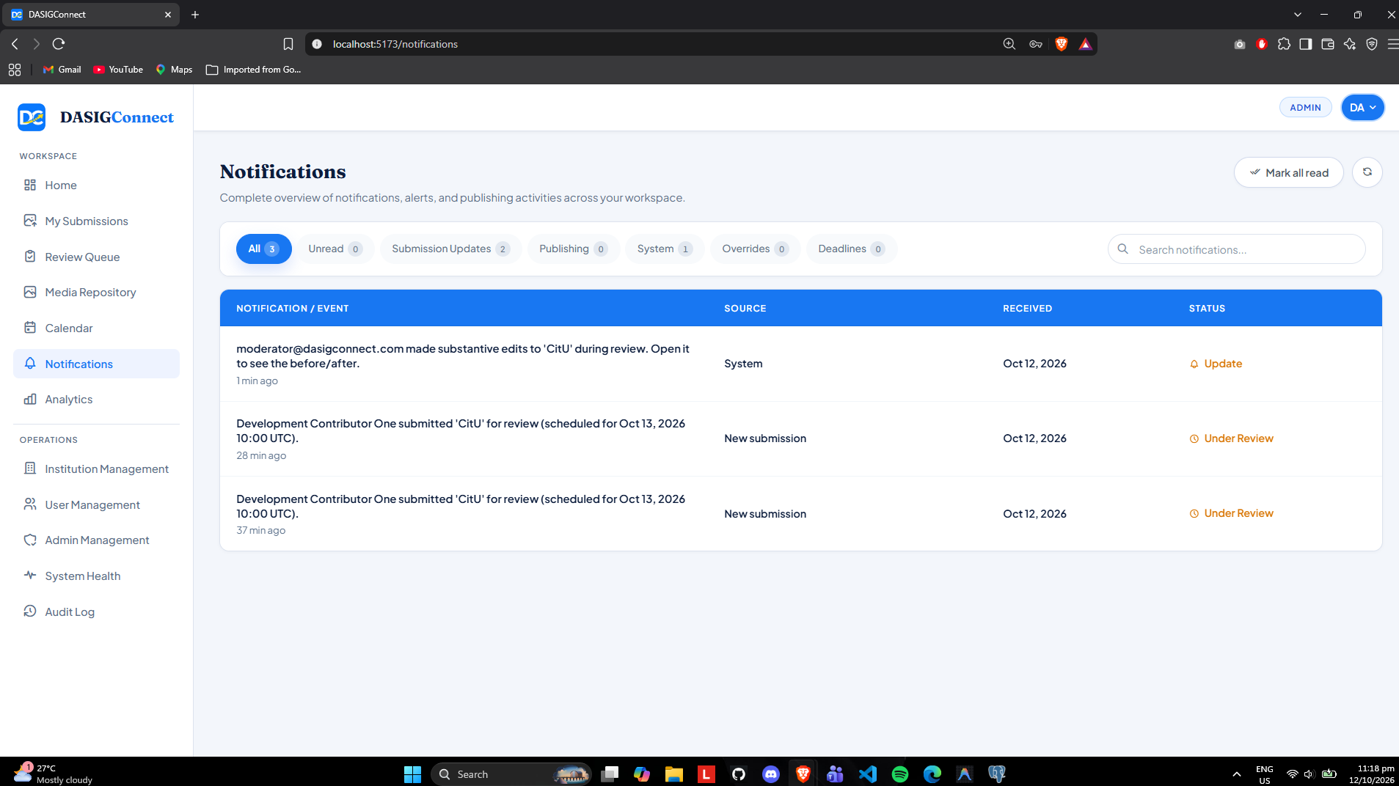

Screenshots for Test 23 (Case-23 — UC-3.4 Social Engagement Analytics & CSV Sanitization)
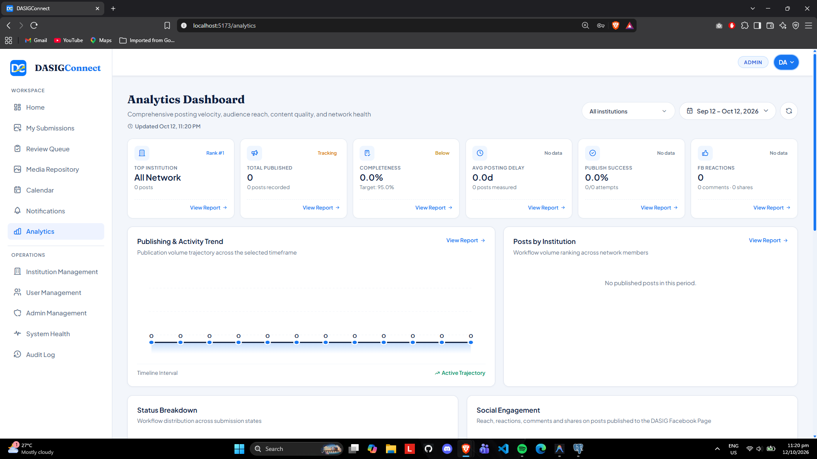
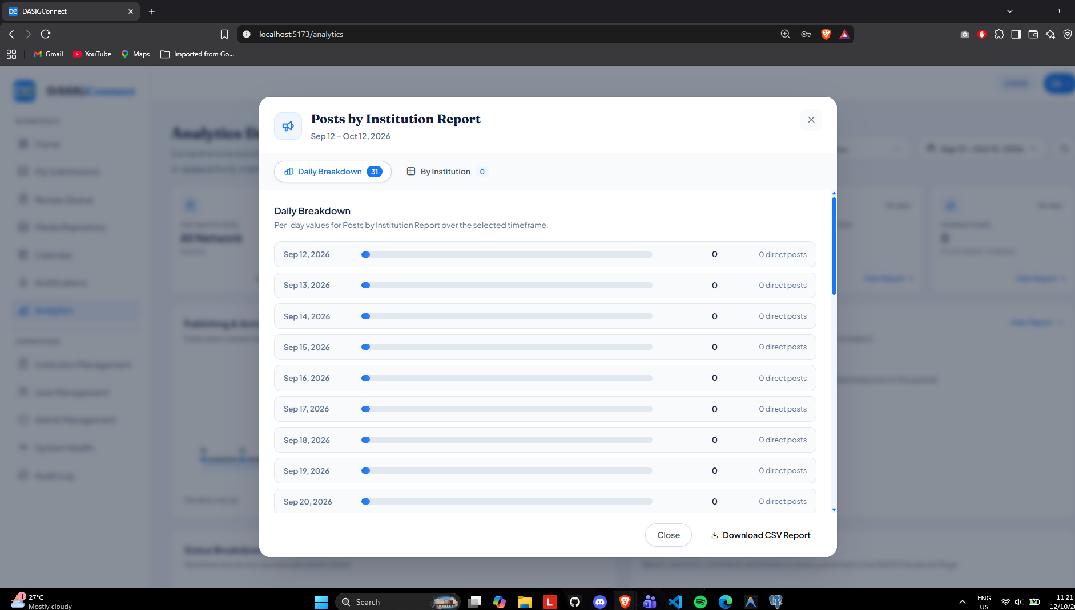
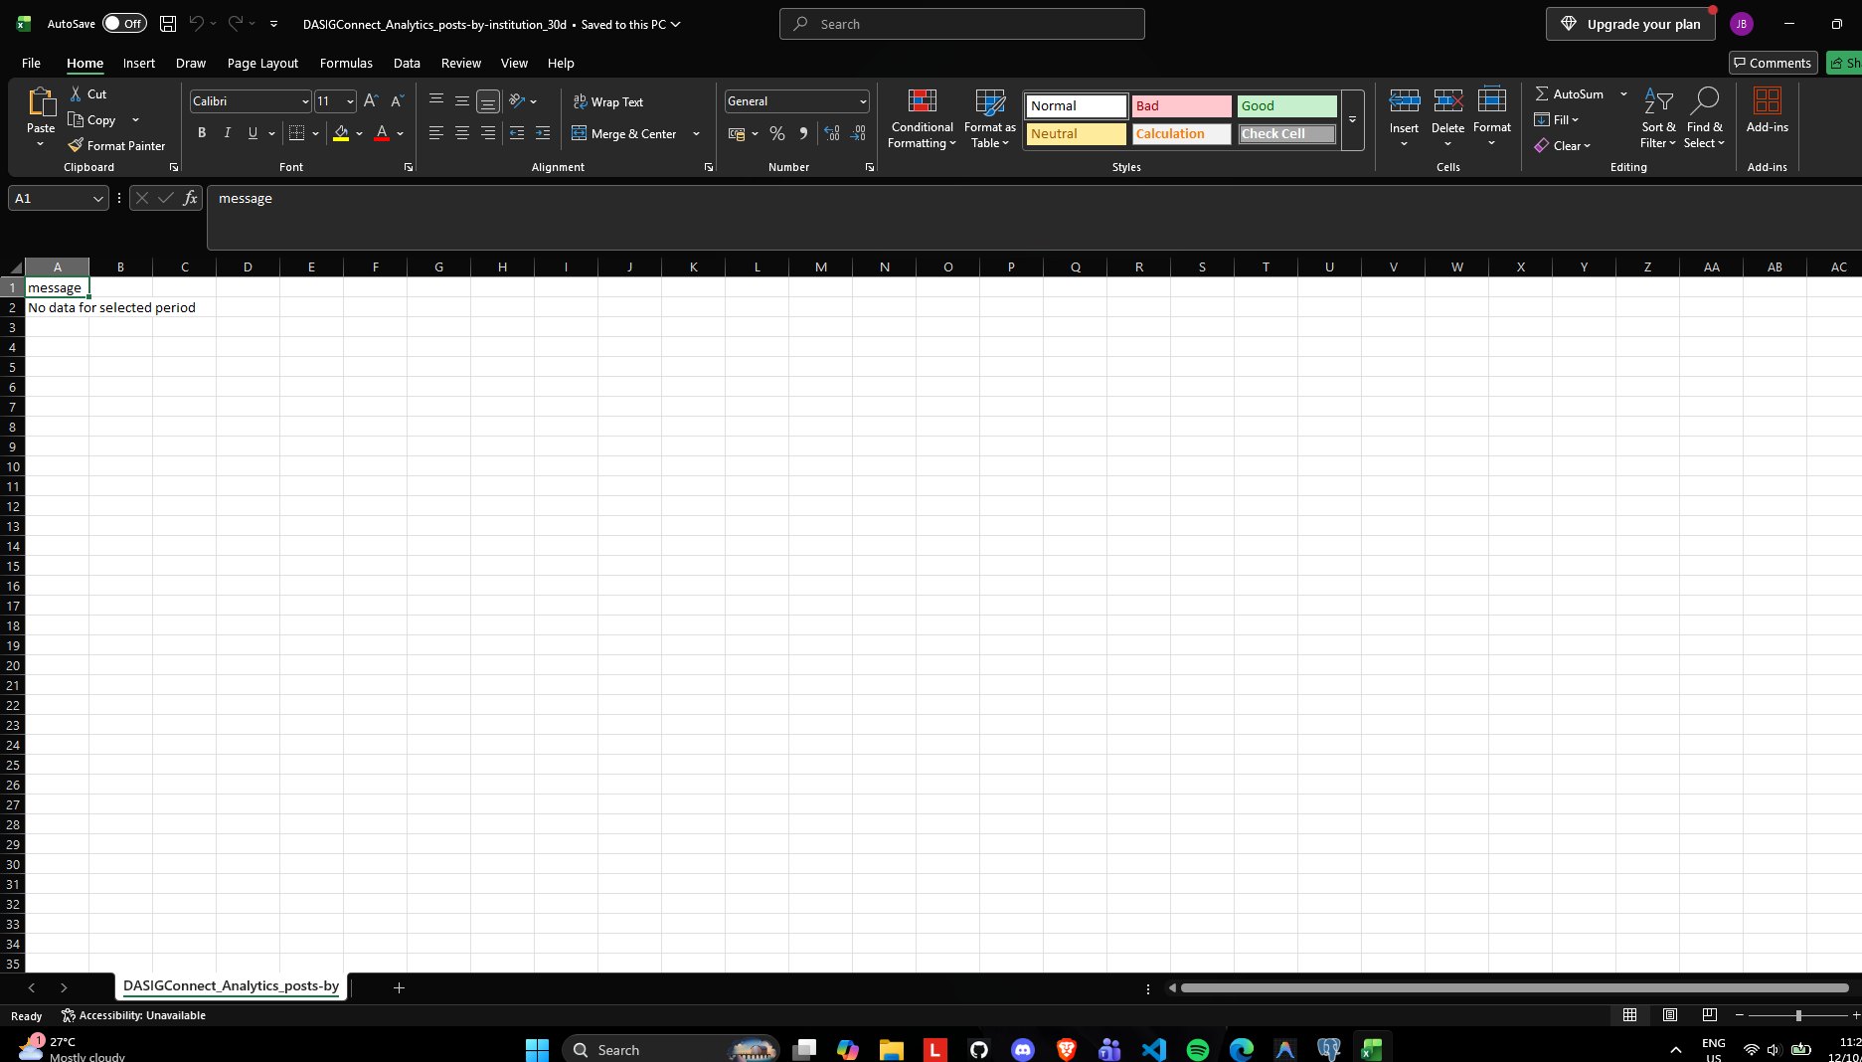

Screenshots for Test 24 (Case-24 — UC-3.5 System Health Analytics & 16 Tracked Jobs)
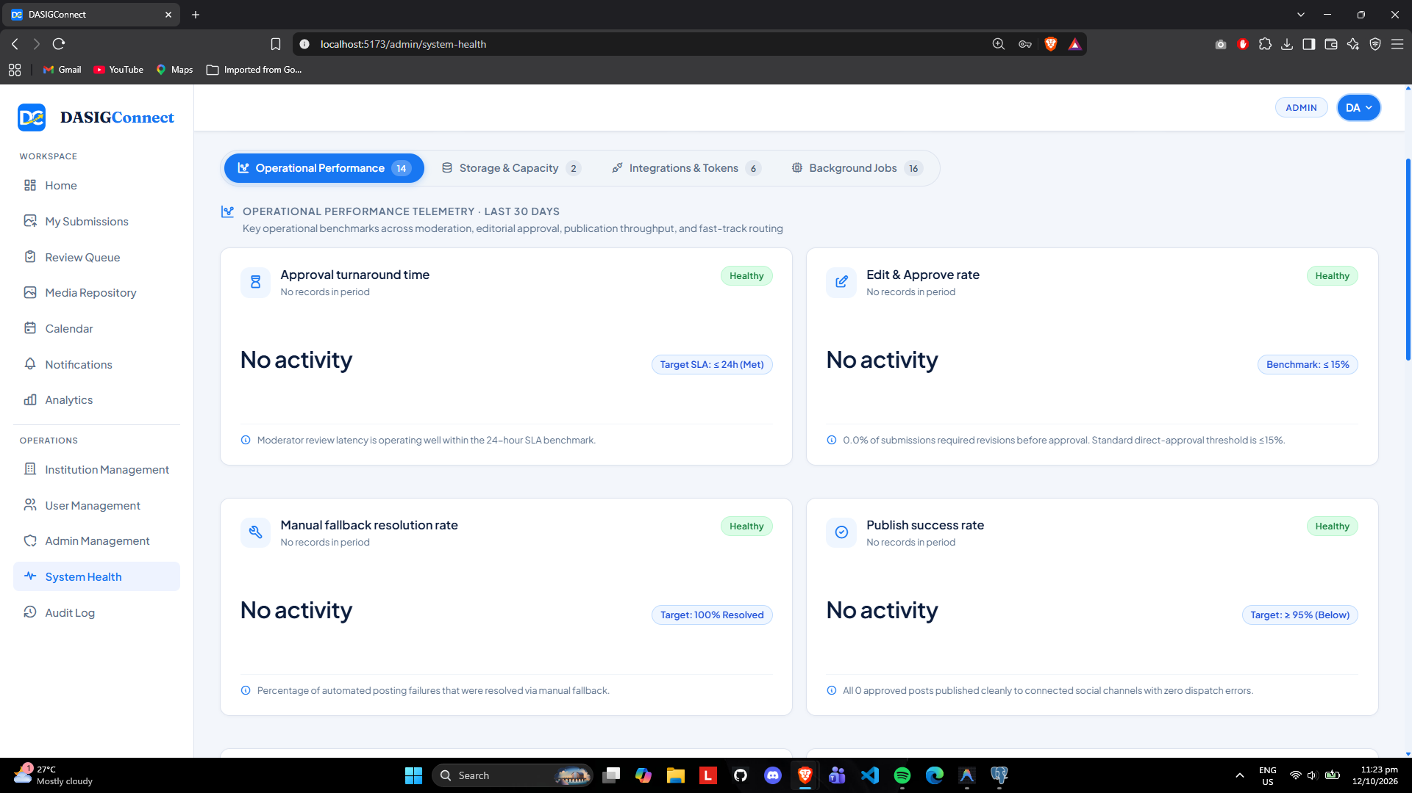
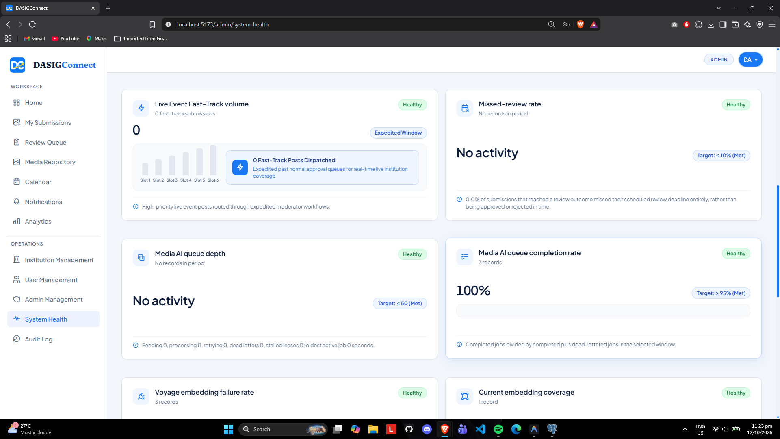

Screenshots for Test 25 (Case-25 — UC-3.6 Immutable Audit Log & Multi-Institution Tenant Isolation)
